**Chapter 1** 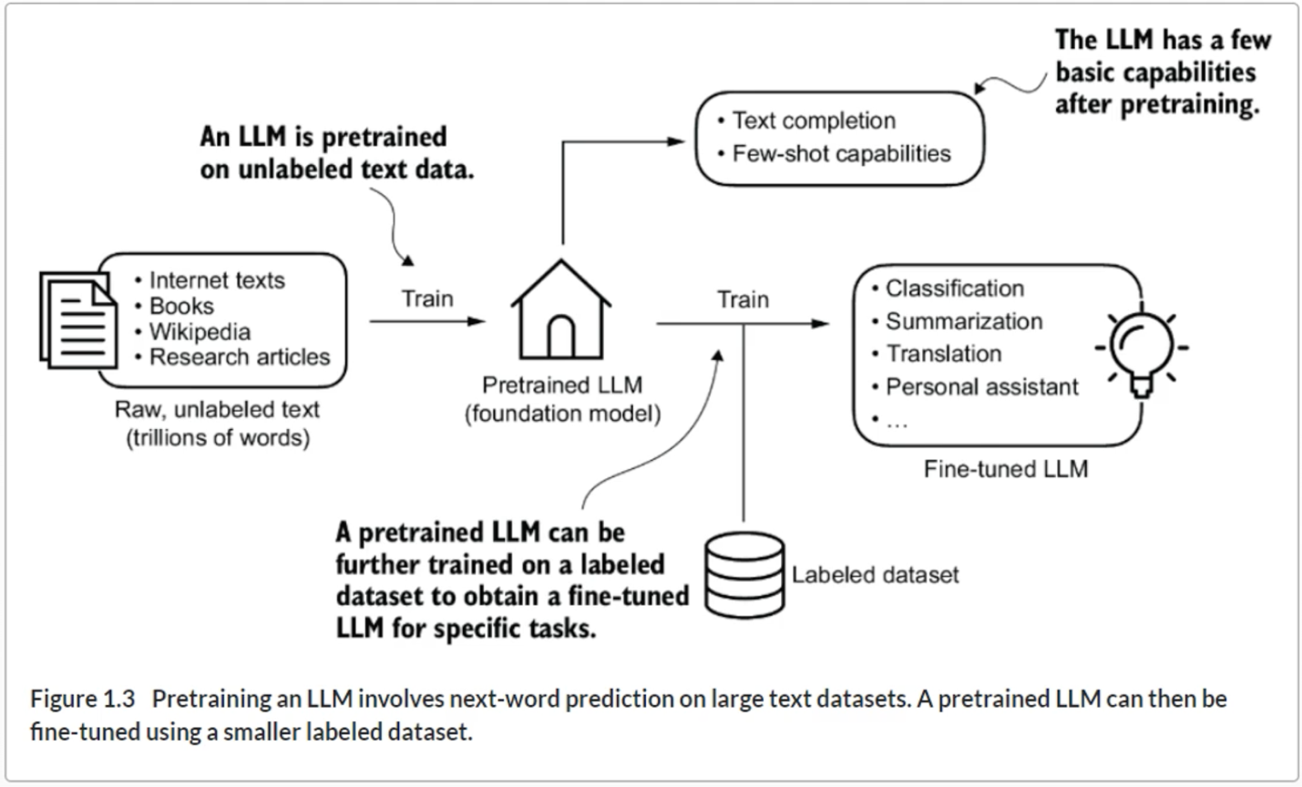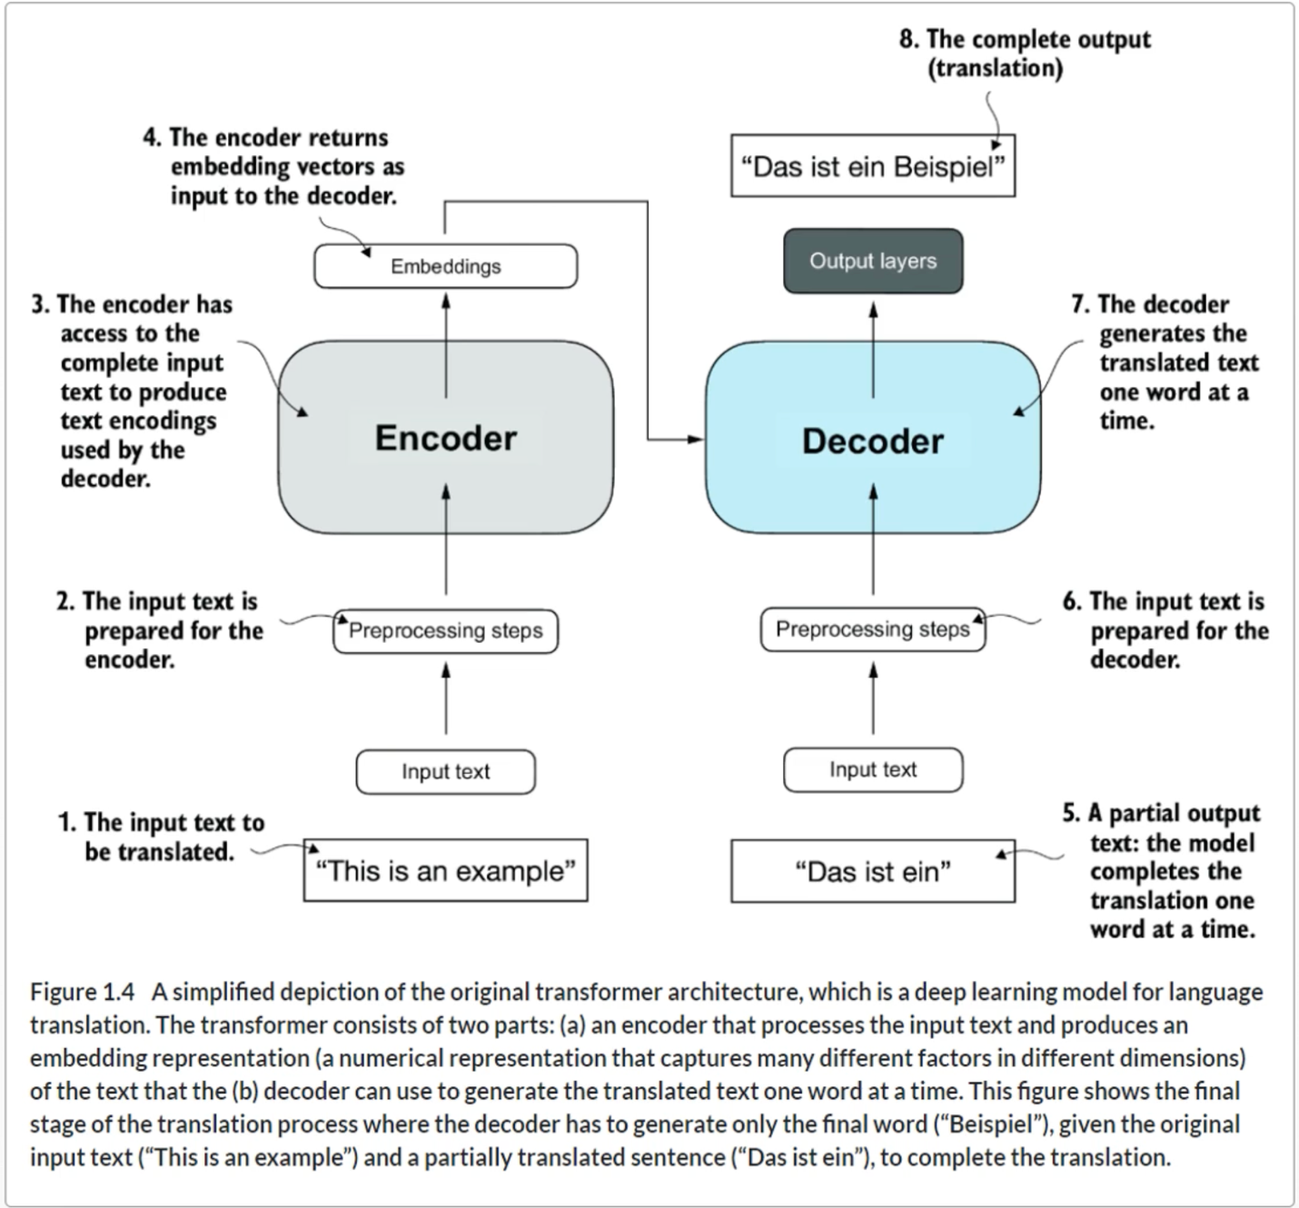

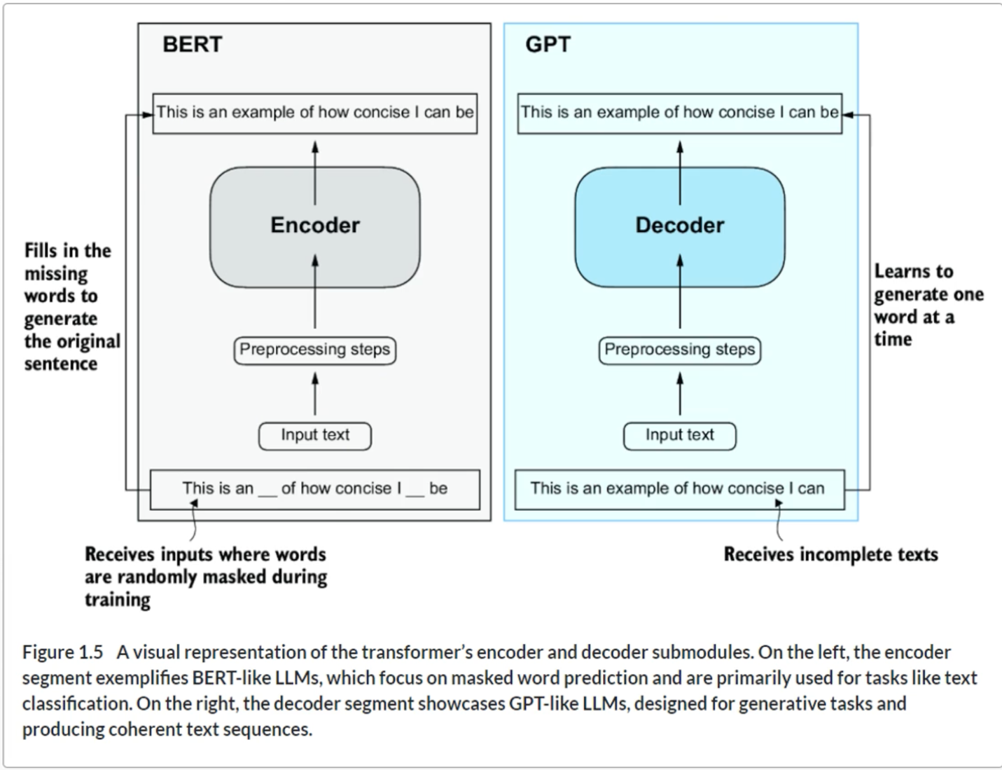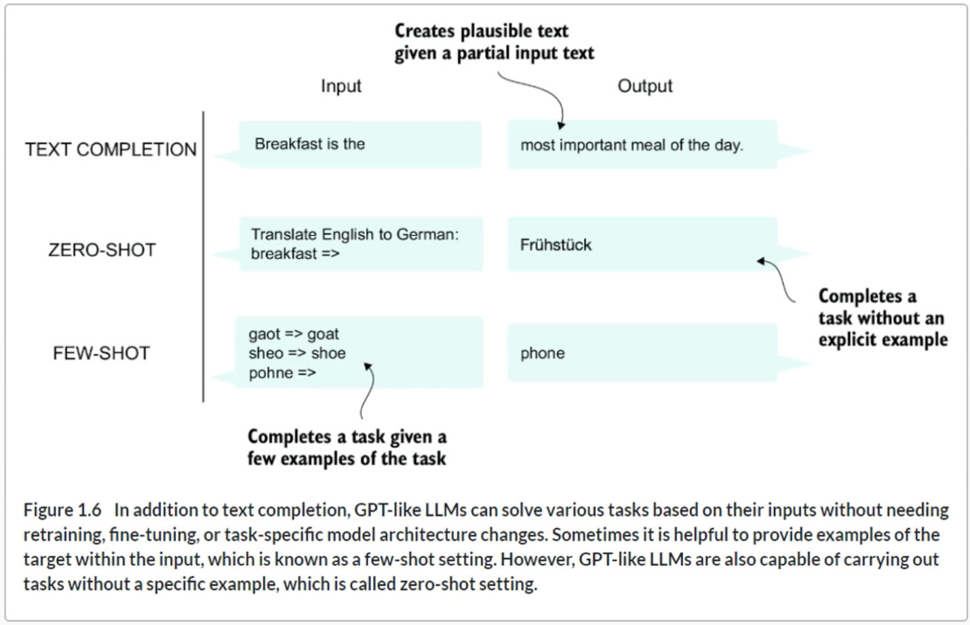

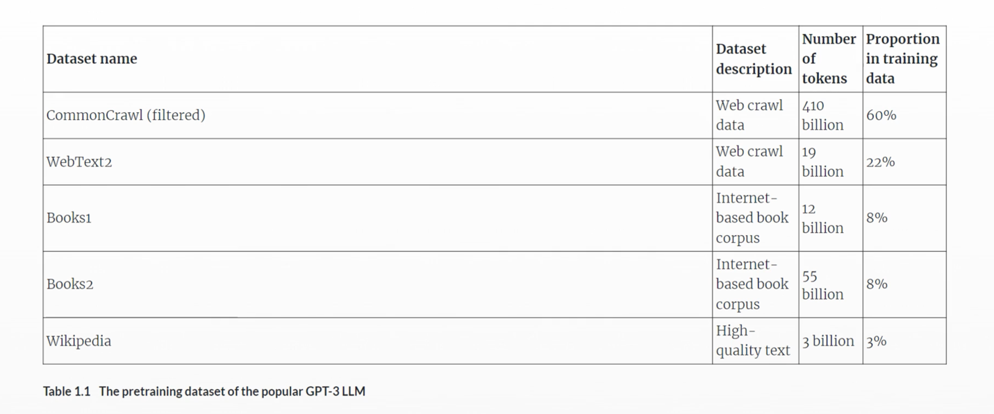

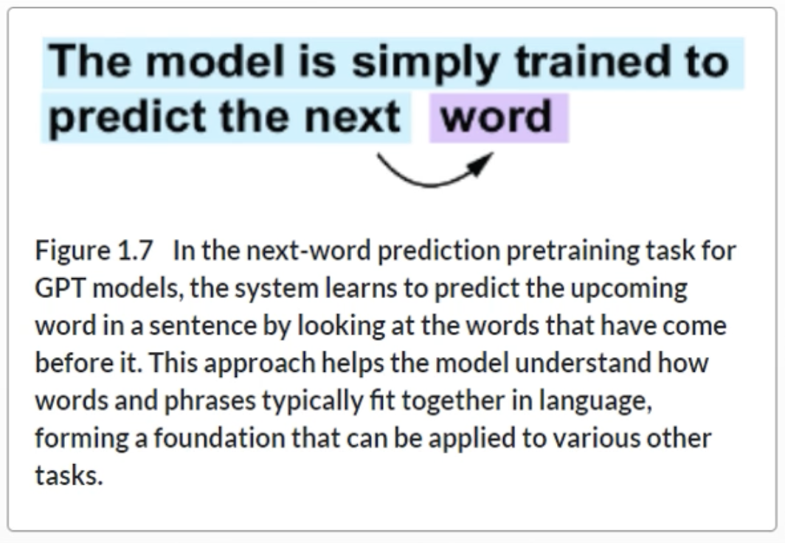

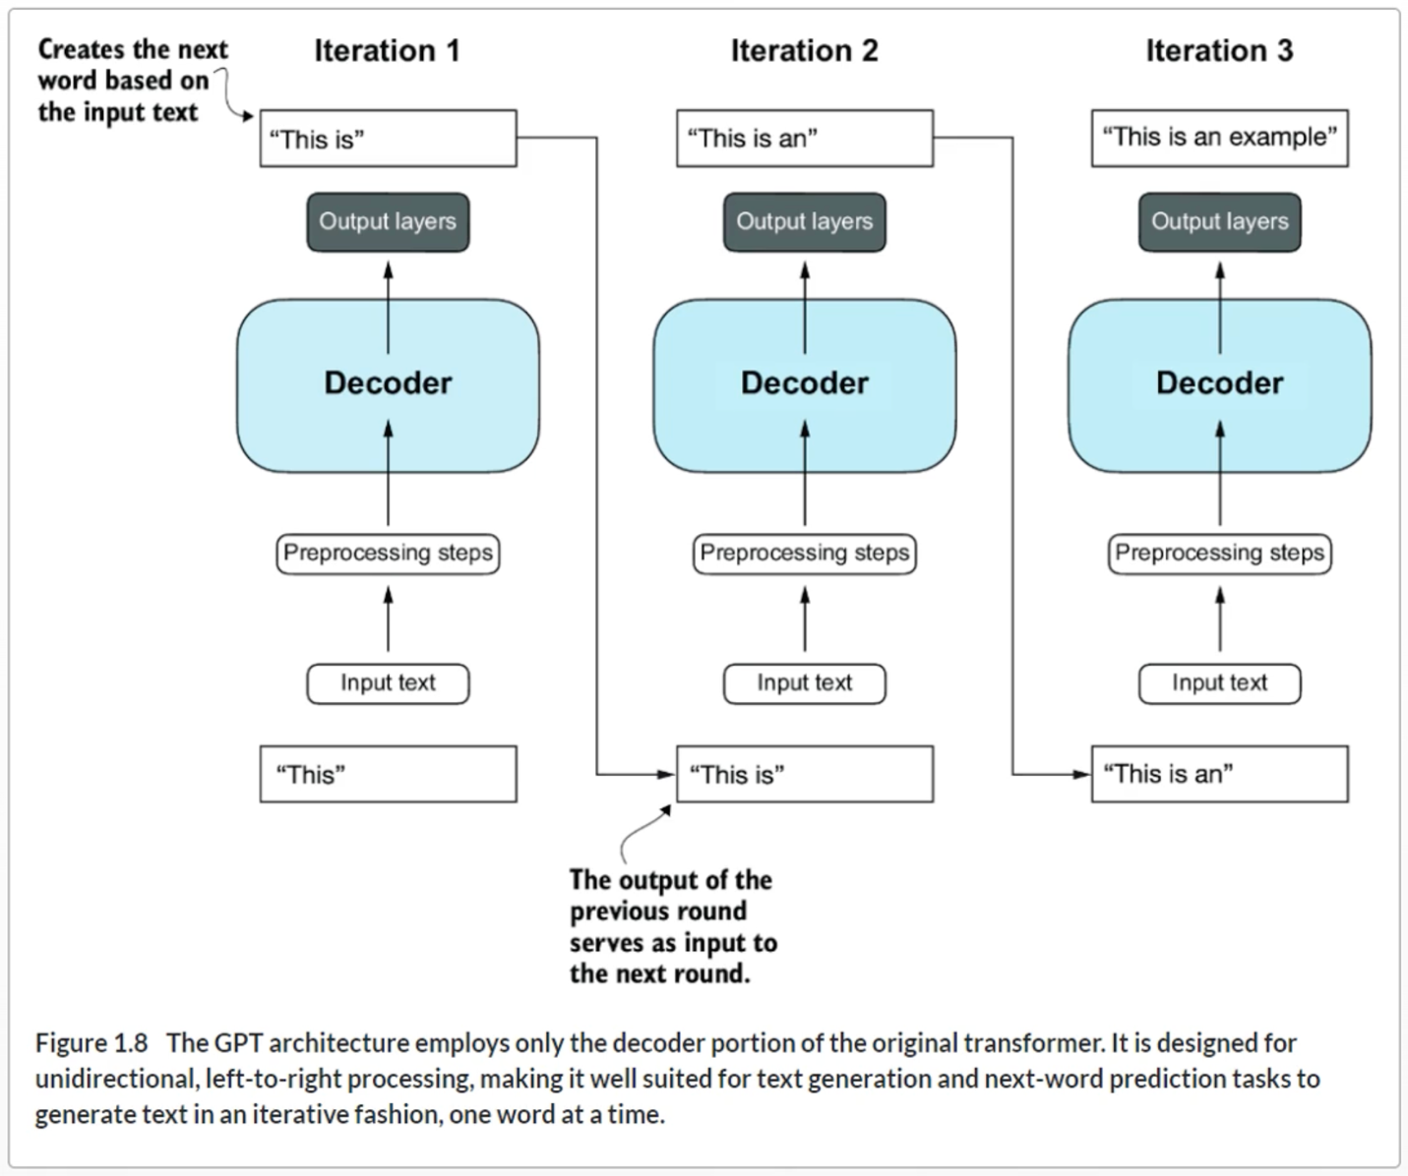

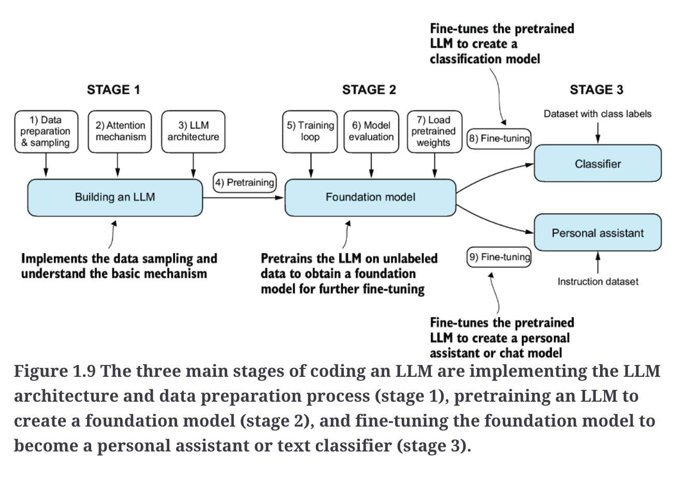

**Summary**

* LLMs have transformed the field of natural language processing, which previously mostly relied on explicit rule-based systems and simpler statistical methods. The advent of LLMs introduced new deep learning-driven approaches that led to advancements in understanding, generating, and translating human language.
* Modern LLMs are trained in two main steps:
  + First, they are pretrained on a large corpus of unlabeled text by using the prediction of the next word in a sentence as a label.
  + Then, they are fine-tuned on a smaller, labeled target dataset to follow instructions or perform classification tasks.
* LLMs are based on the transformer architecture. The key idea of the transformer architecture is an attention mechanism that gives the LLM selective access to the whole input sequence when generating the output one word at a time.
* The original transformer architecture consists of an encoder for parsing text and a decoder for generating text.
* LLMs for generating text and following instructions, such as GPT-3 and ChatGPT, only implement decoder modules, simplifying the architecture.
* Large datasets consisting of billions of words are essential for pretraining LLMs.
* While the general pretraining task for GPT-like models is to predict the next word in a sentence, these LLMs exhibit emergent properties, such as capabilities to classify, translate, or summarize texts.
* Once an LLM is pretrained, the resulting foundation model can be fine-tuned more efficiently for various downstream tasks.
* LLMs fine-tuned on custom datasets can outperform general LLMs on specific tasks.

**Chapter 2**

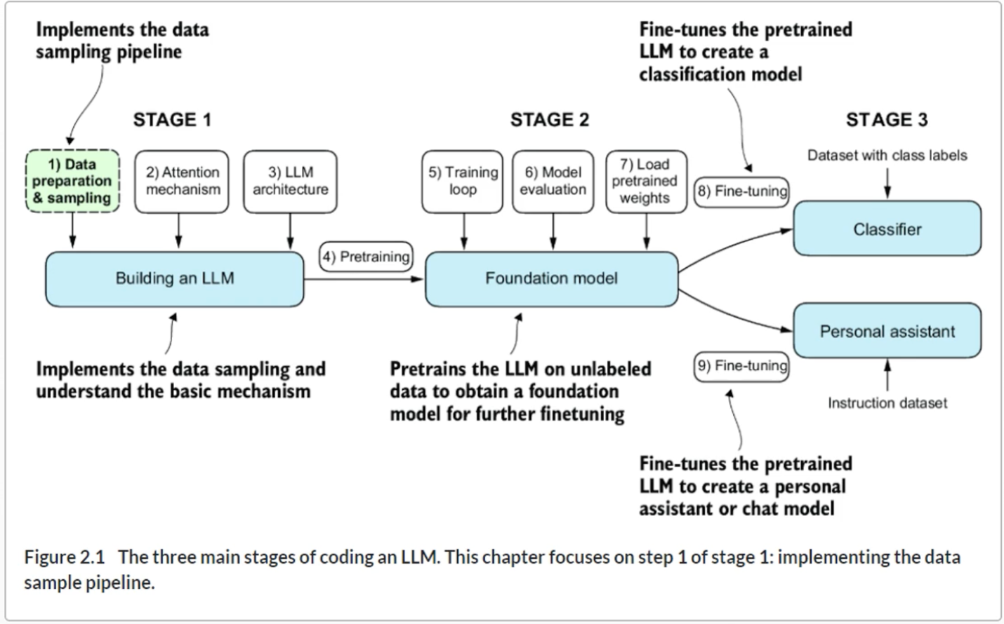

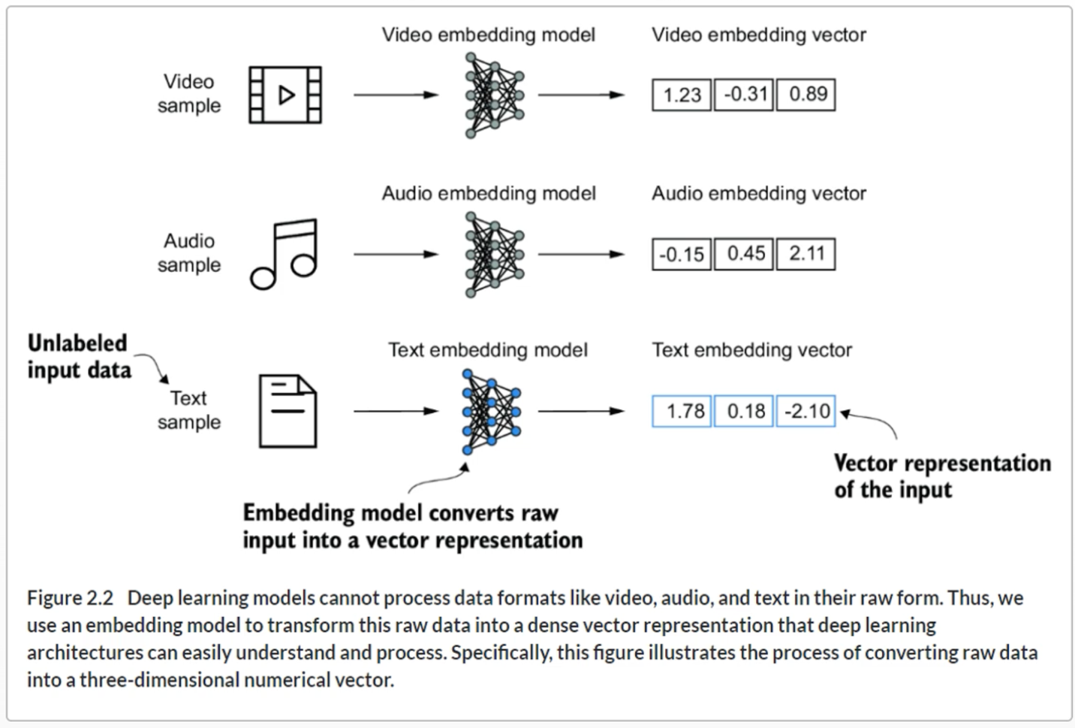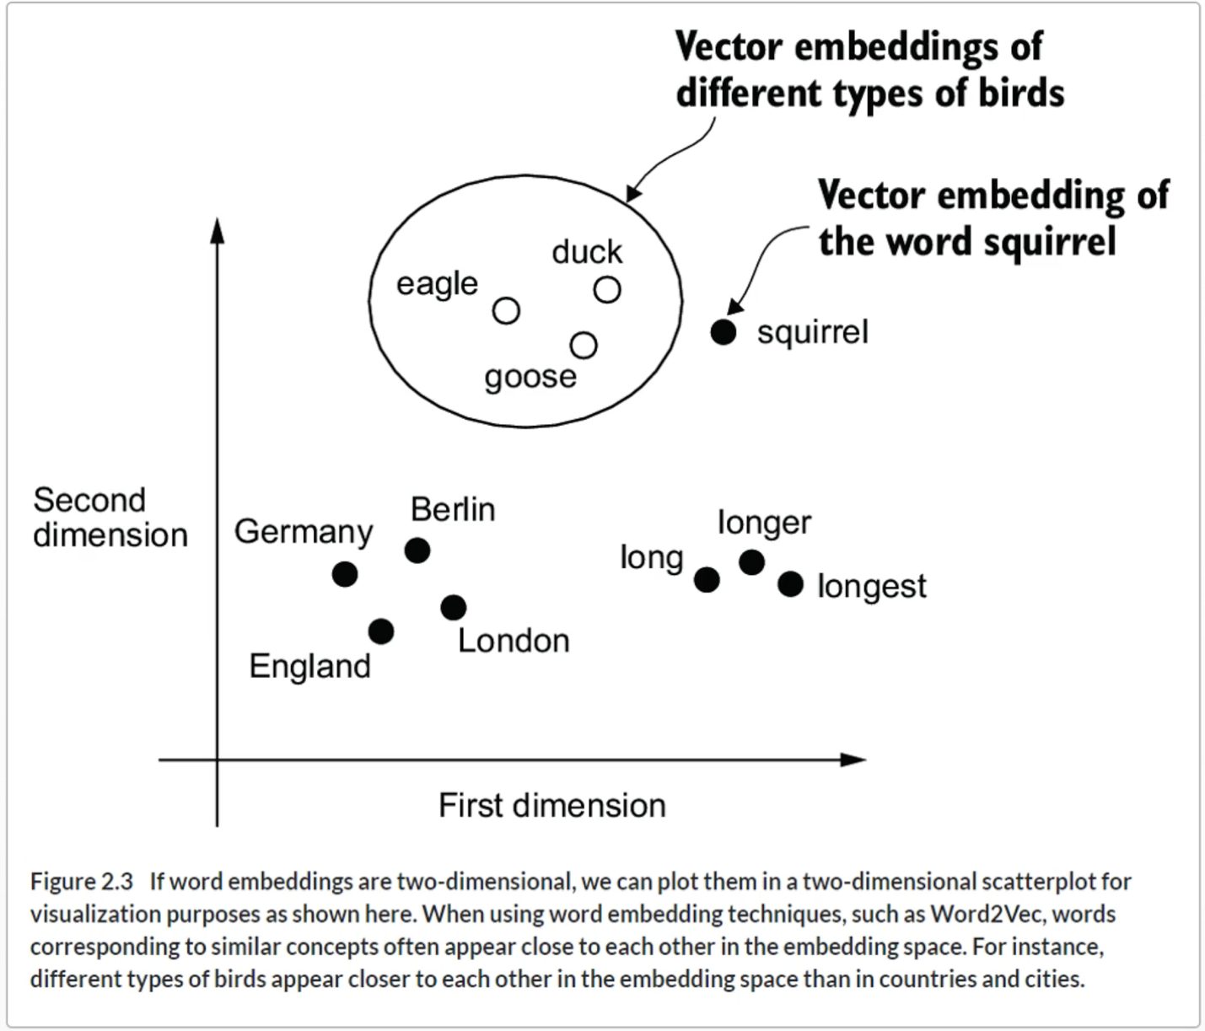

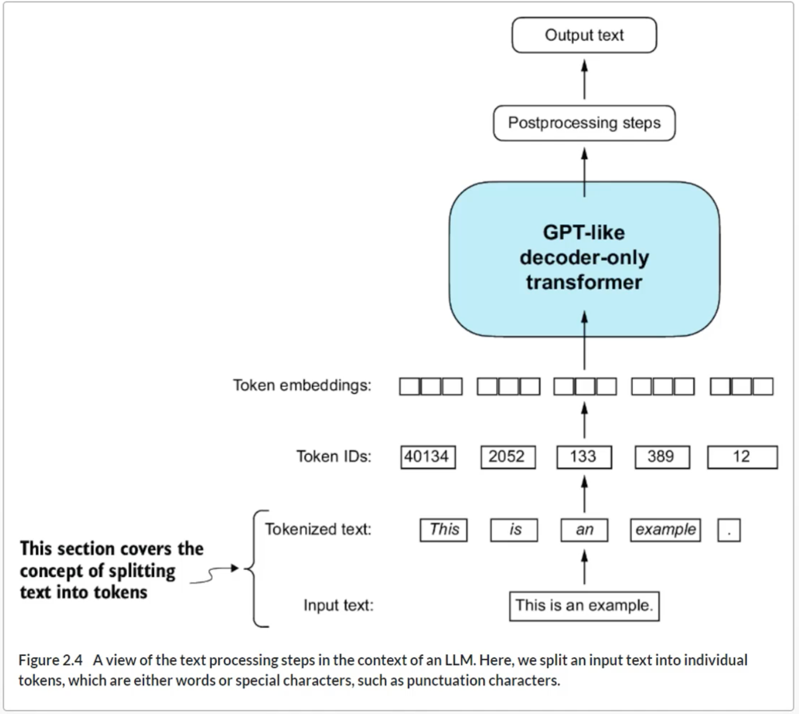

**Tokenization**

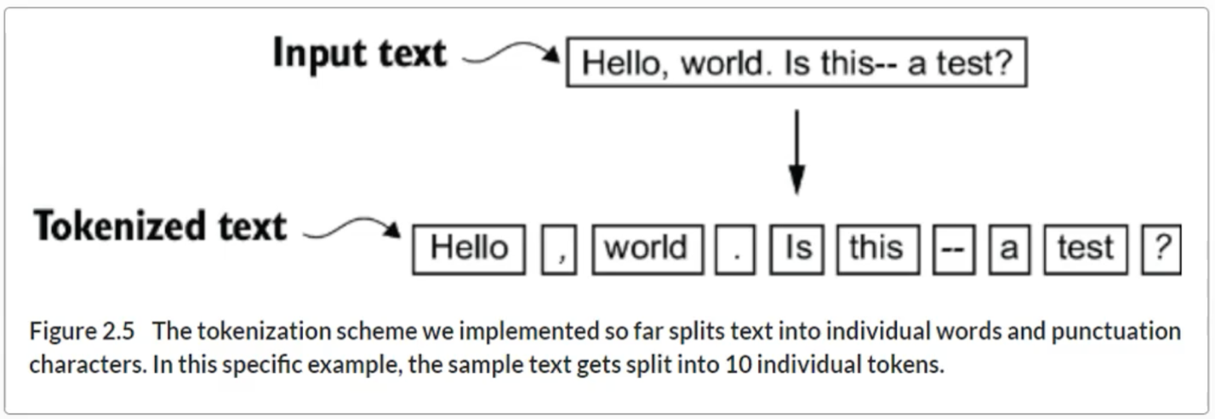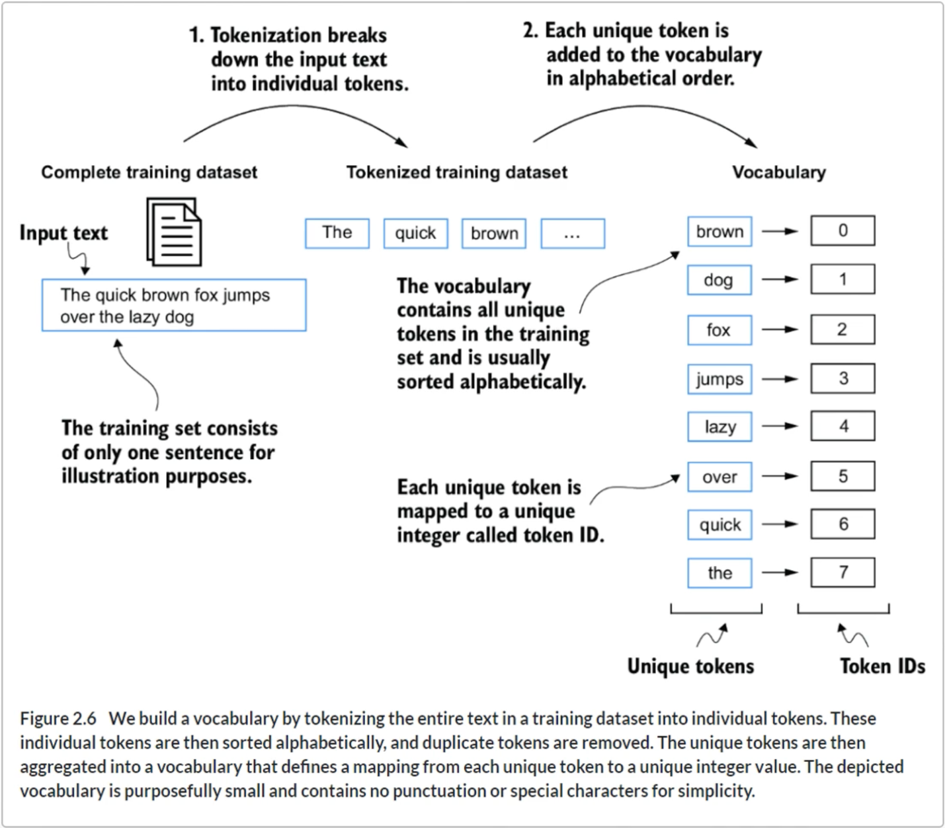

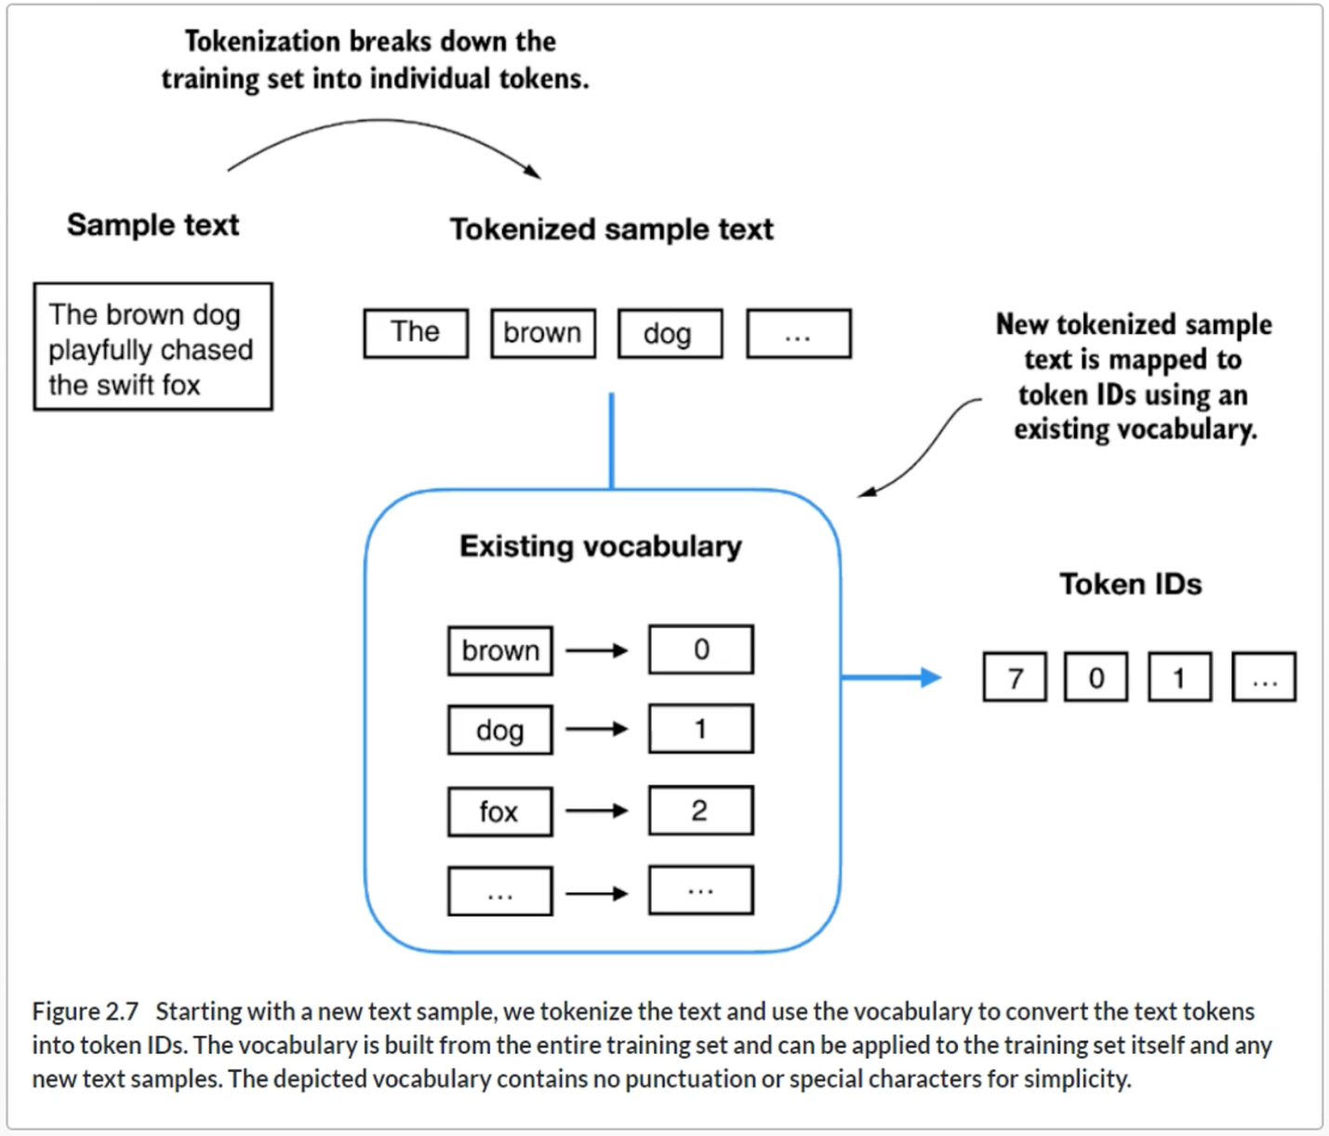

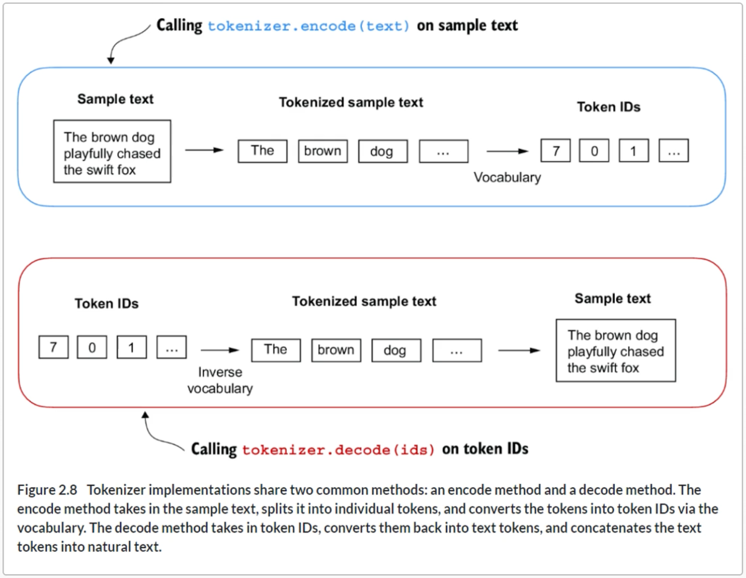

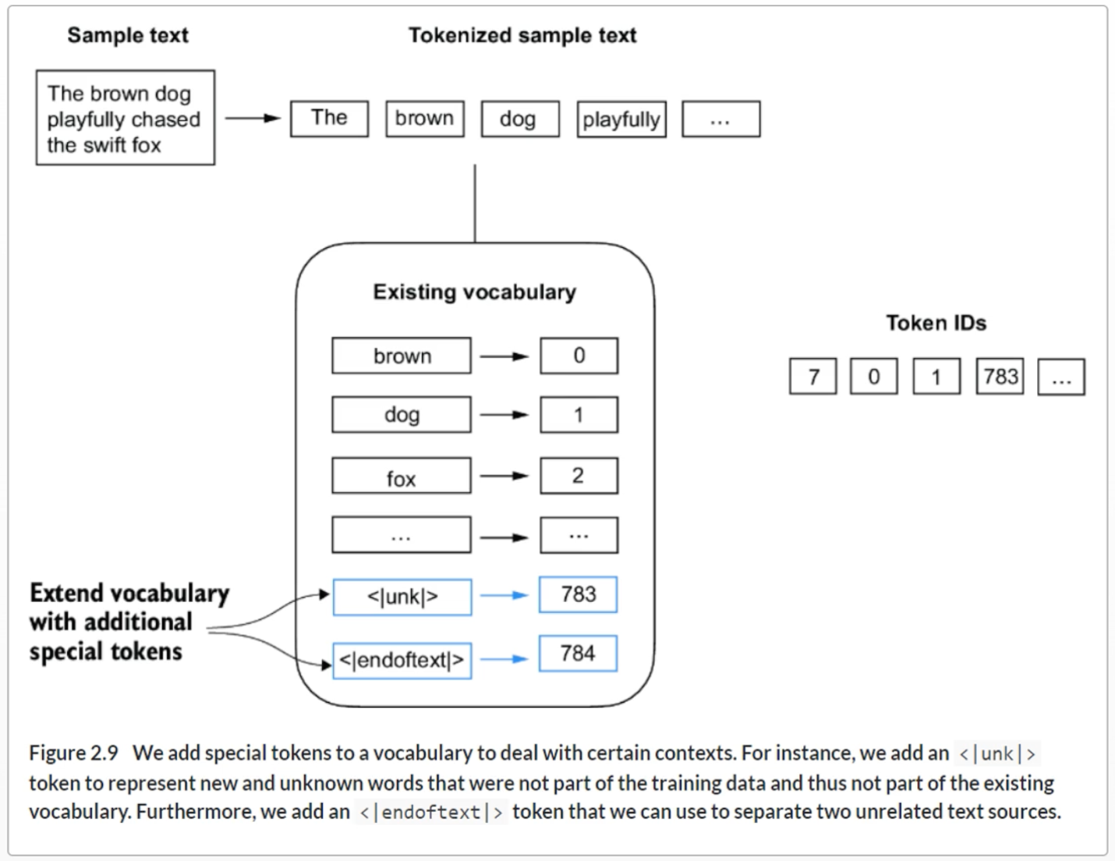

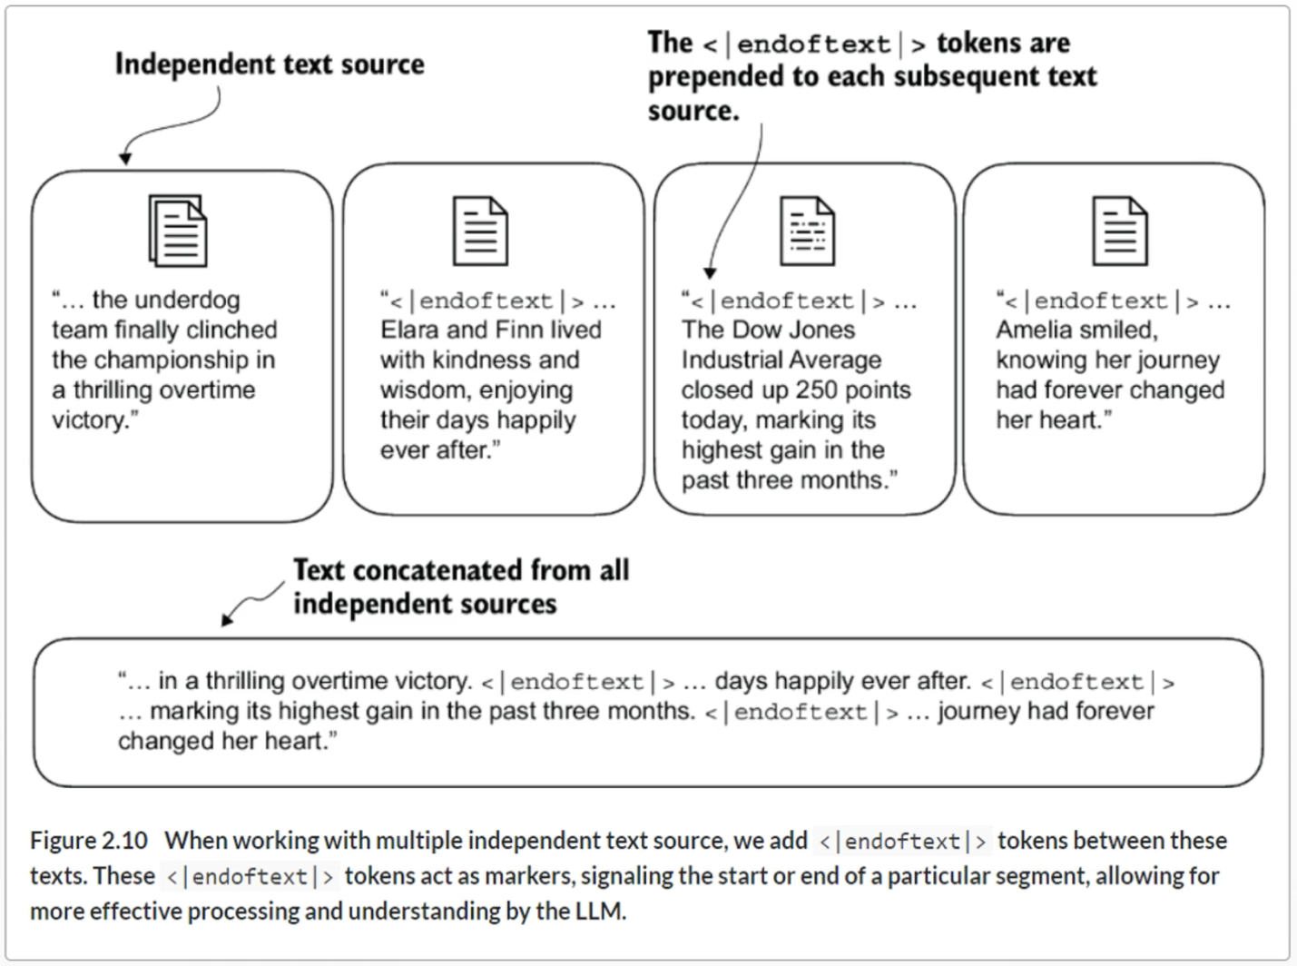

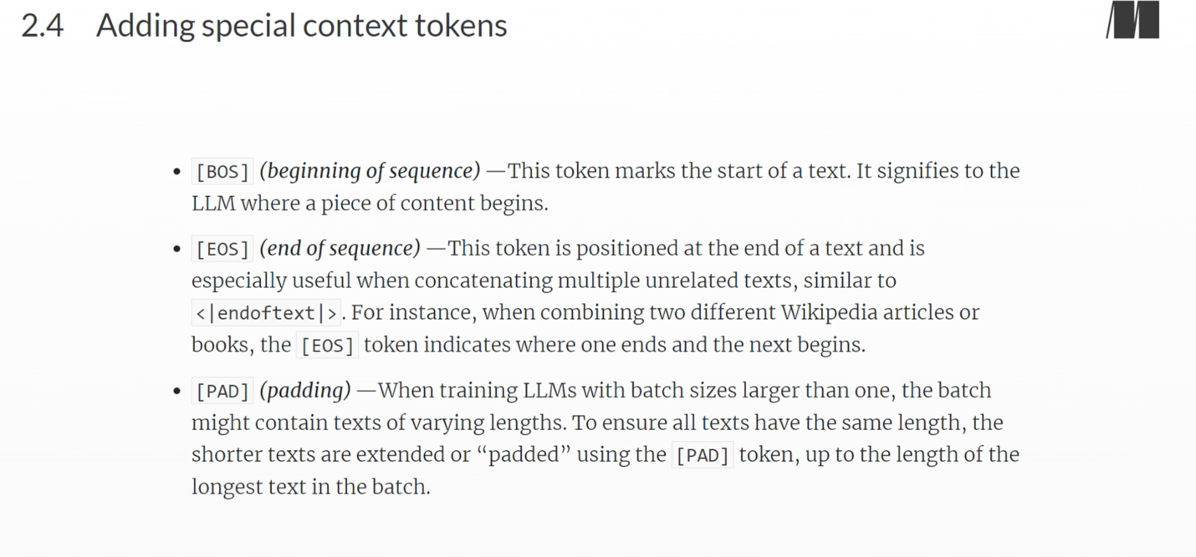

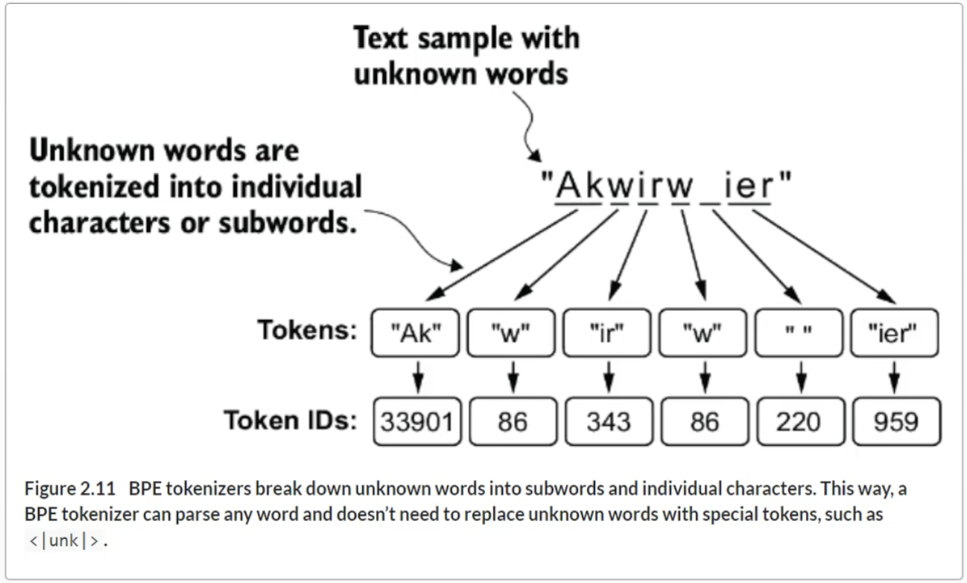

**Data sampling with a sliding window**

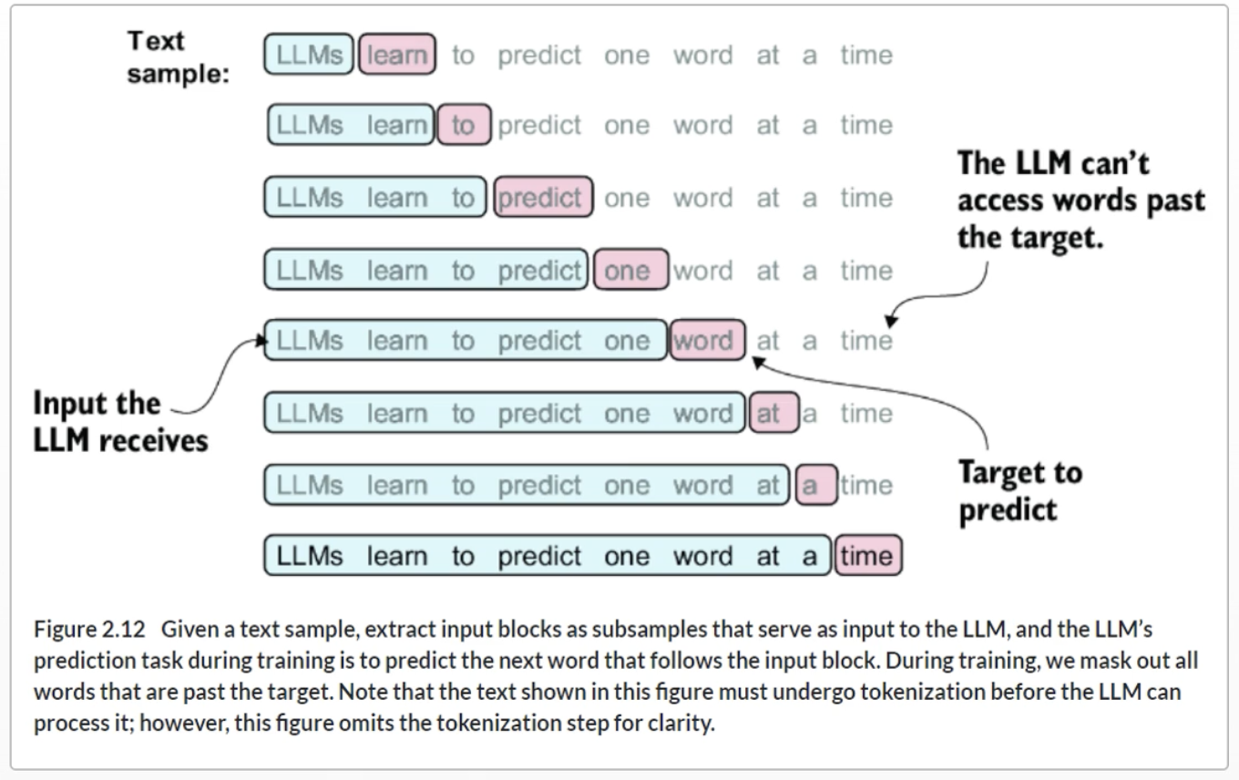

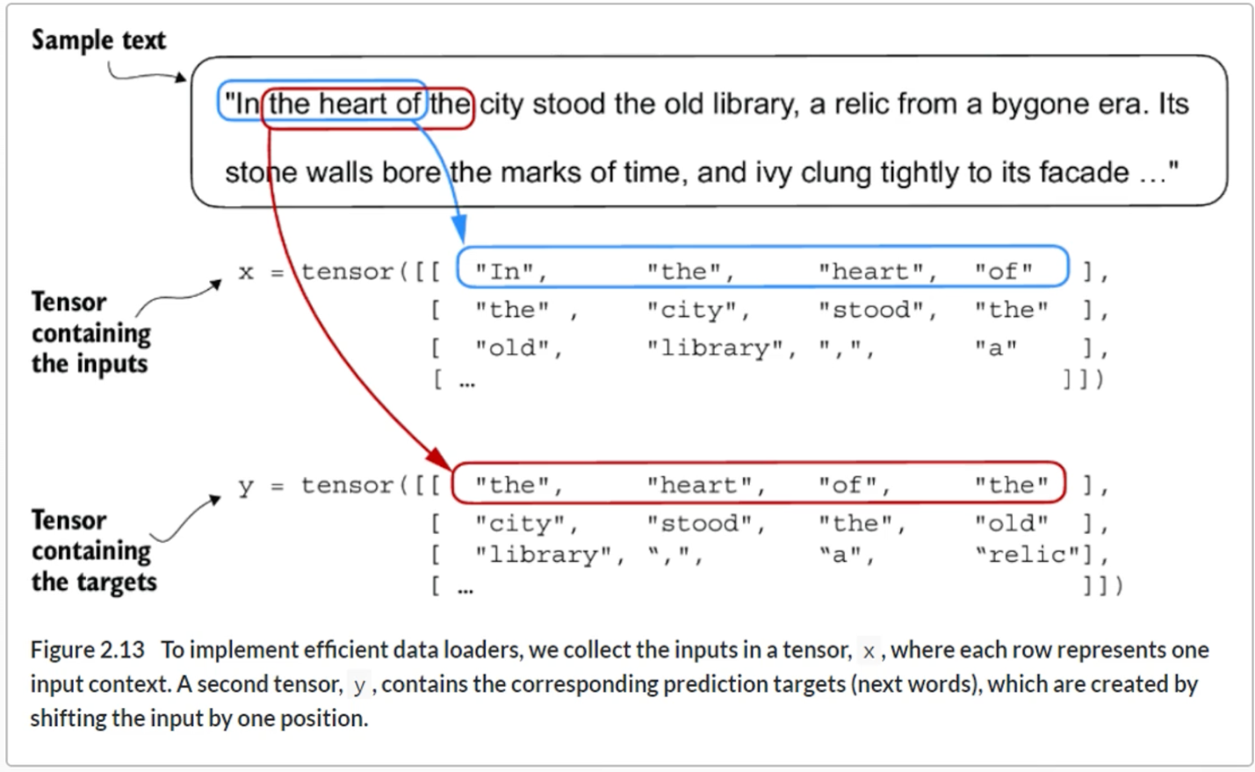

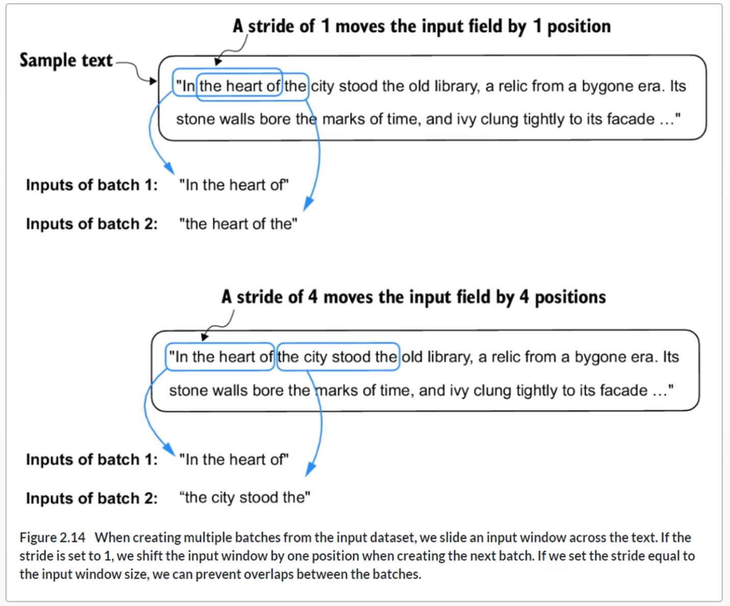

**Creating Token Embeddings**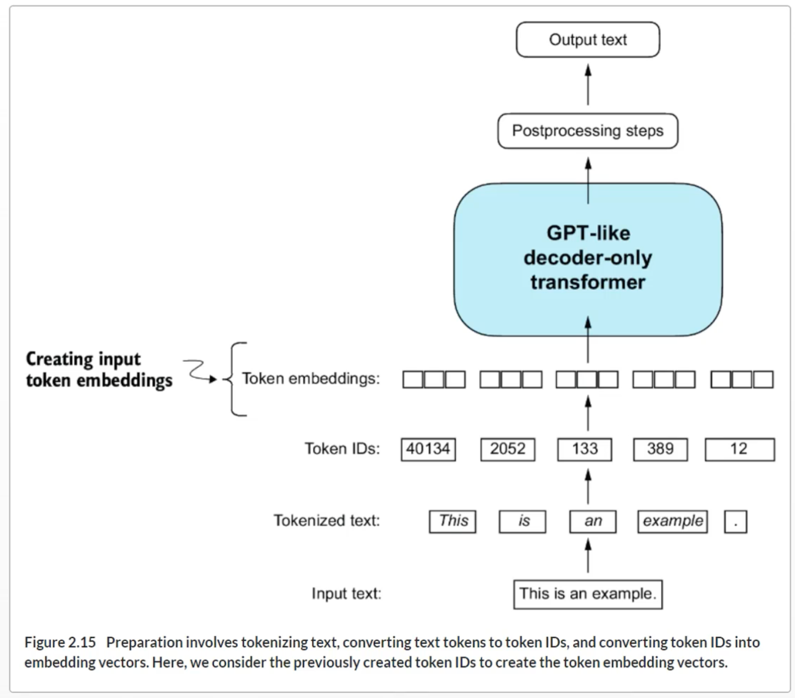

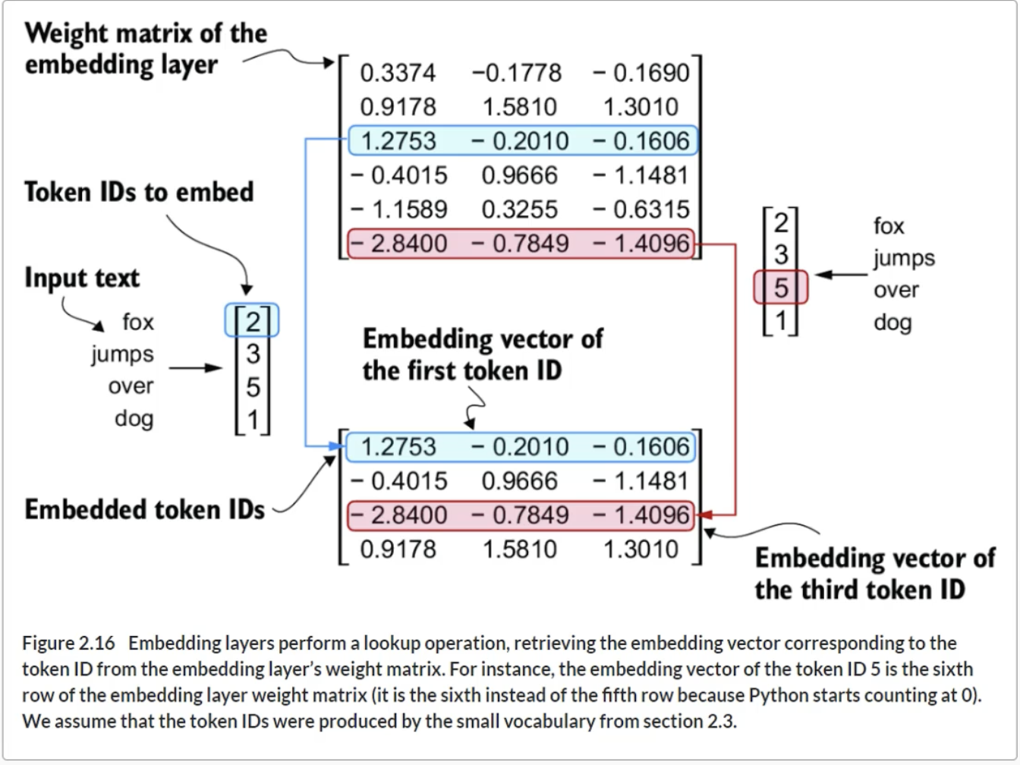

**Positional Encoding**

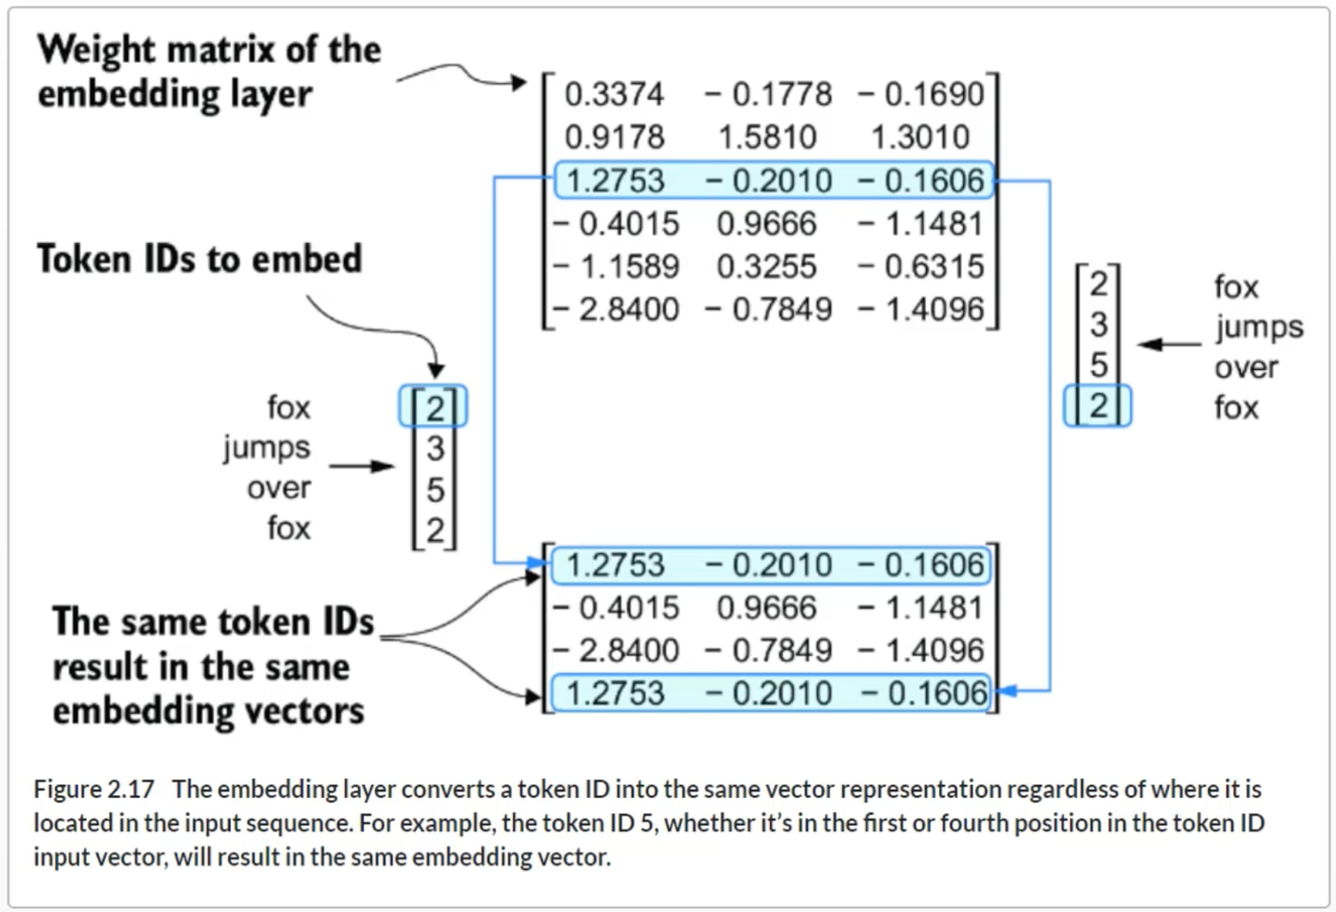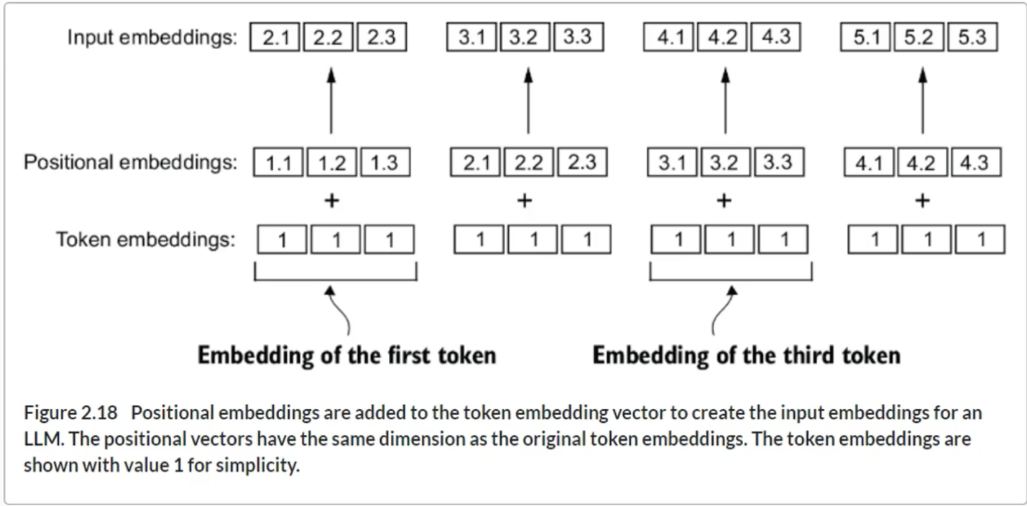

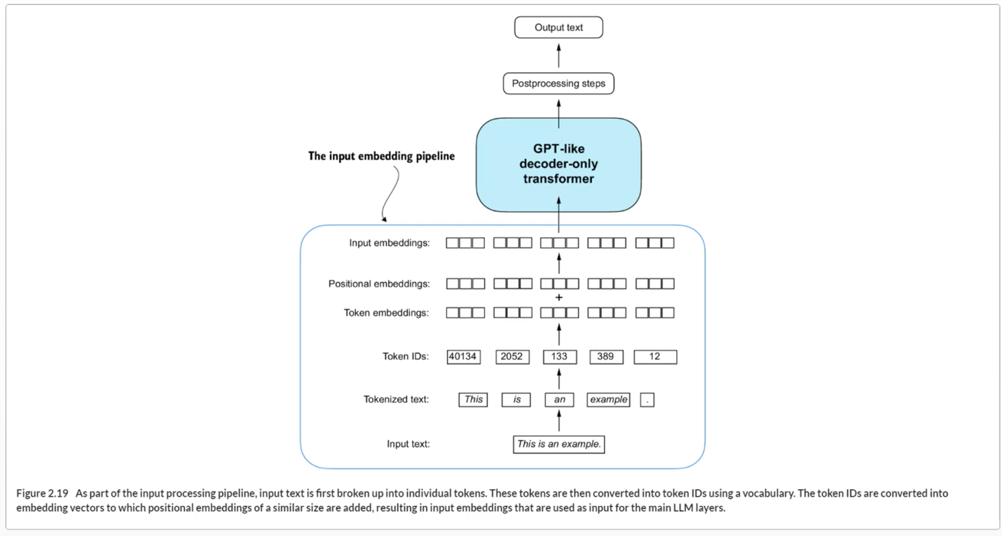

**Chapter 2 Summary**

* LLMs require textual data to be converted into numerical vectors, known as embeddings, since they can’t process raw text. Embeddings transform discrete data (like words or images) into continuous vector spaces, making them compatible with neural network operations.
* As the first step, raw text is broken into tokens, which can be words or characters. Then, the tokens are converted into integer representations, termed token IDs.
* Special tokens, such as <|unk|> and <|endoftext|>, can be added to enhance the model’s understanding and handle various contexts, such as unknown words or marking the boundary between unrelated texts.
* The byte pair encoding (BPE) tokenizer used for LLMs like GPT-2 and GPT-3 can efficiently handle unknown words by breaking them down into subword units or individual characters.
* We use a sliding window approach on tokenized data to generate input–target pairs for LLM training.
* Embedding layers in PyTorch function as a lookup operation, retrieving vectors corresponding to token IDs. The resulting embedding vectors provide continuous representations of tokens, which is crucial for training deep learning models like LLMs.
* While token embeddings provide consistent vector representations for each token, they lack a sense of the token’s position in a sequence. To rectify this, two main types of positional embeddings exist: absolute and relative. OpenAI’s GPT models utilize absolute positional embeddings, which are added to the token embedding vectors and are optimized during the model training.

**Chapter 3**

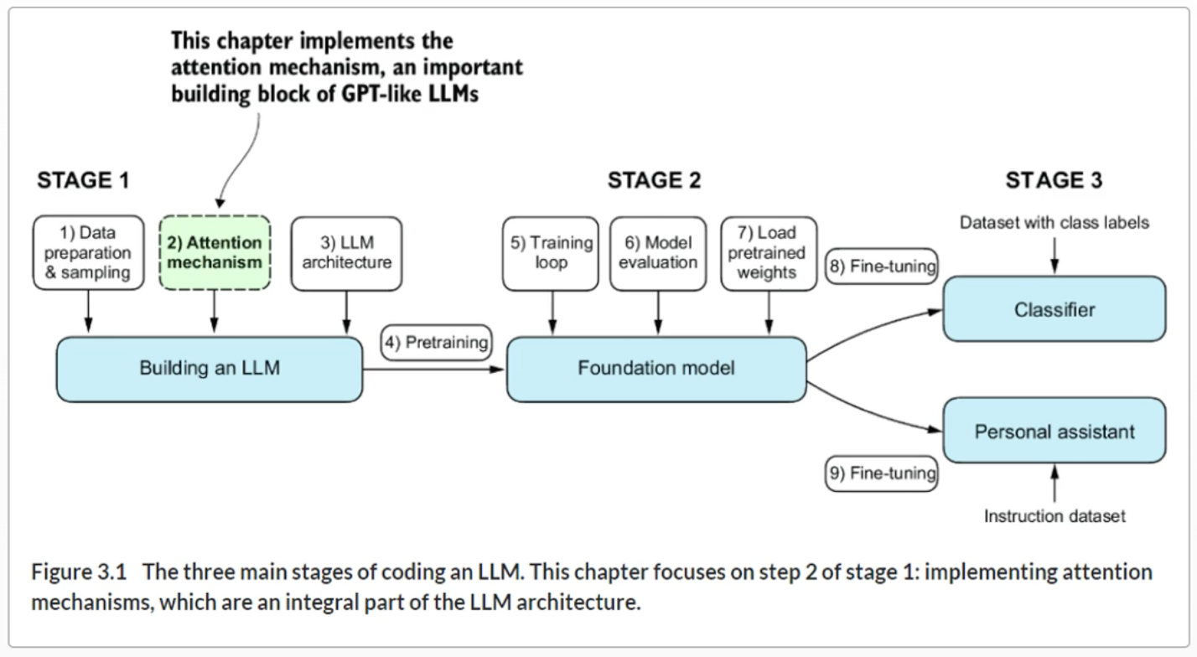

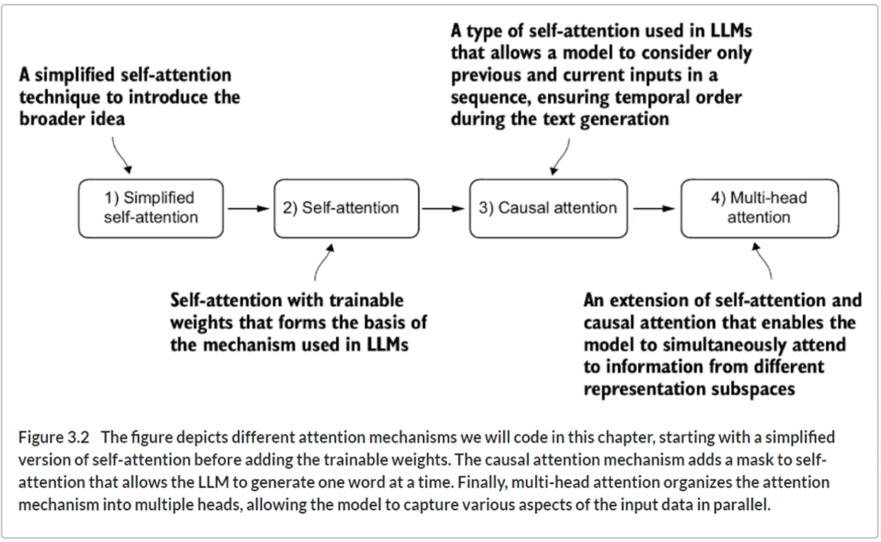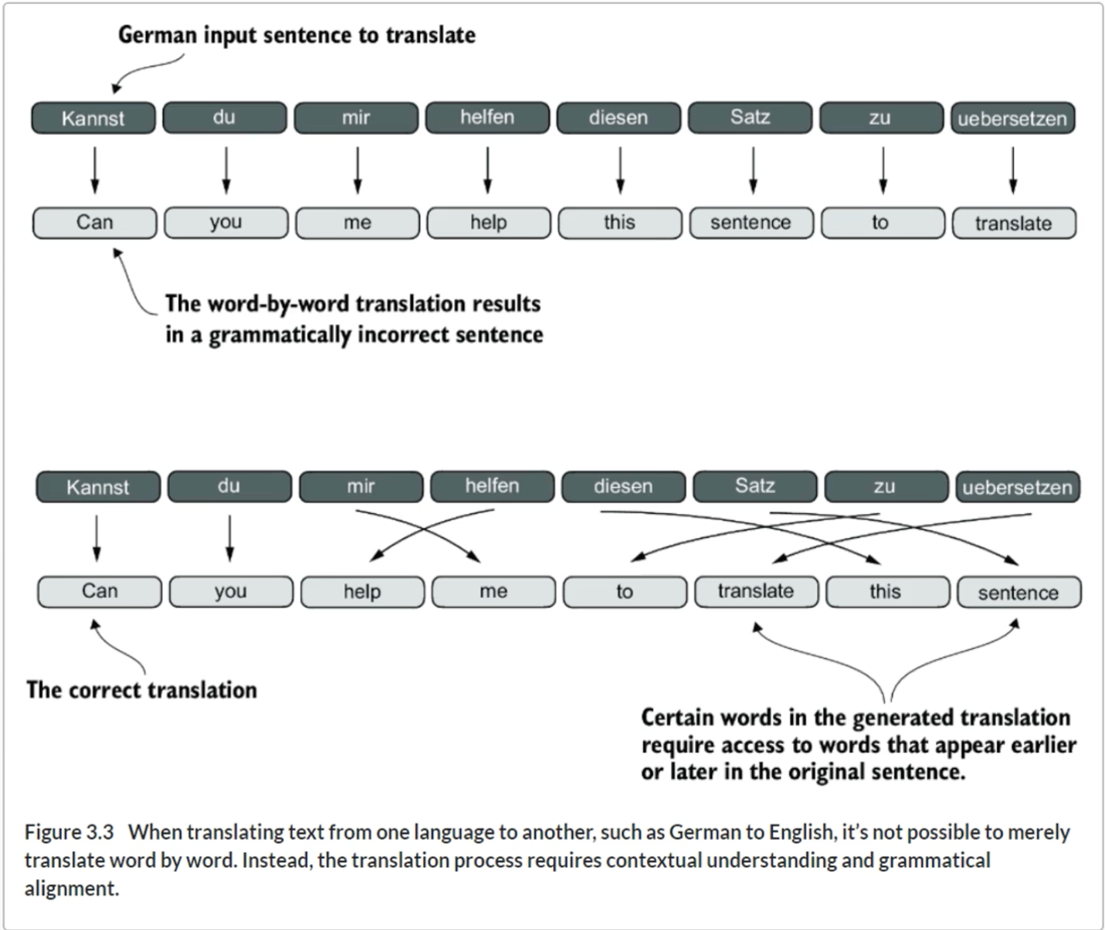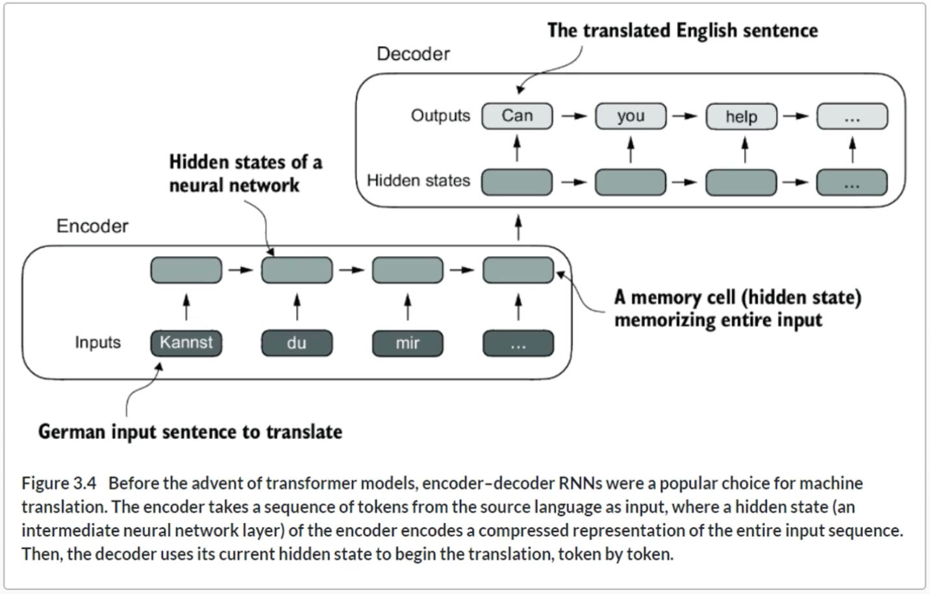

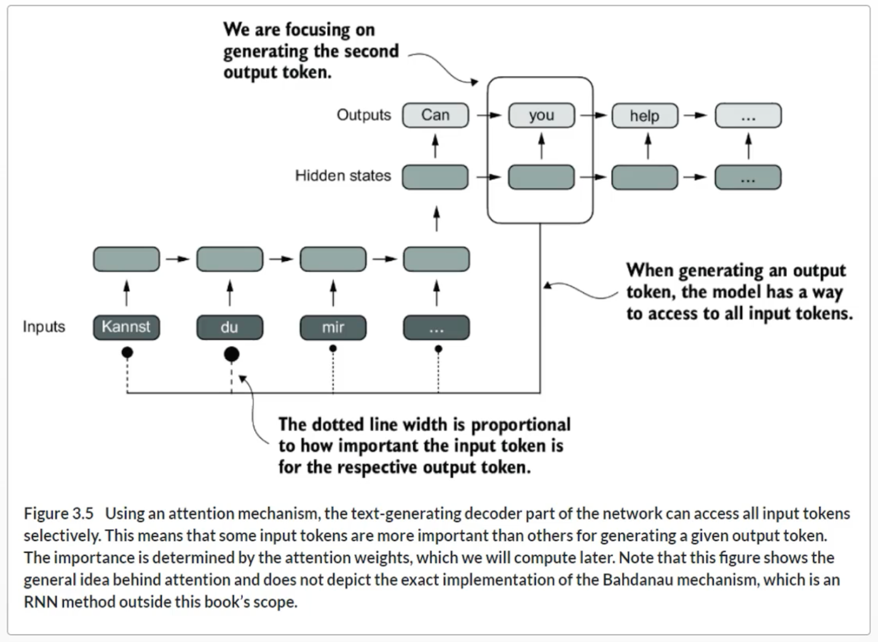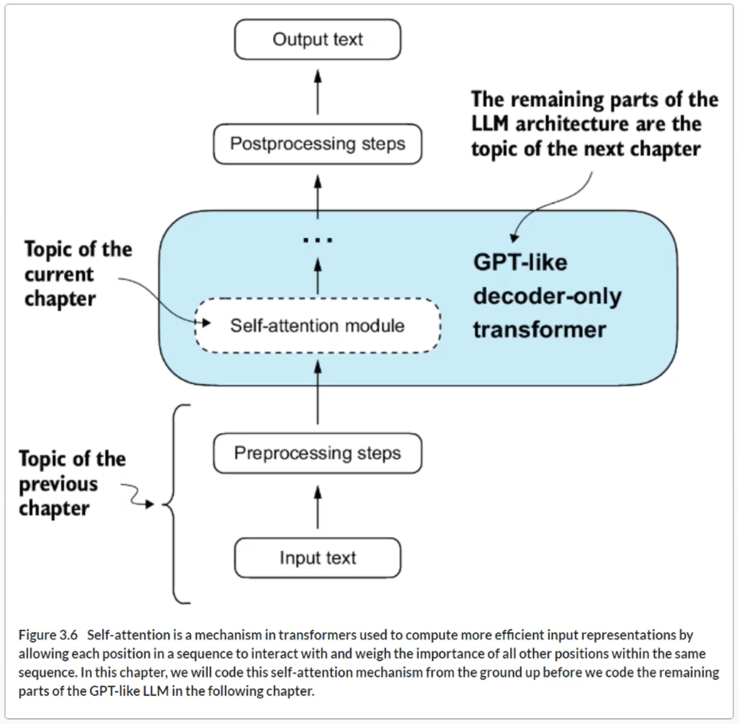

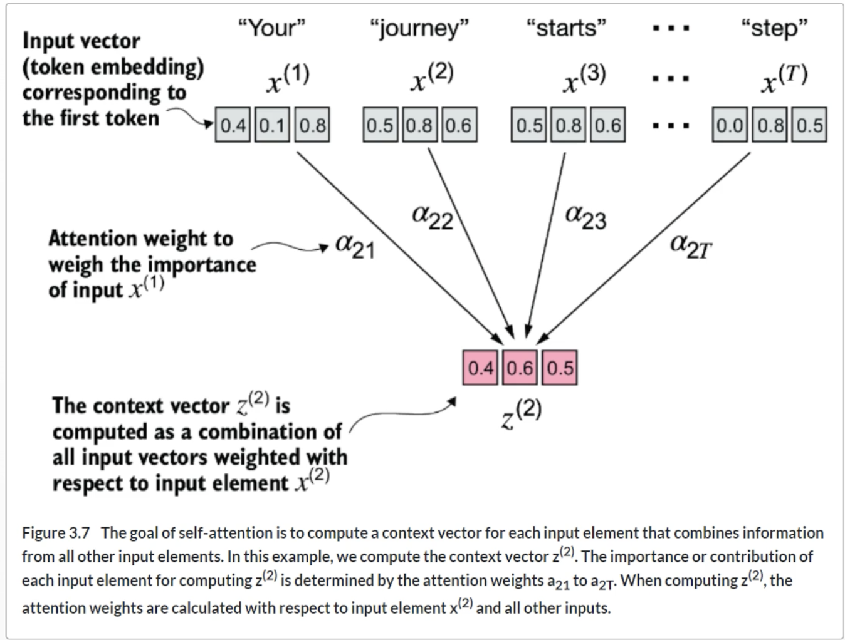

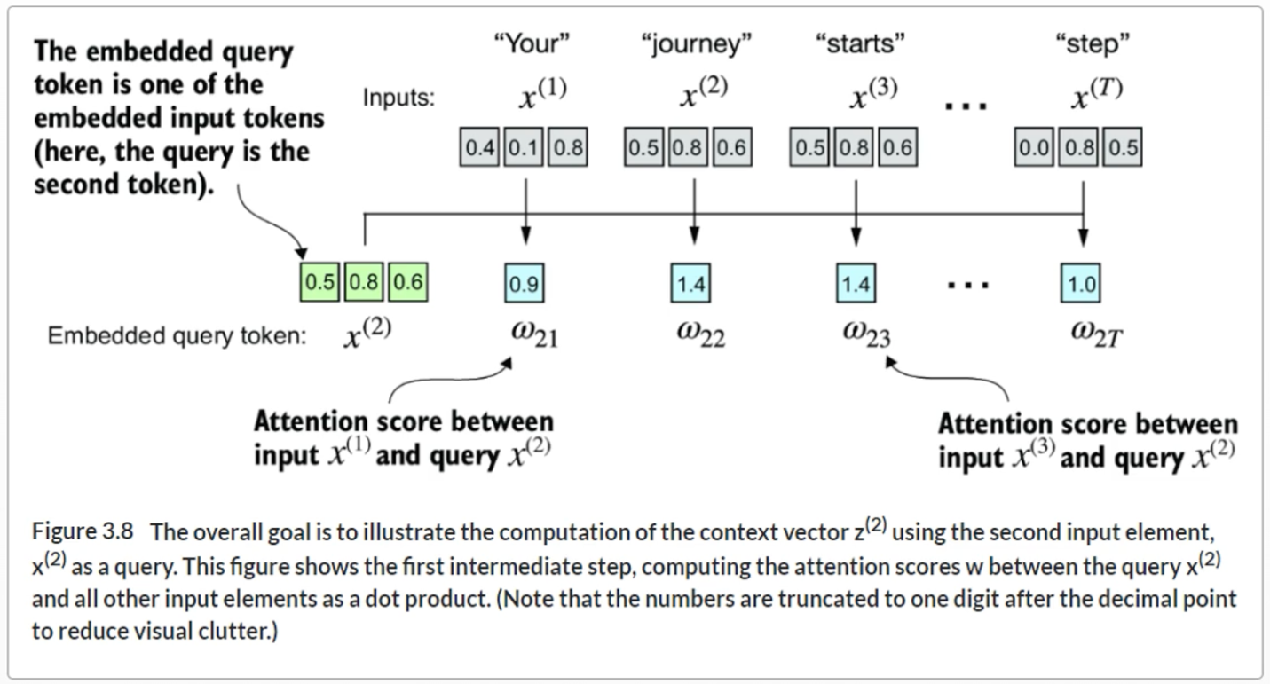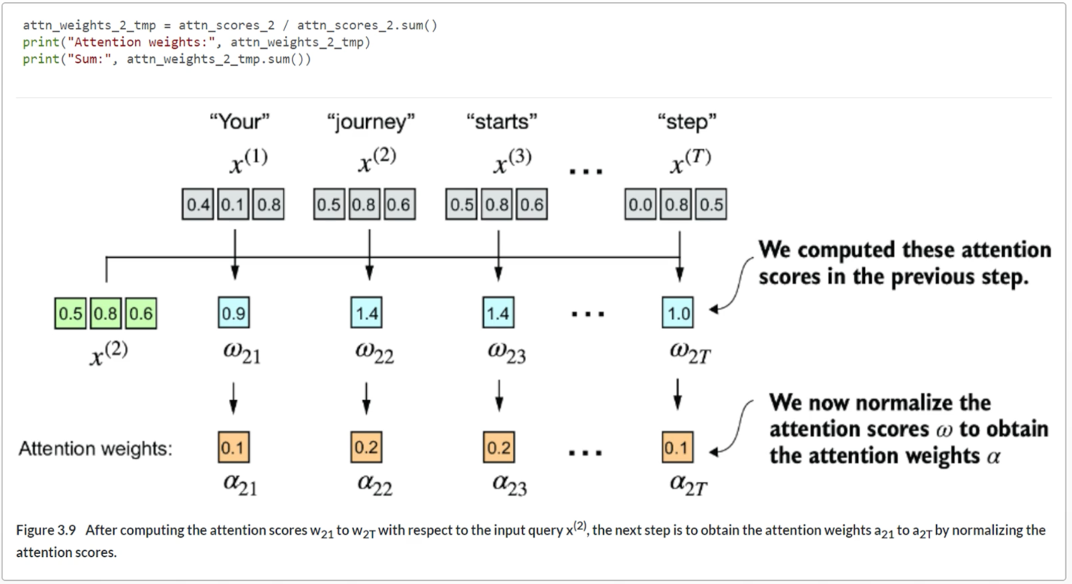

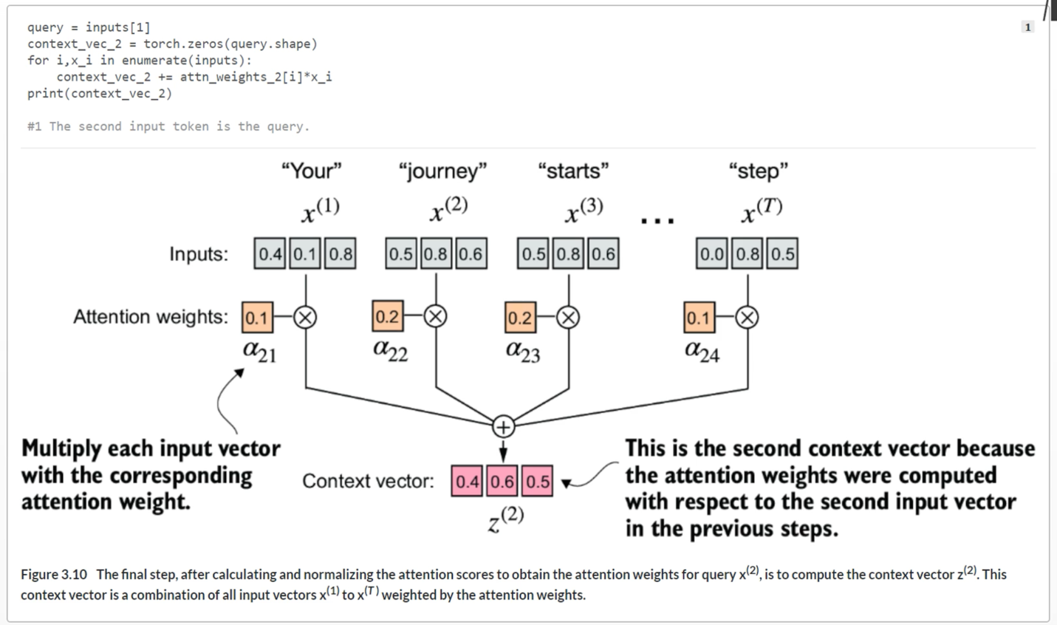

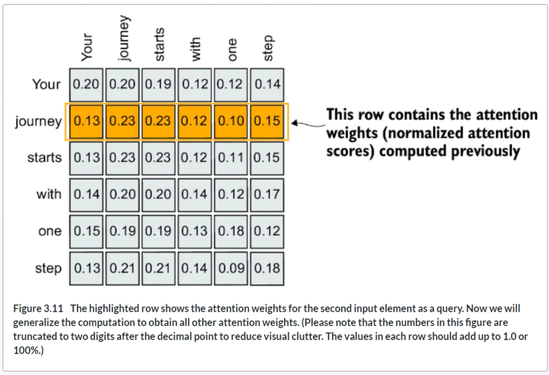

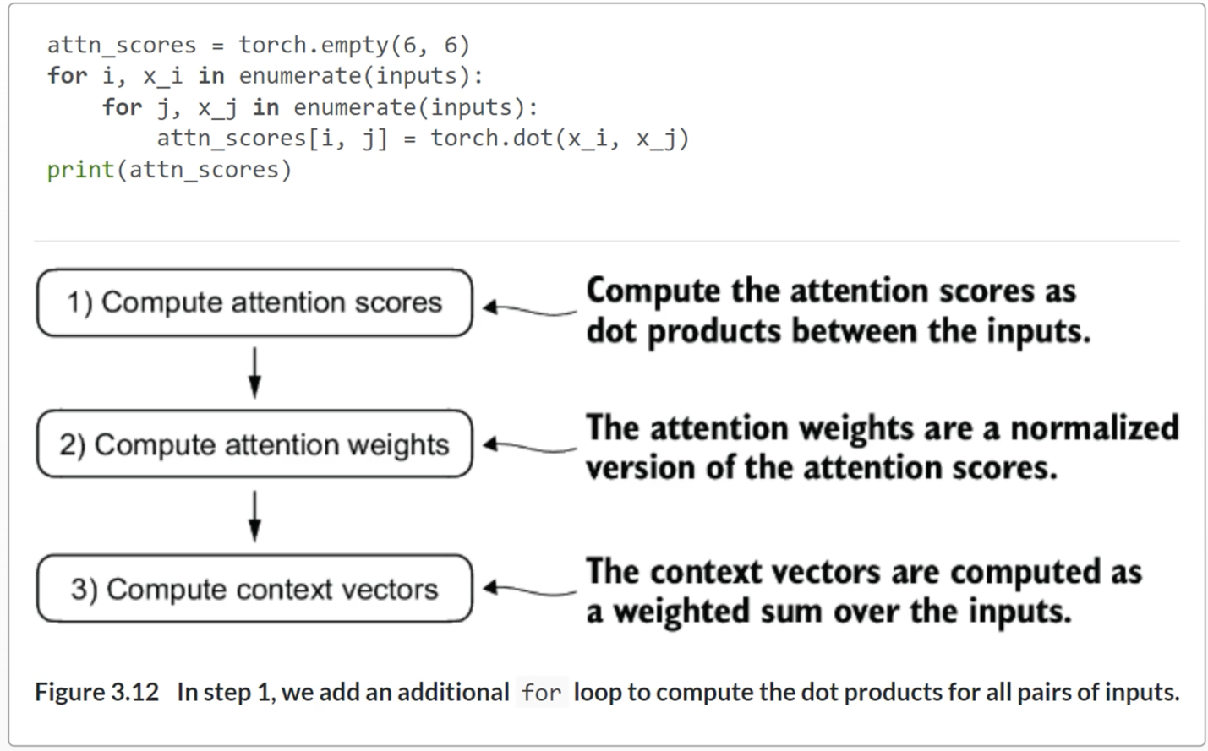

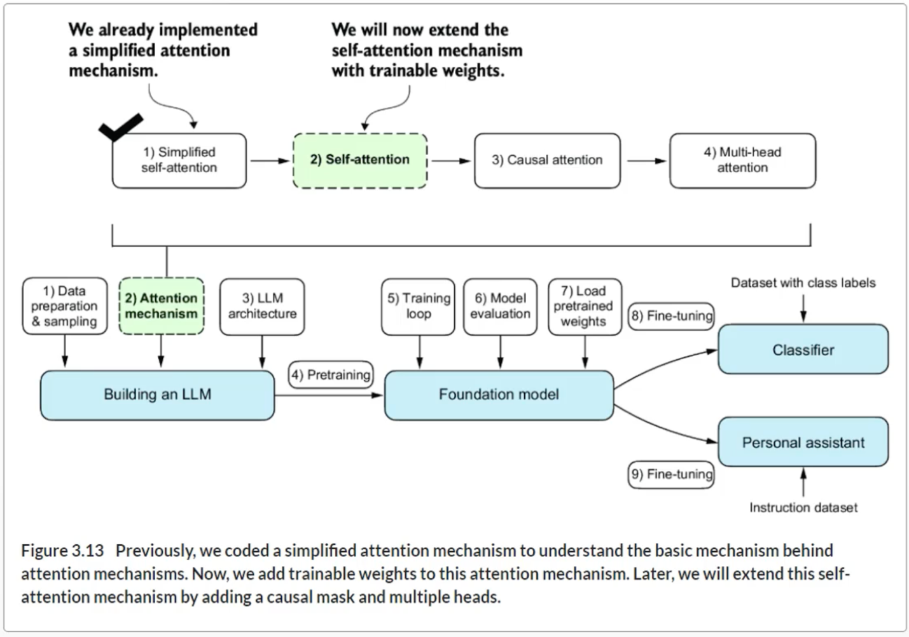

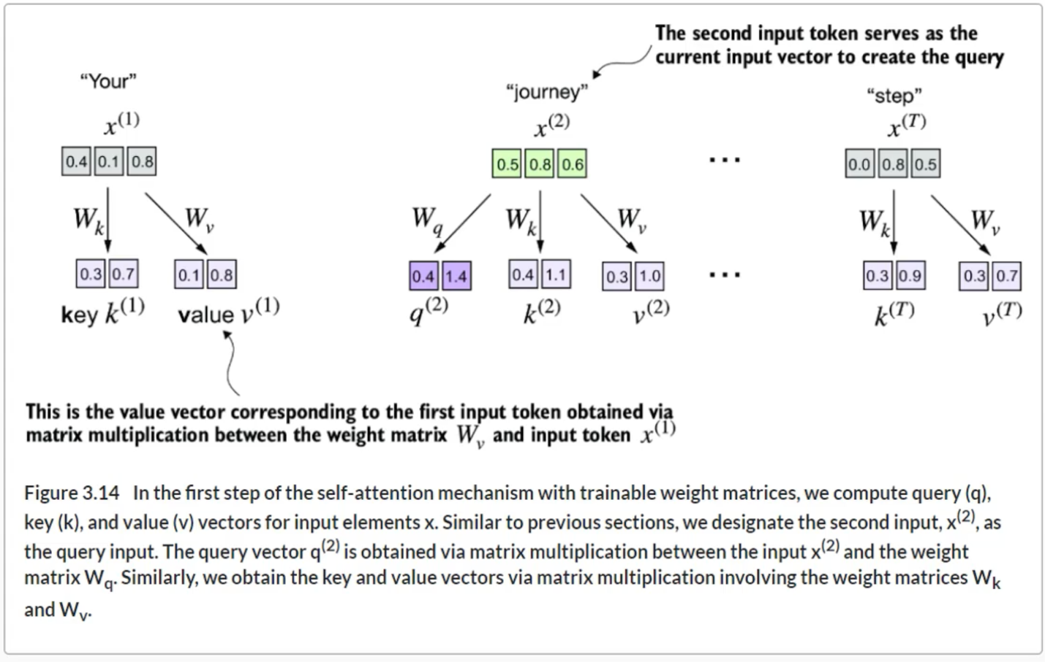

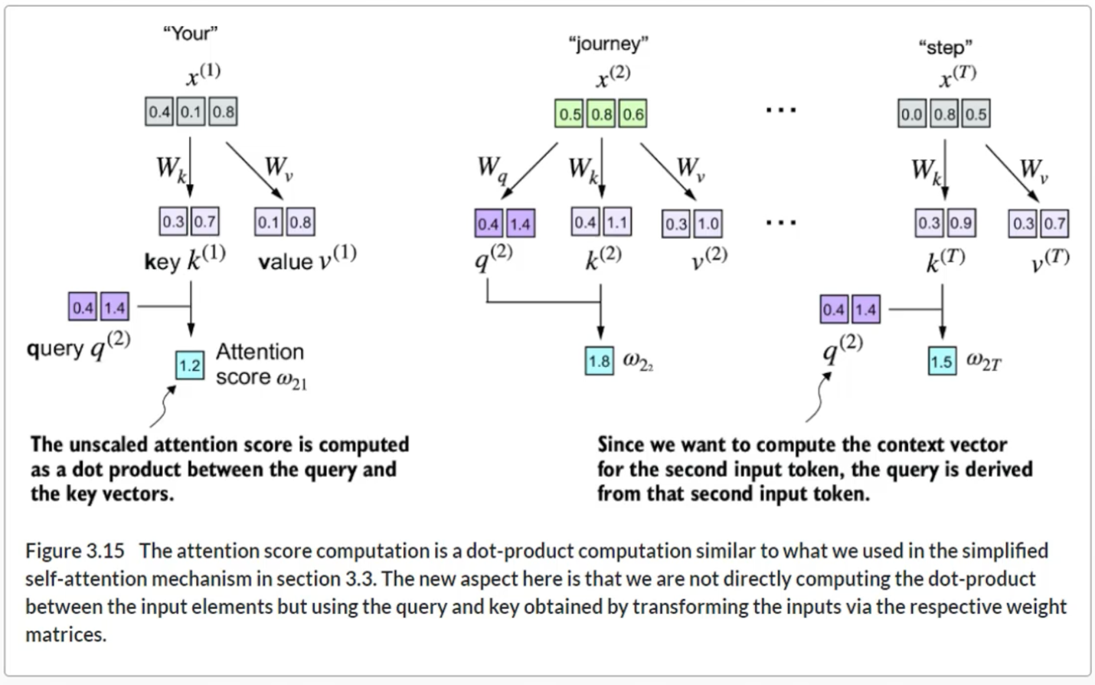

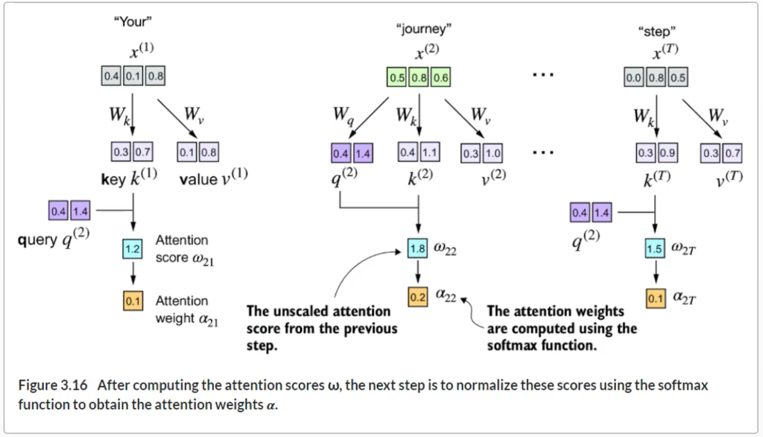

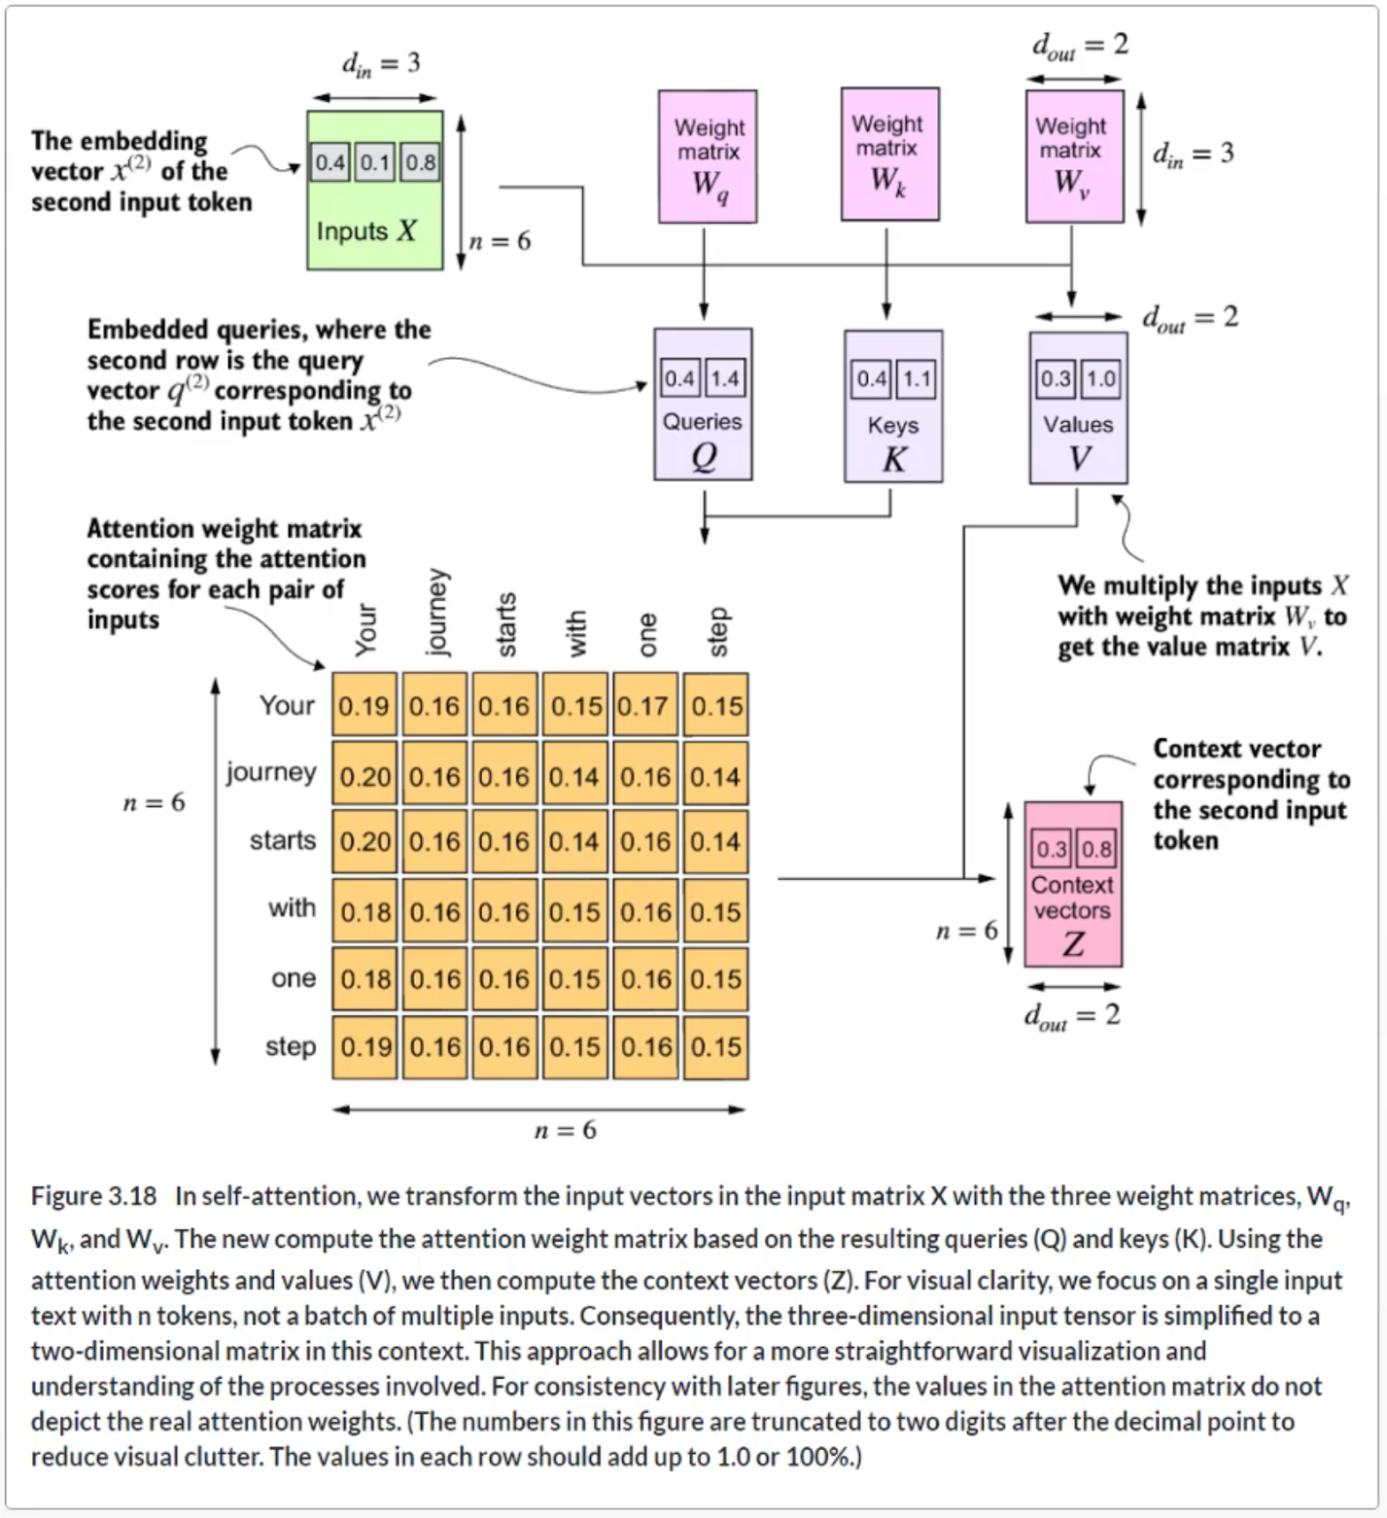

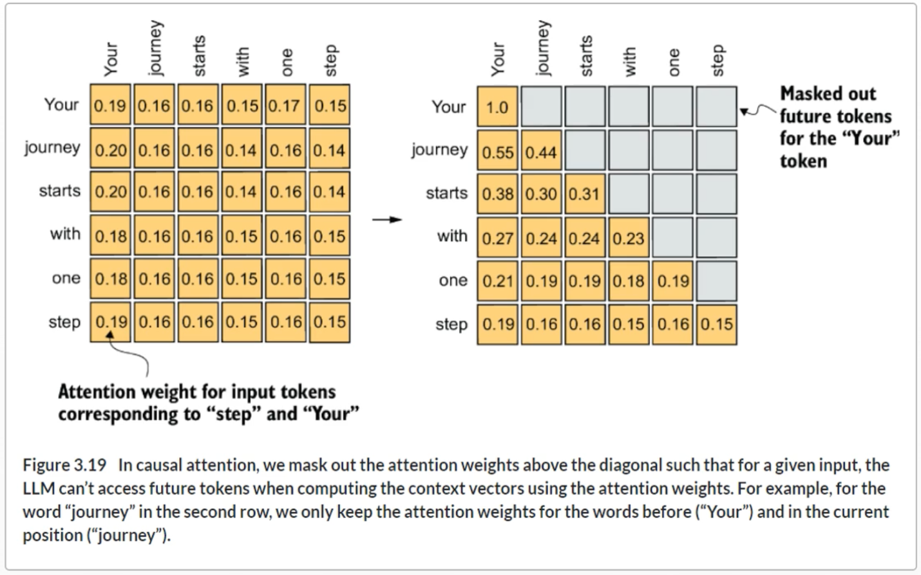

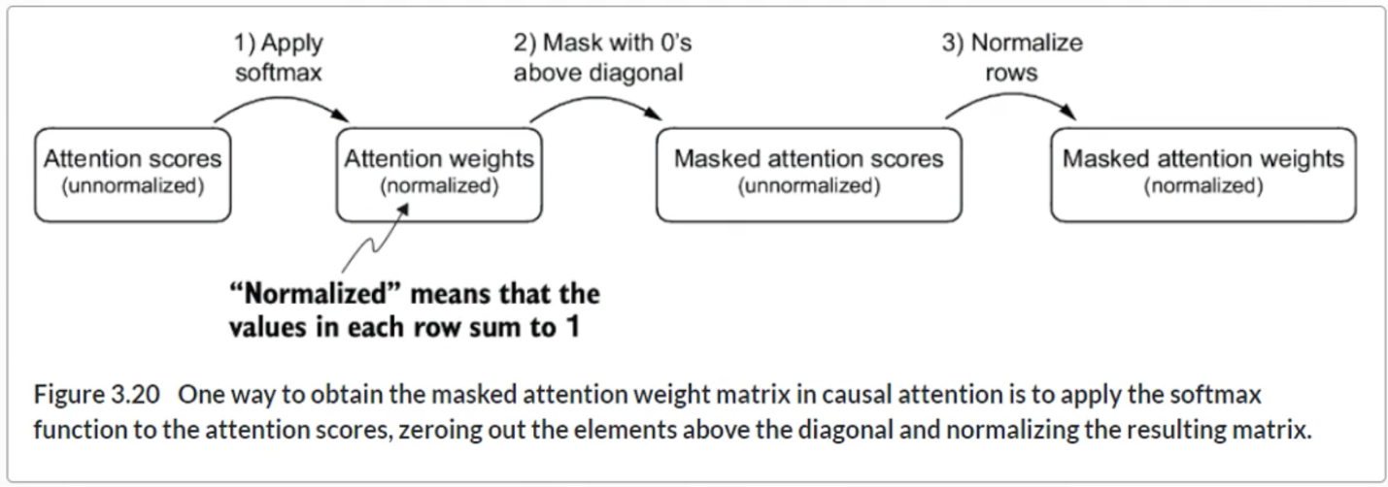

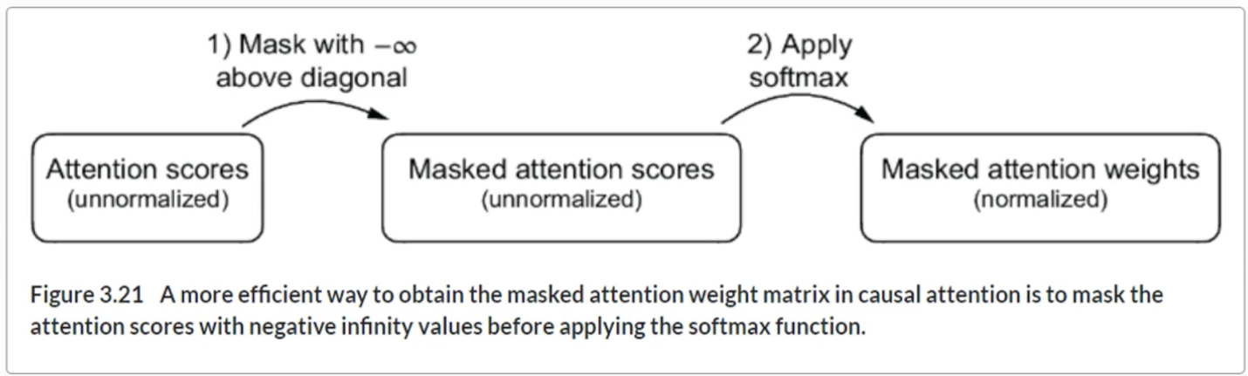

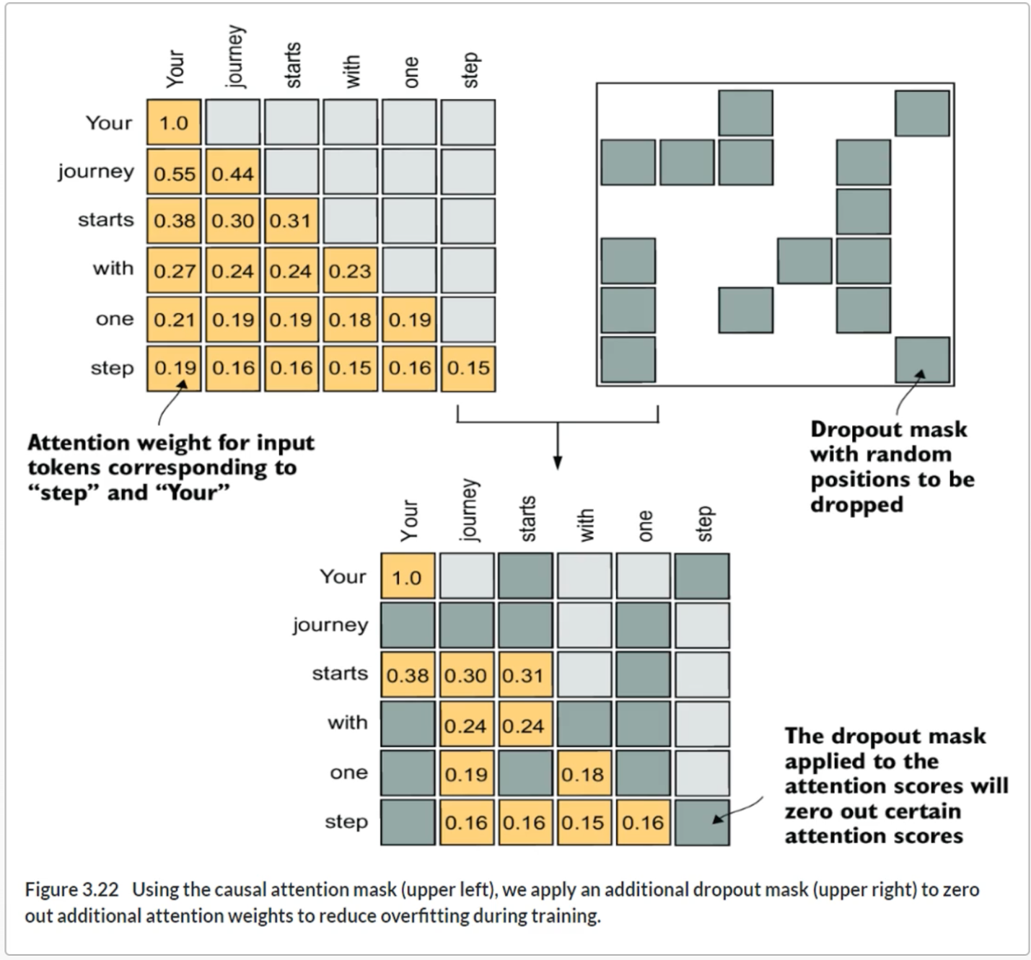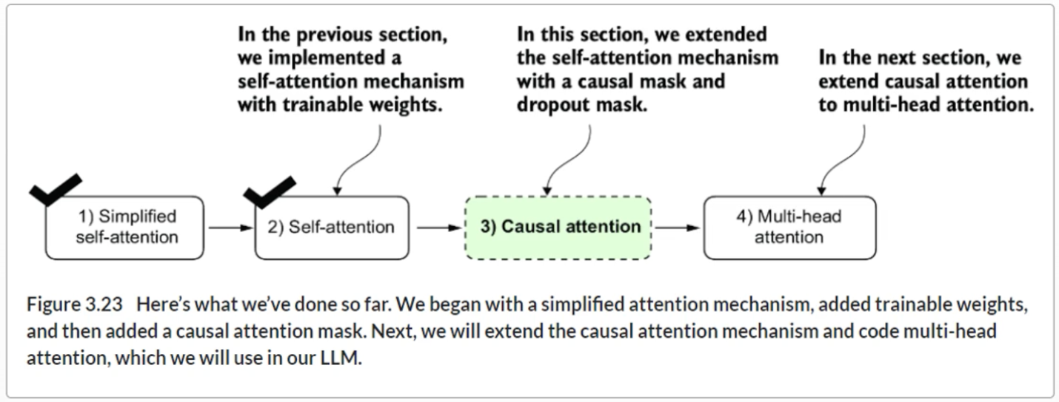

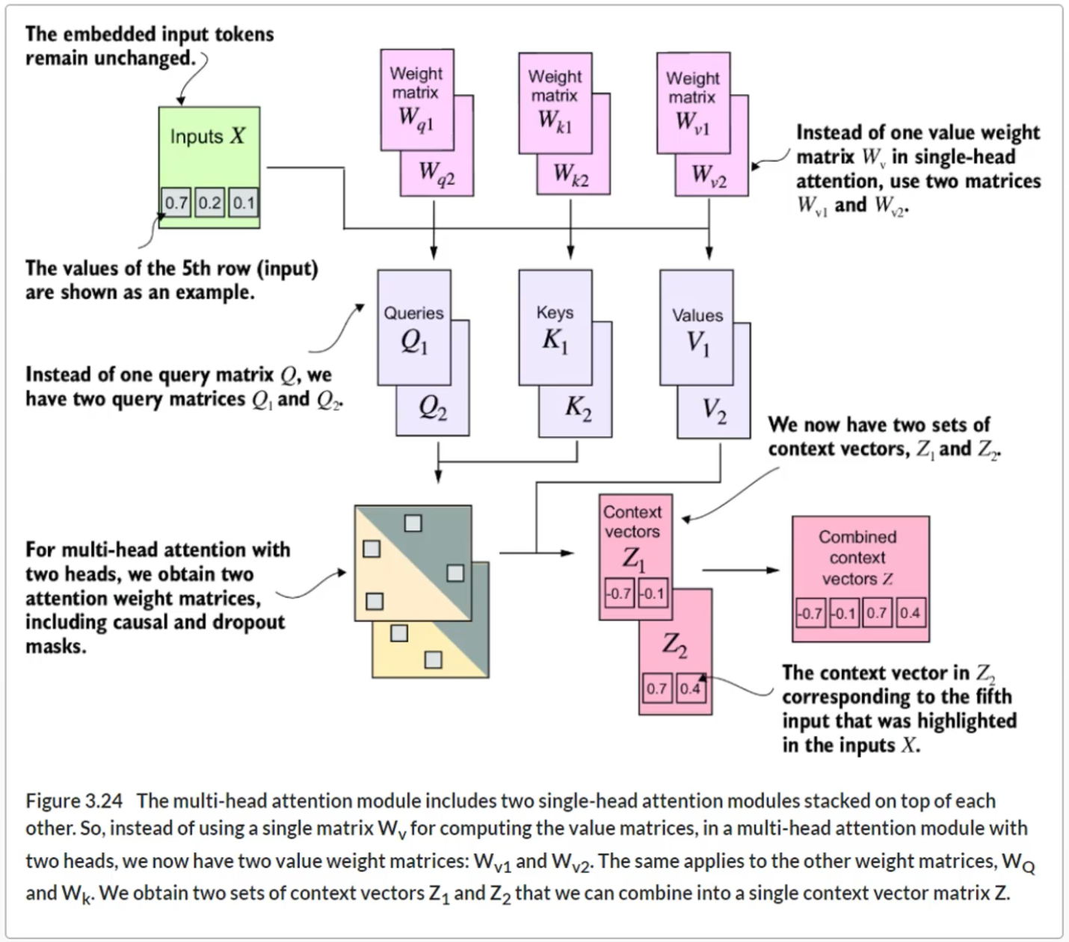

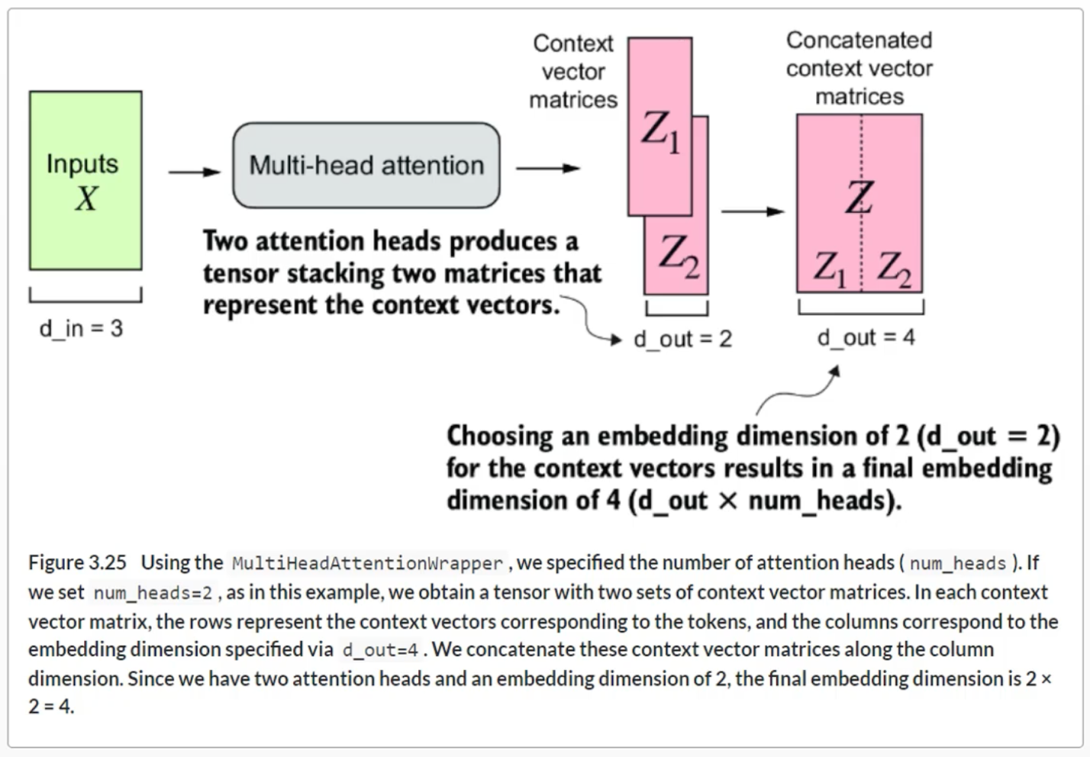

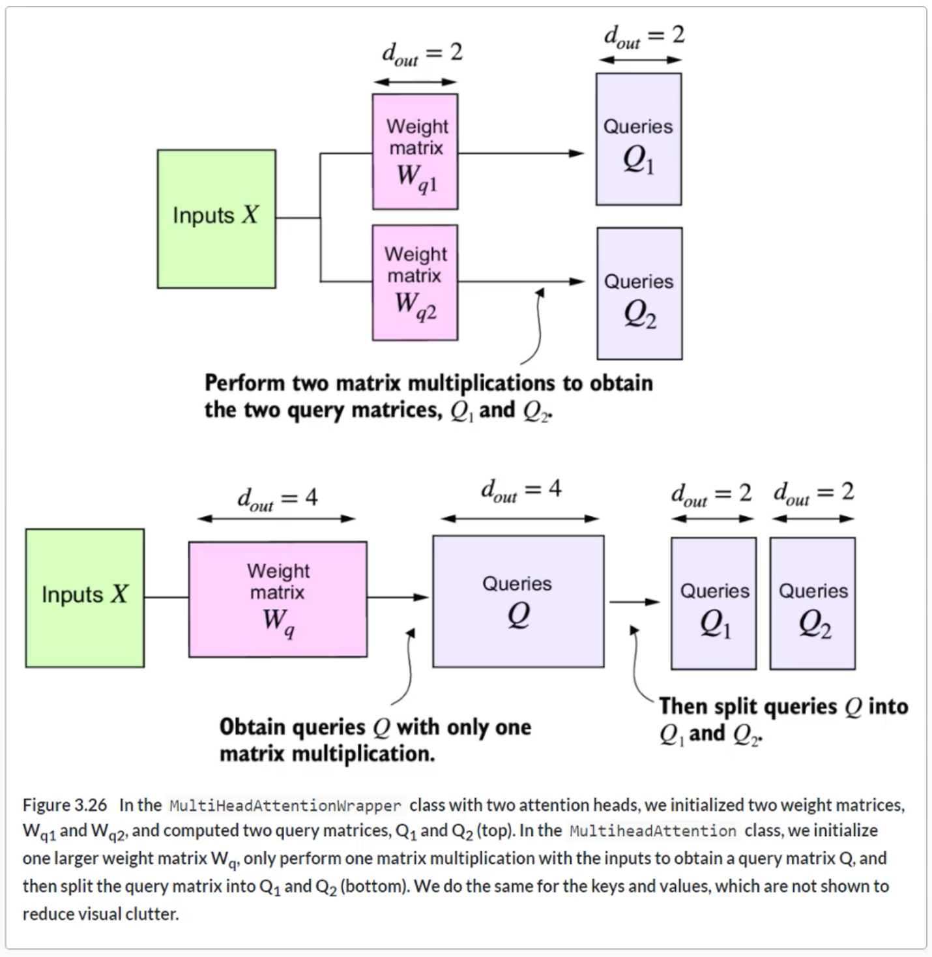

**Summary**

* Attention mechanisms transform input elements into enhanced context vector representations that incorporate information about all inputs.
* A self-attention mechanism computes the context vector representation as a weighted sum over the inputs.
* In a simplified attention mechanism, the attention weights are computed via dot products.
* A dot product is a concise way of multiplying two vectors element-wise and then summing the products.
* Matrix multiplications, while not strictly required, help us implement computations more efficiently and compactly by replacing nested for loops.
* In self-attention mechanisms used in LLMs, also called scaled-dot product attention, we include trainable weight matrices to compute intermediate transformations of the inputs: queries, values, and keys.
* When working with LLMs that read and generate text from left to right, we add a causal attention mask to prevent the LLM from accessing future tokens.
* In addition to causal attention masks to zero-out attention weights, we can add a dropout mask to reduce overfitting in LLMs.
* The attention modules in transformer-based LLMs involve multiple instances of causal attention, which is called multi-head attention.
* We can create a multi-head attention module by stacking multiple instances of causal attention modules.
* A more efficient way of creating multi-head attention modules involves batched matrix multiplications.

**Chapter 4**

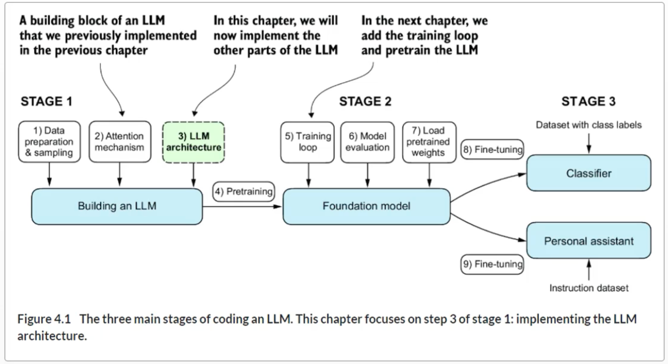

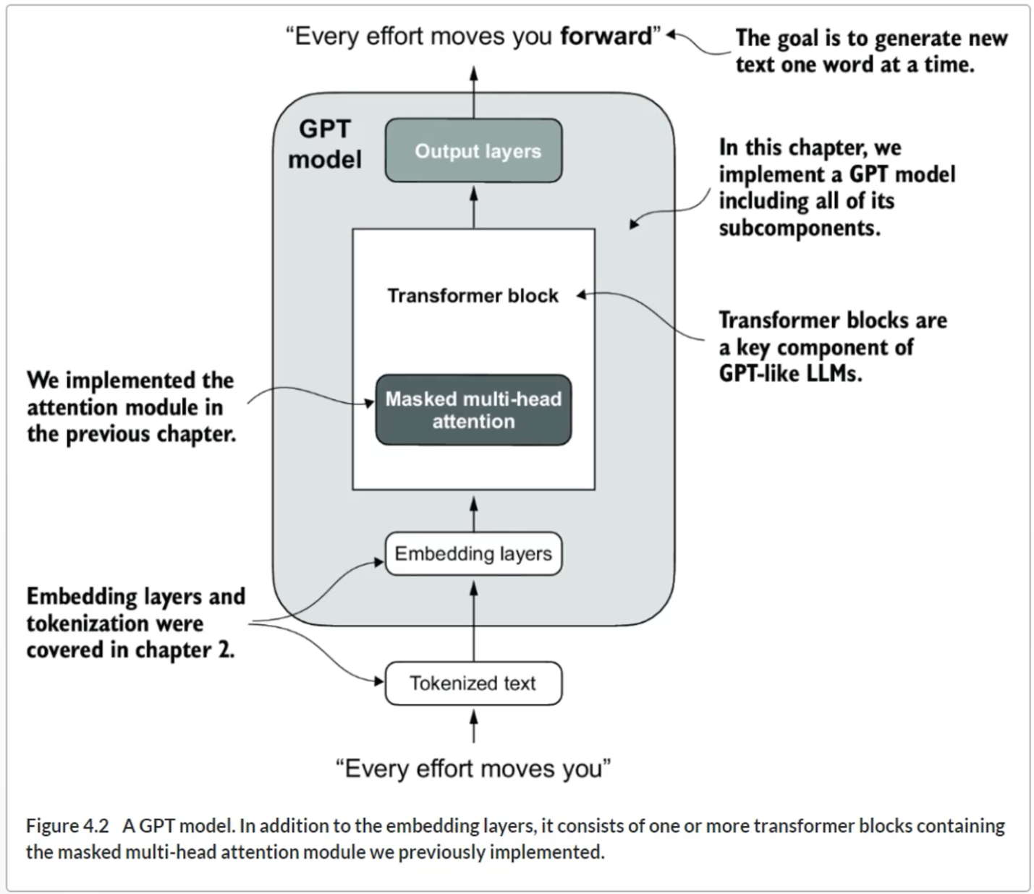

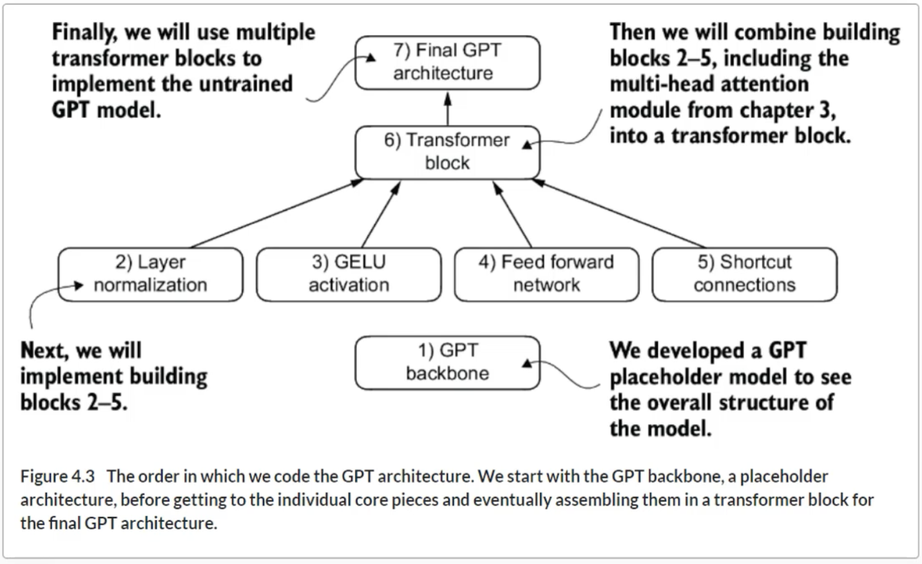

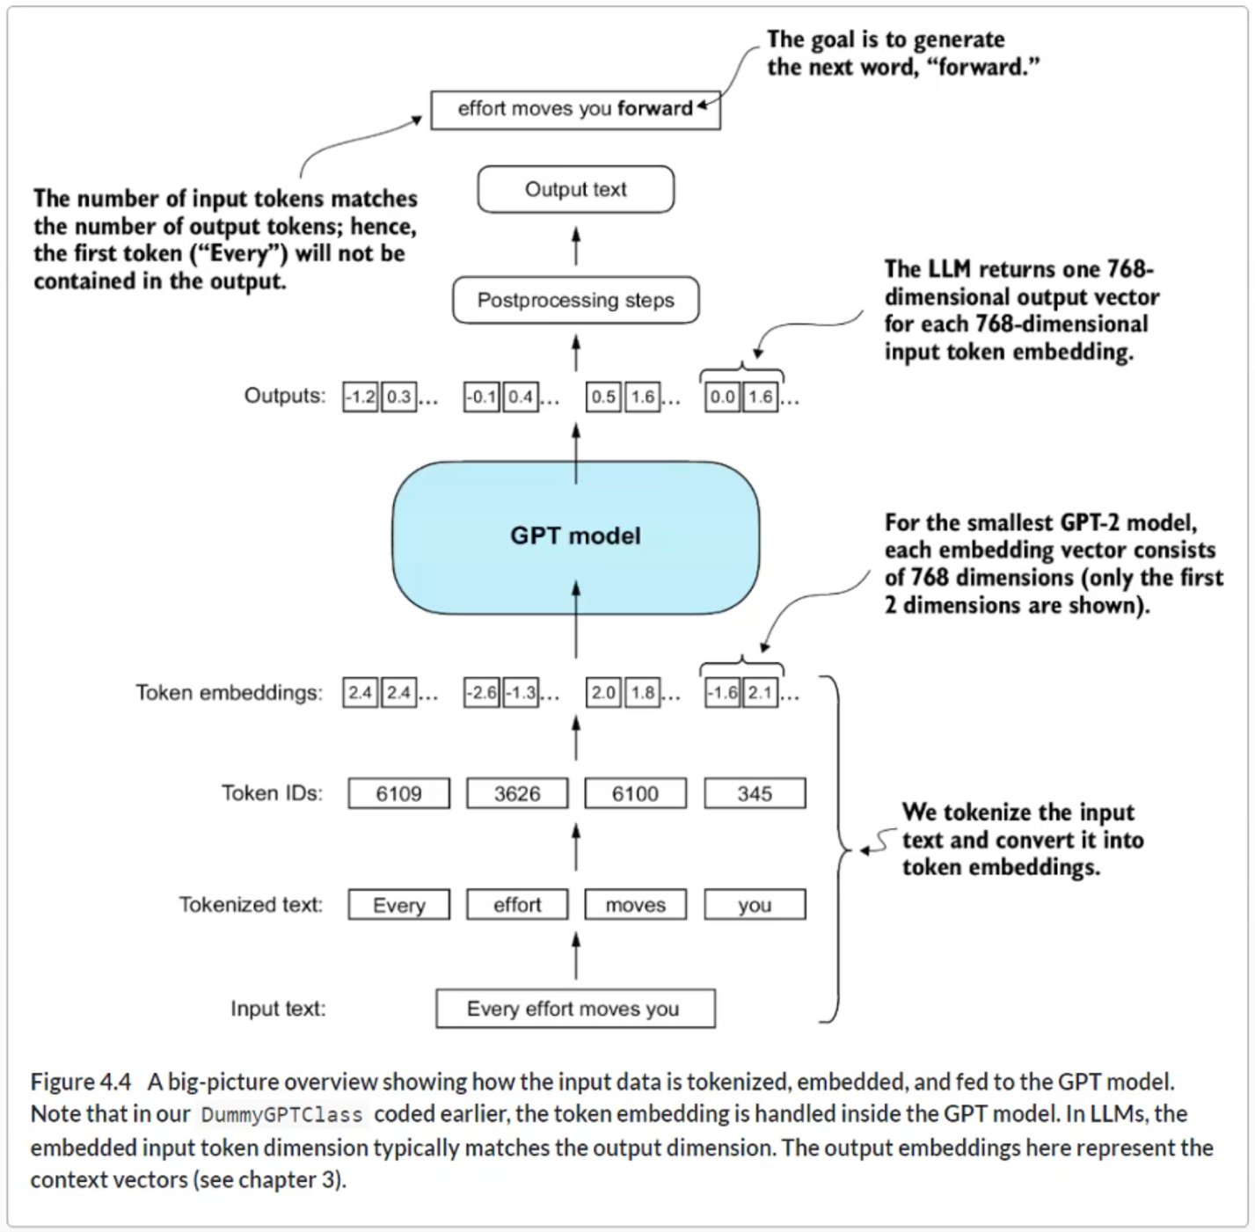

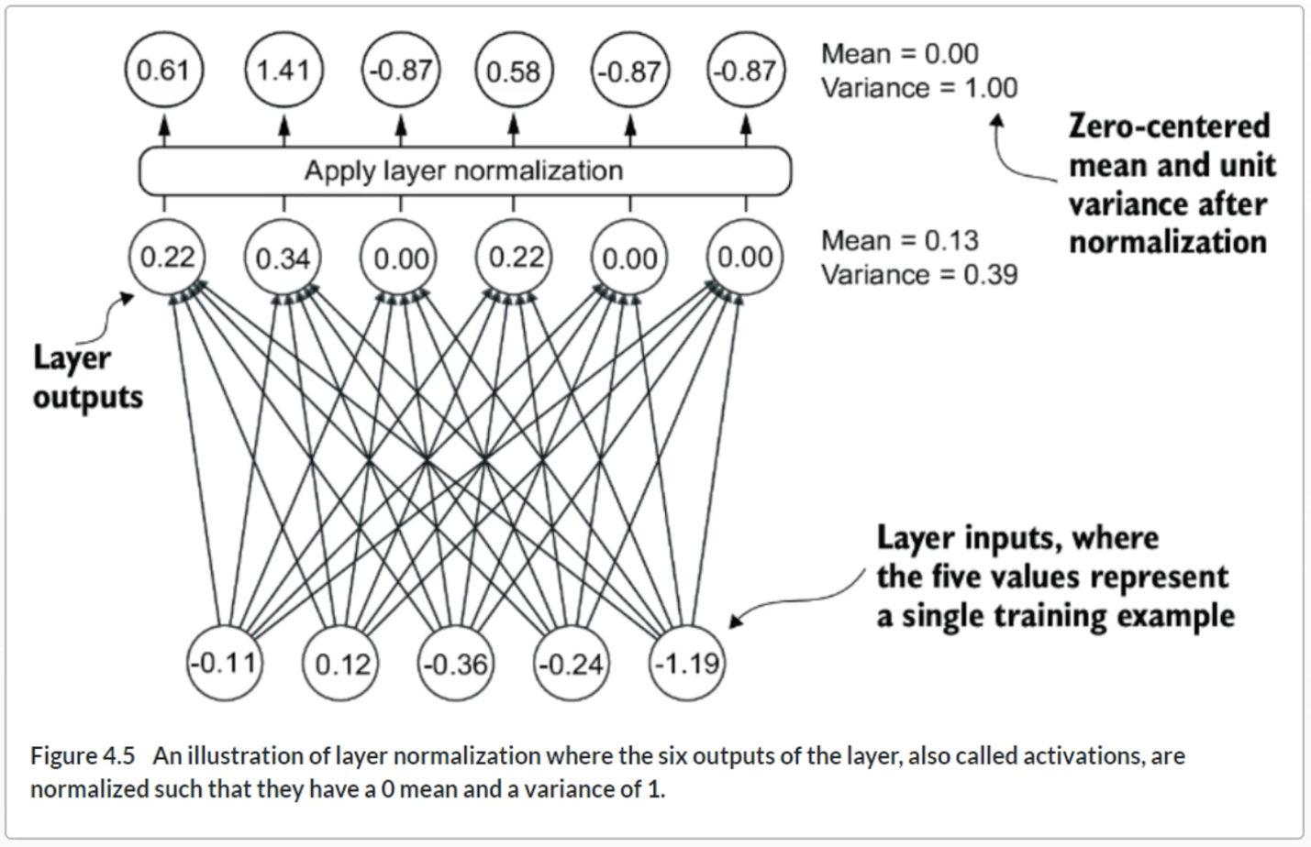

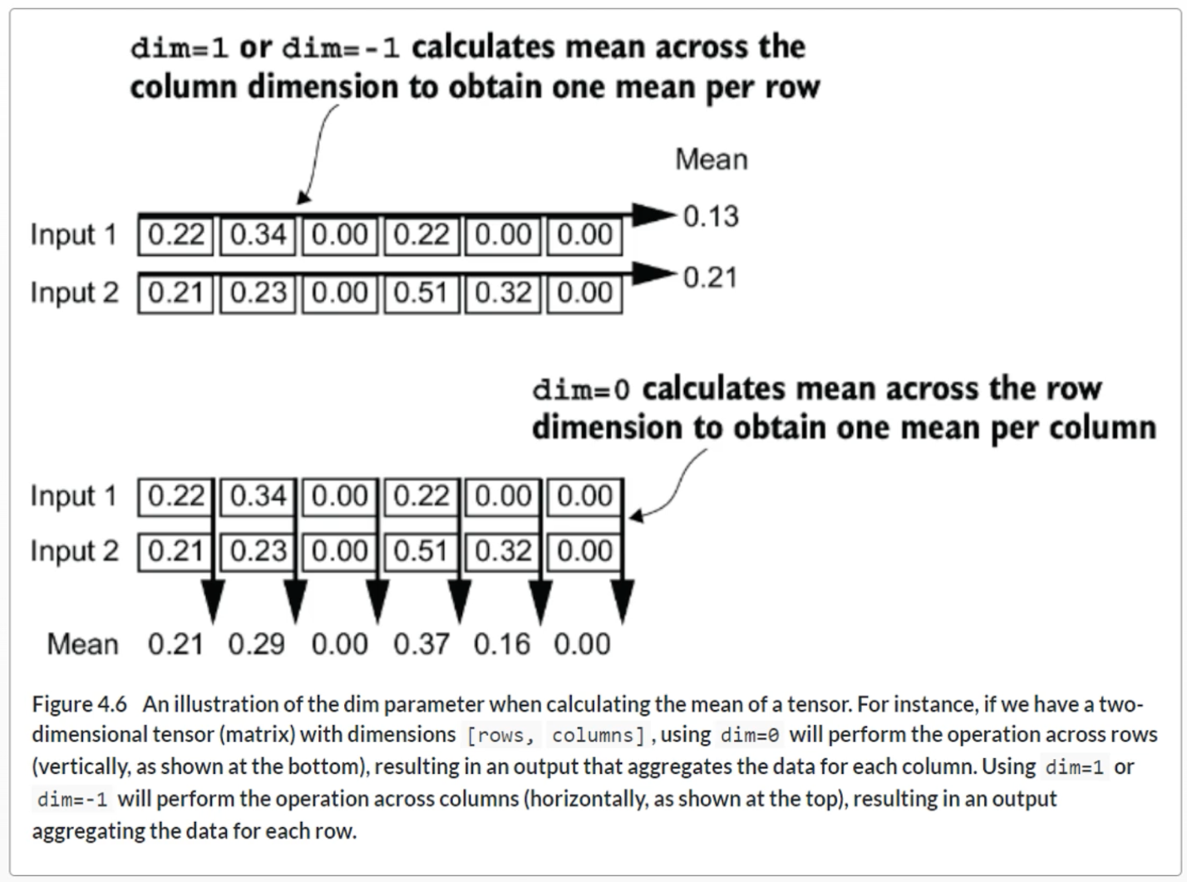

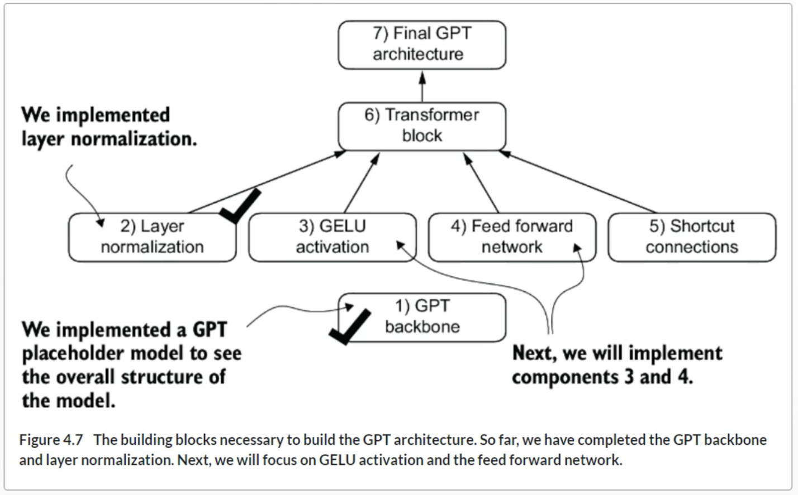

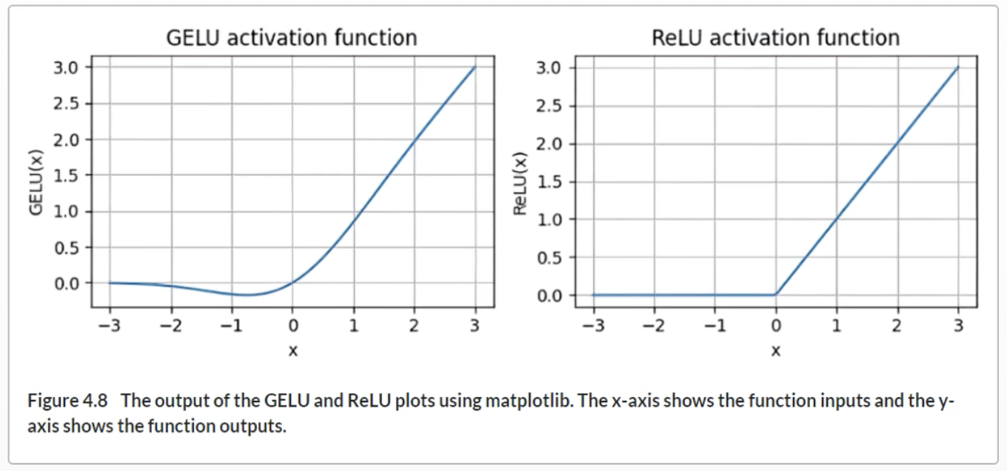

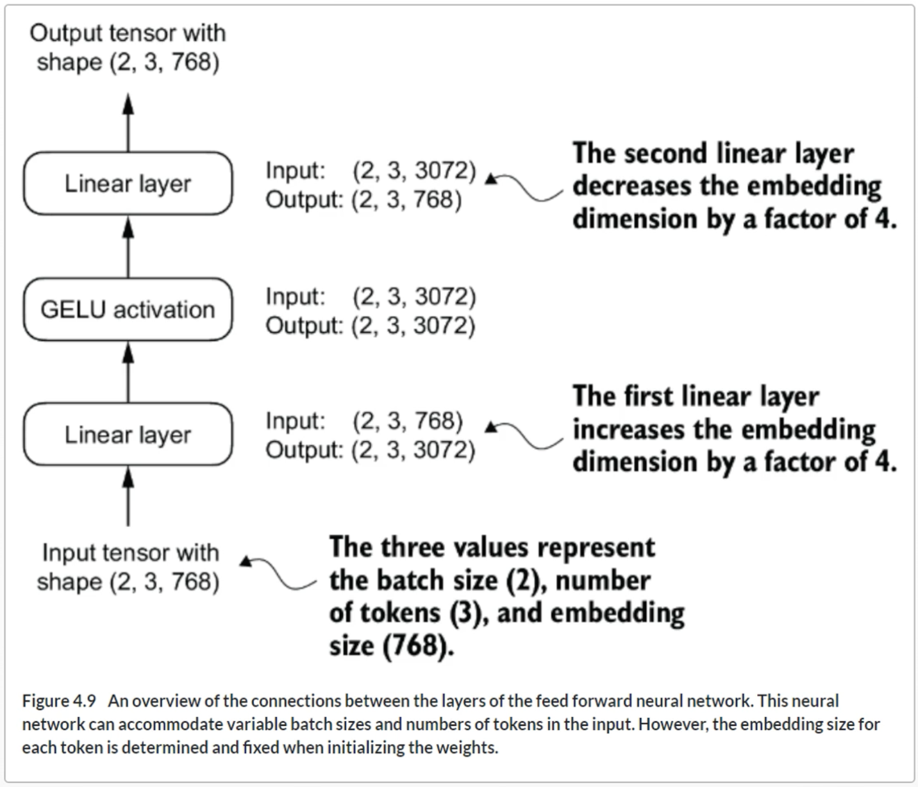

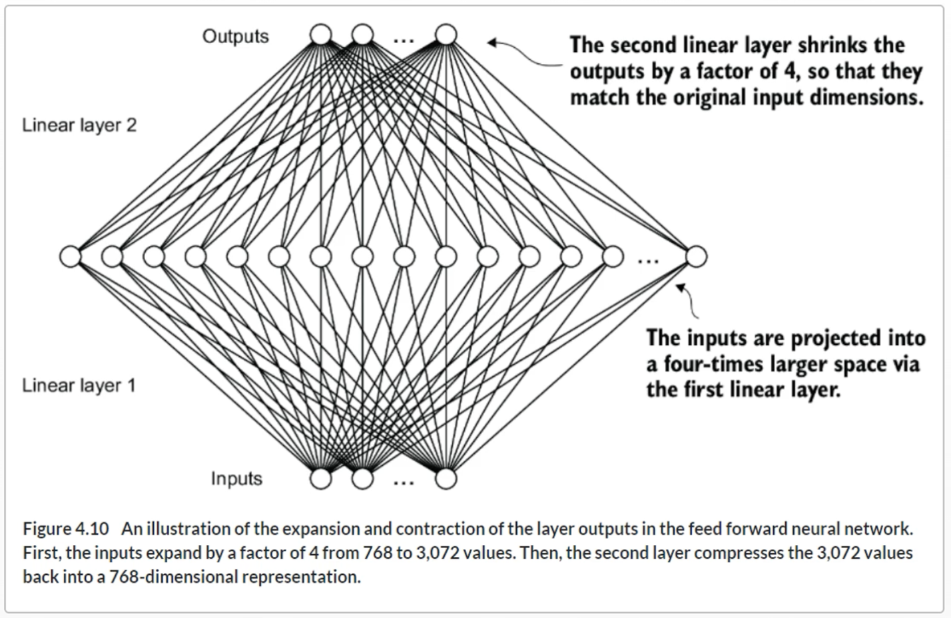

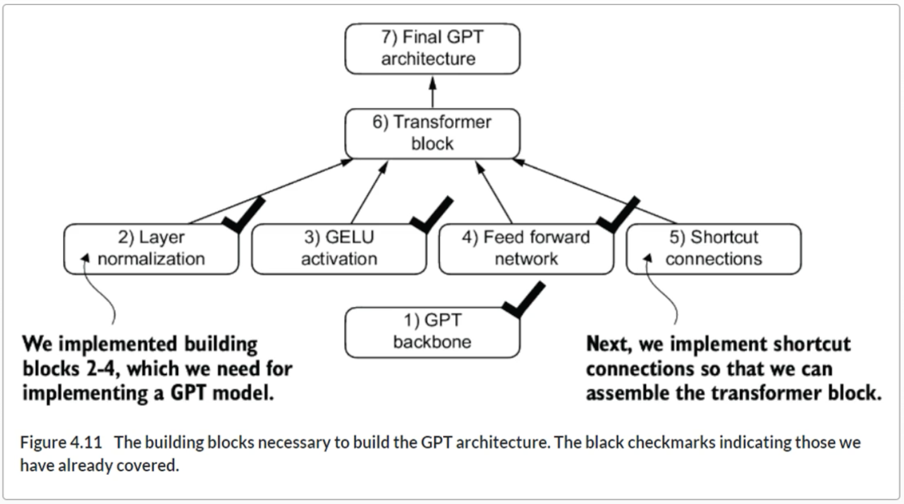

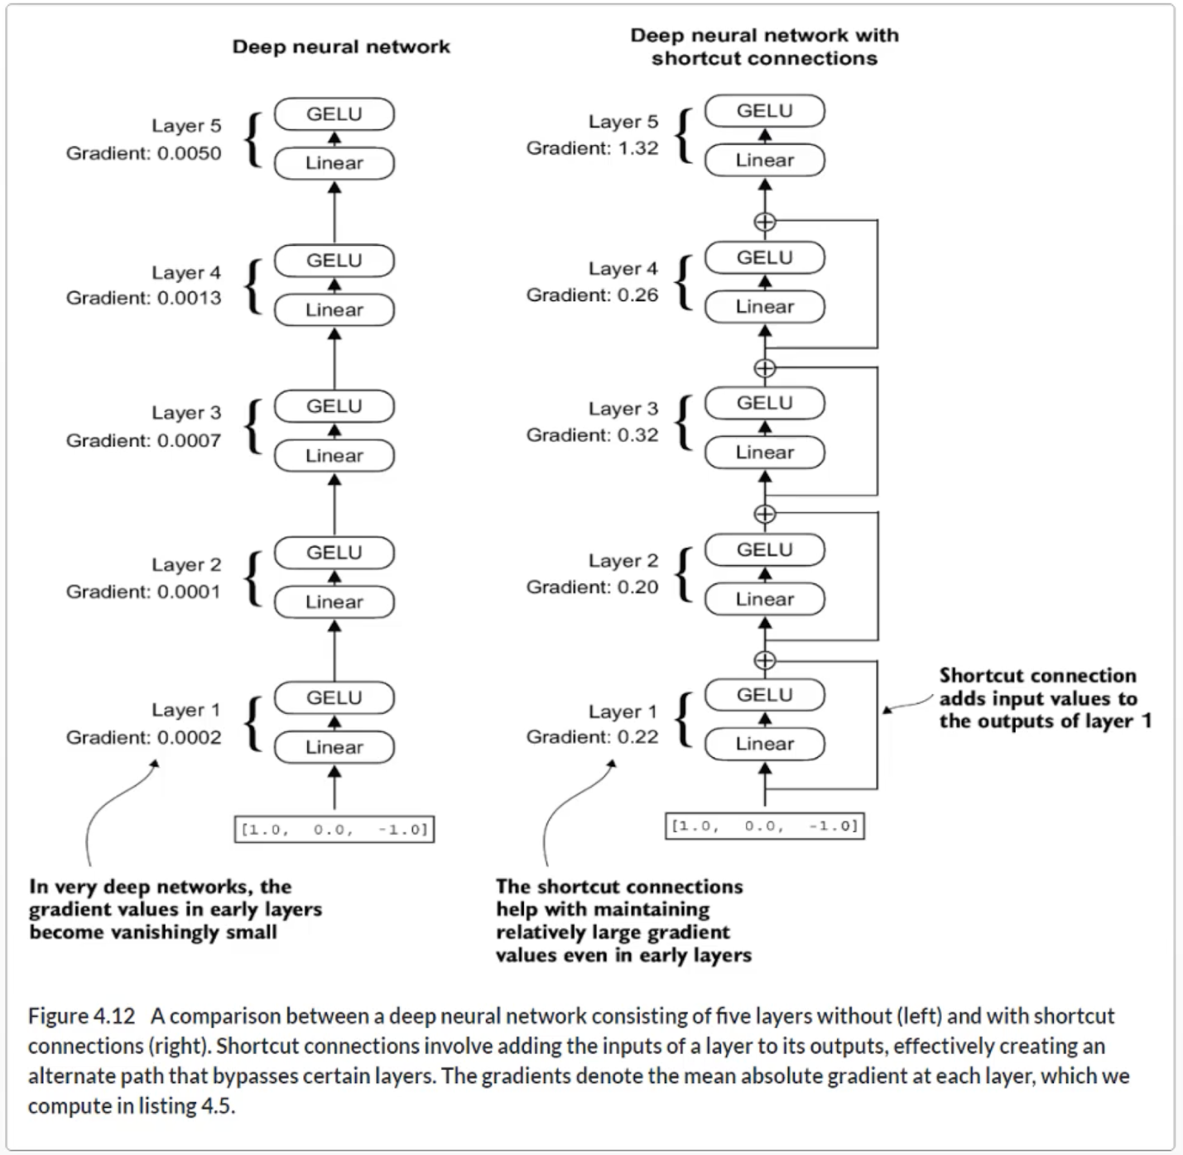

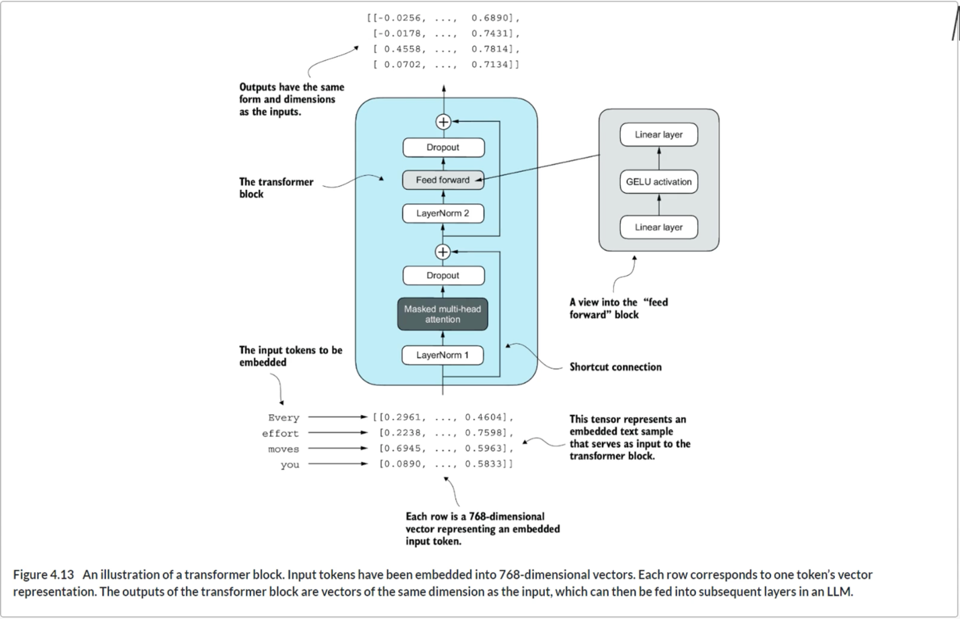

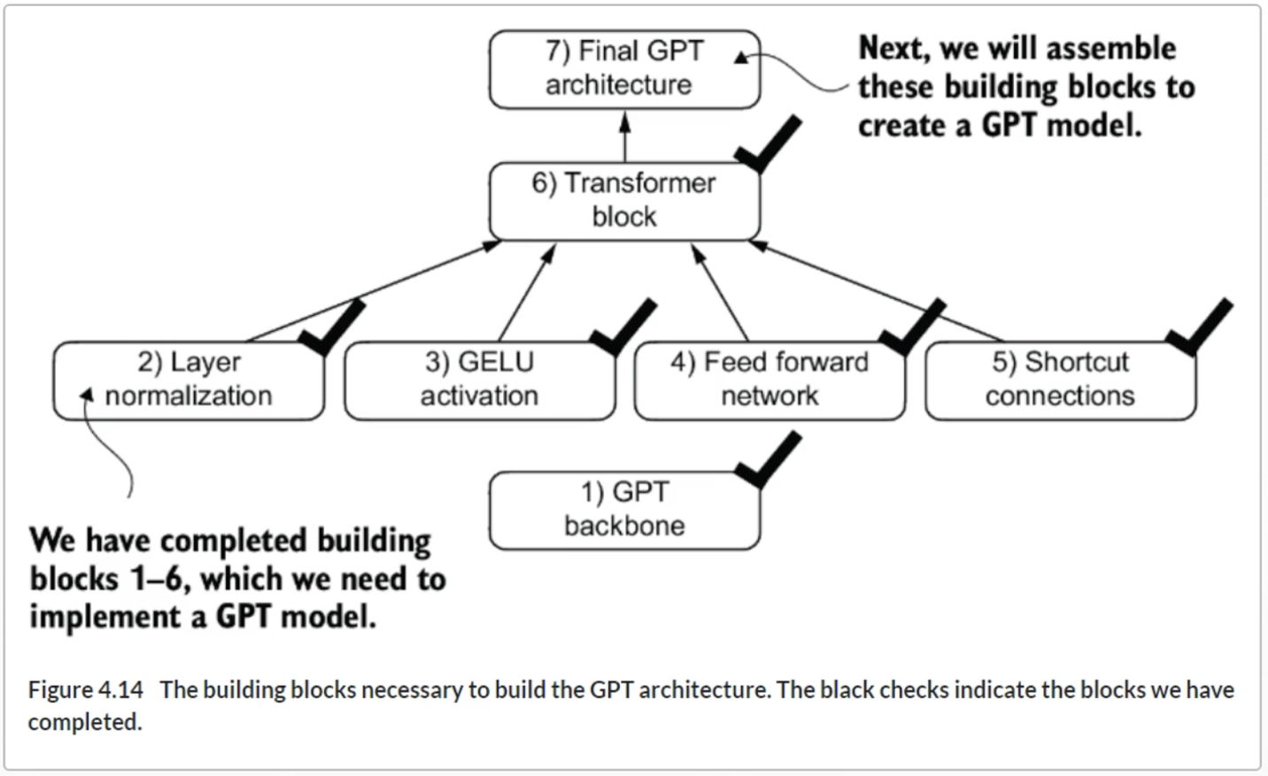

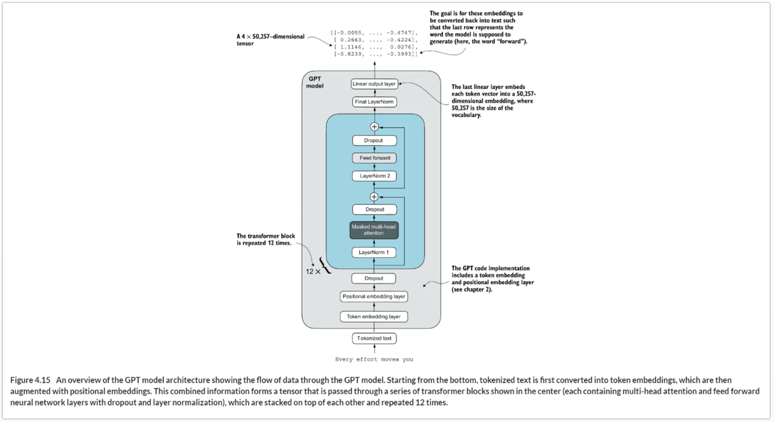

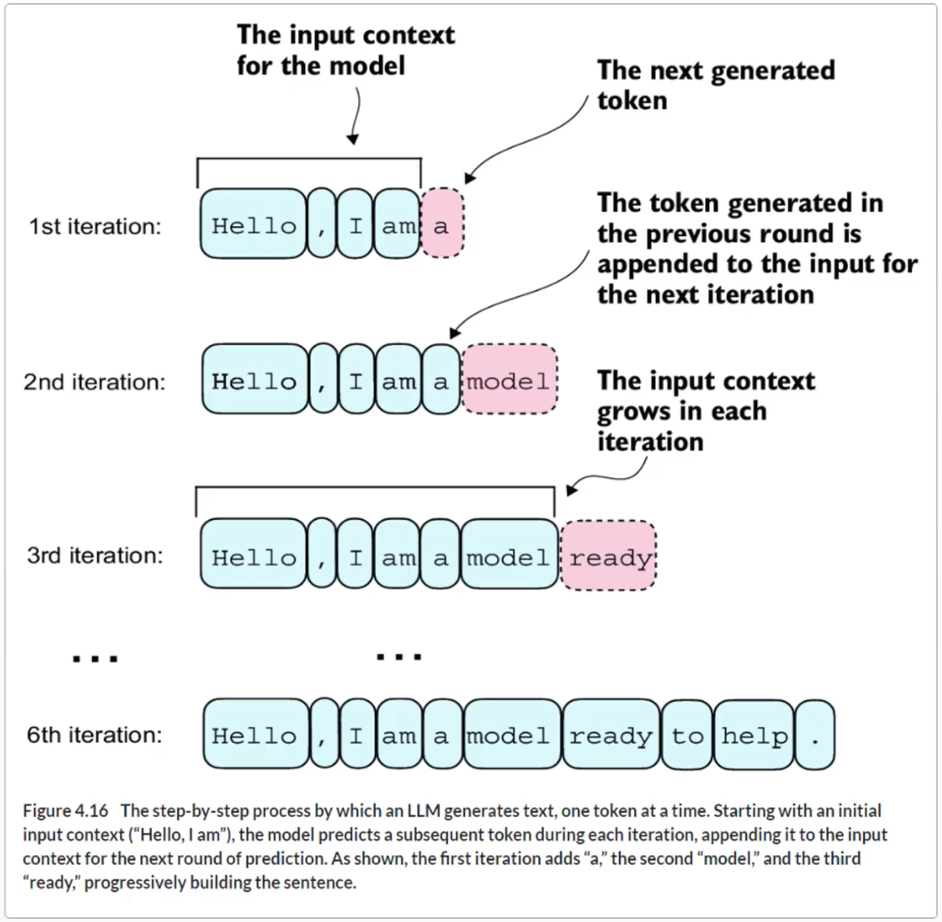

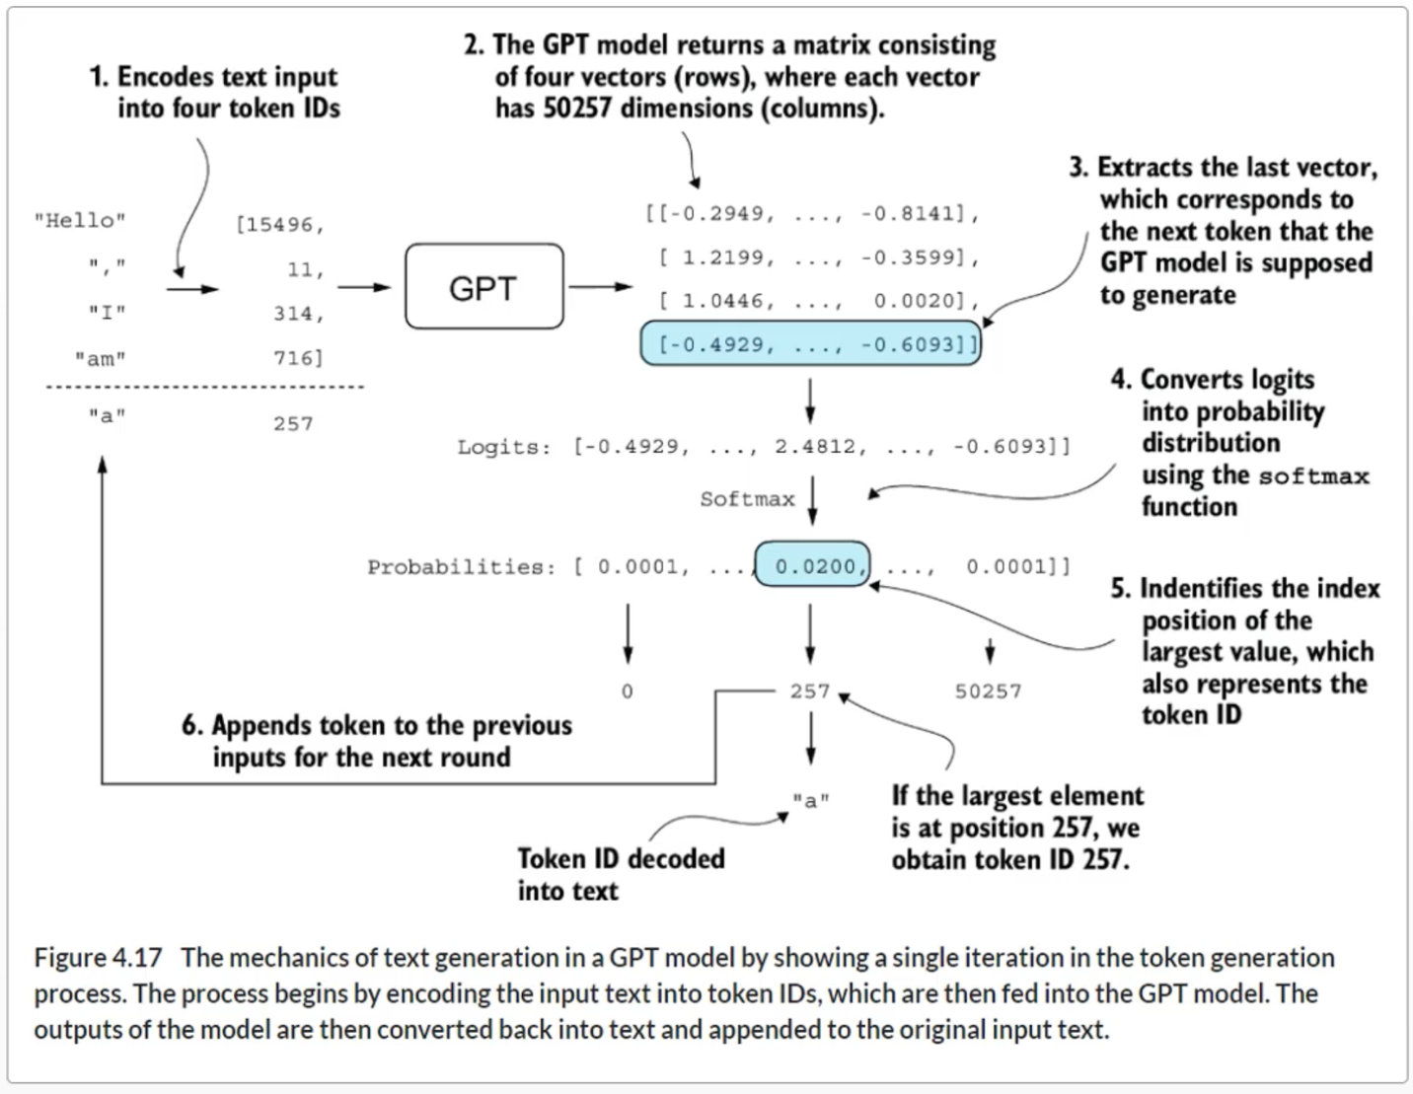

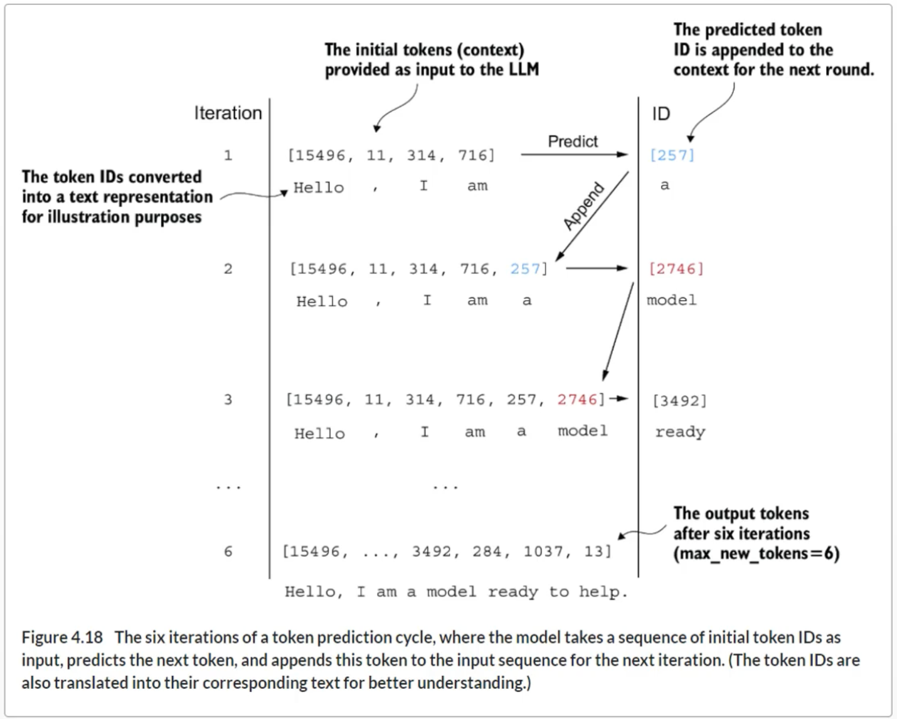

**Summary**

* Layer normalization stabilizes training by ensuring that each layer’s outputs have a consistent mean and variance.
* Shortcut connections are connections that skip one or more layers by feeding the output of one layer directly to a deeper layer, which helps mitigate the vanishing gradient problem when training deep neural networks, such as LLMs.
* Transformer blocks are a core structural component of GPT models, combining masked multi-head attention modules with fully connected feed forward networks that use the GELU activation function.
* GPT models are LLMs with many repeated transformer blocks that have millions to billions of parameters.
* GPT models come in various sizes, for example, 124, 345, 762, and 1,542 million parameters, which we can implement with the same GPTModel Python class.
* The text-generation capability of a GPT-like LLM involves decoding output tensors into human-readable text by sequentially predicting one token at a time based on a given input context.
* Without training, a GPT model generates incoherent text, which underscores the importance of model training for coherent text generation.

**Chapter 5**

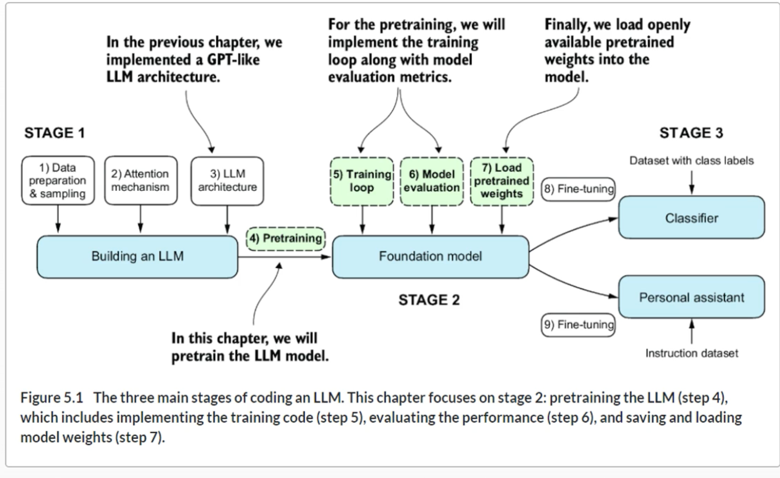

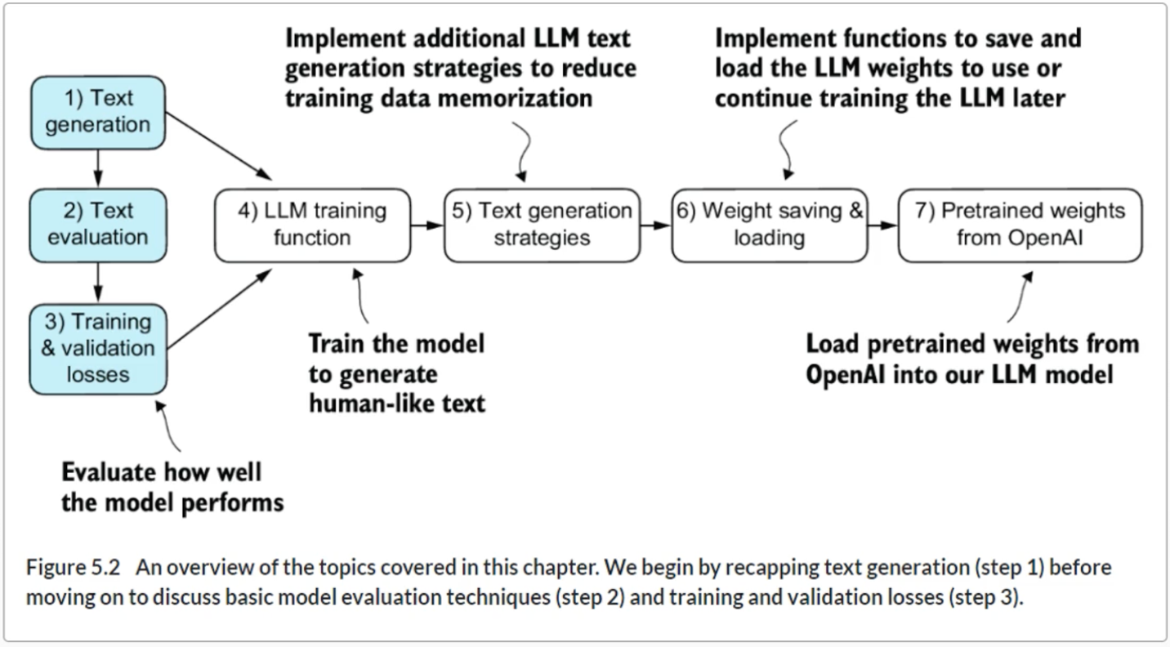

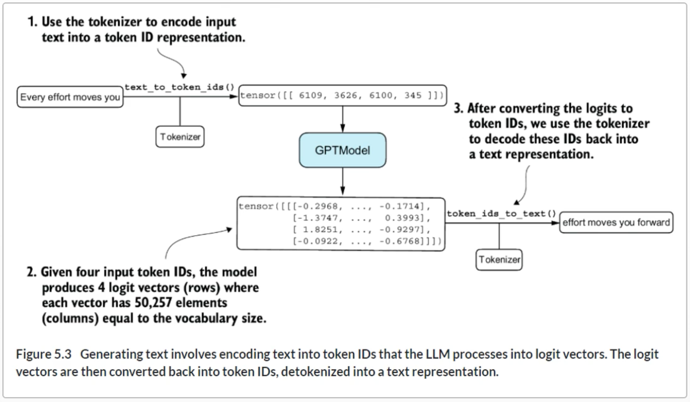

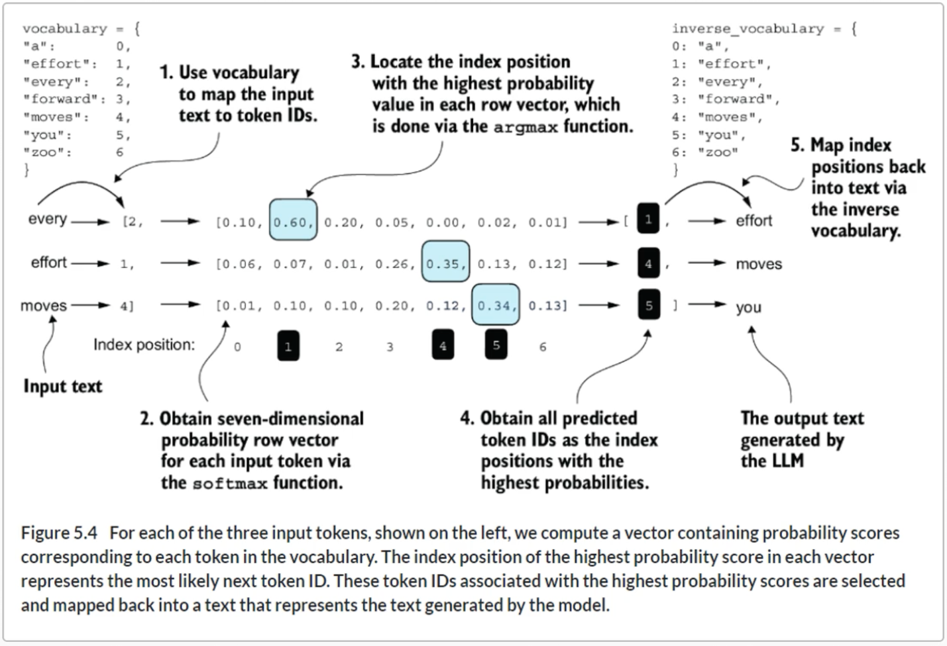

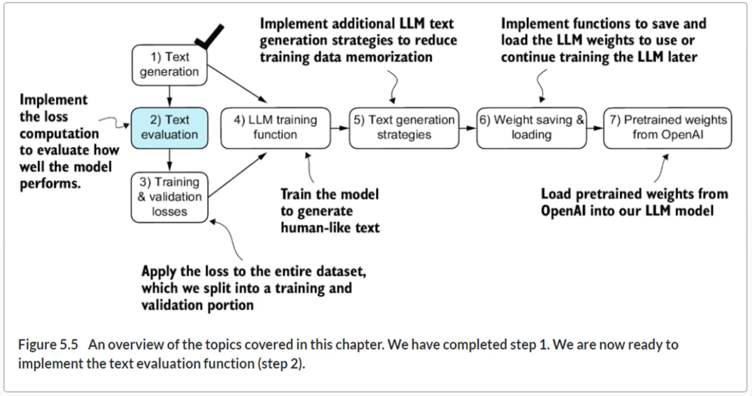

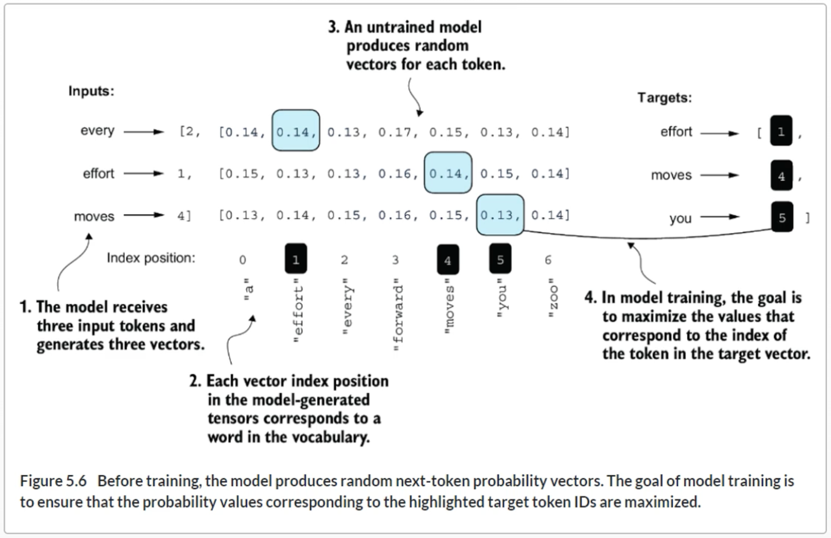

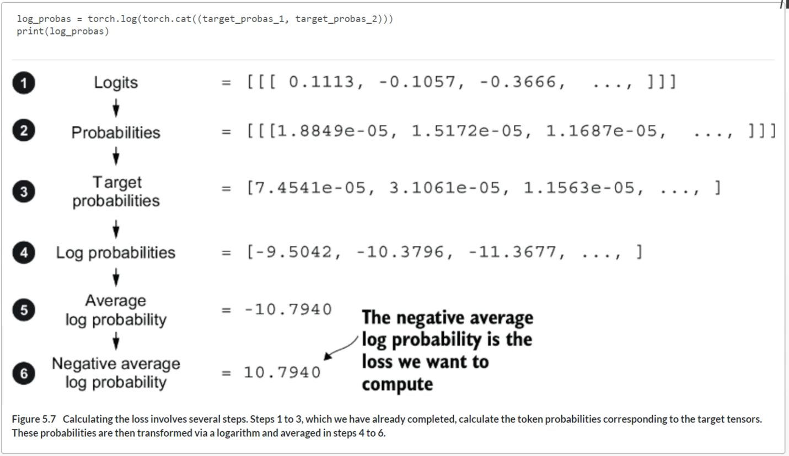

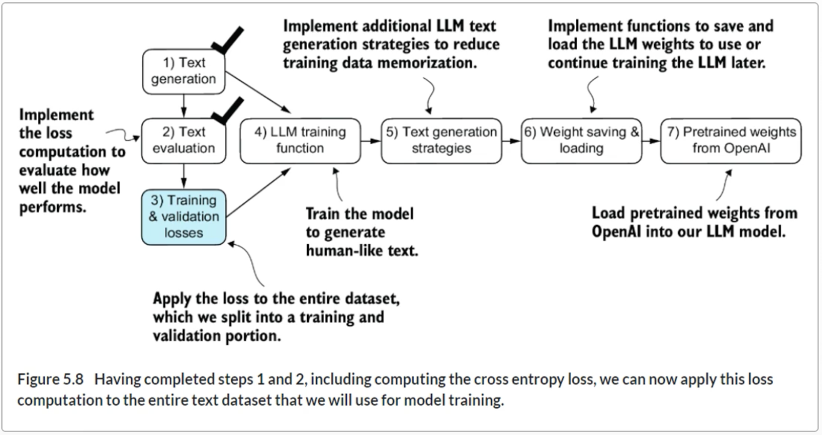

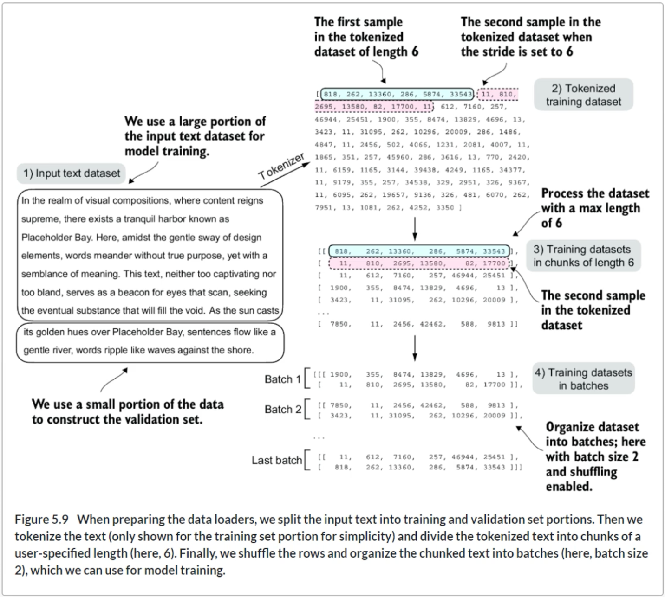

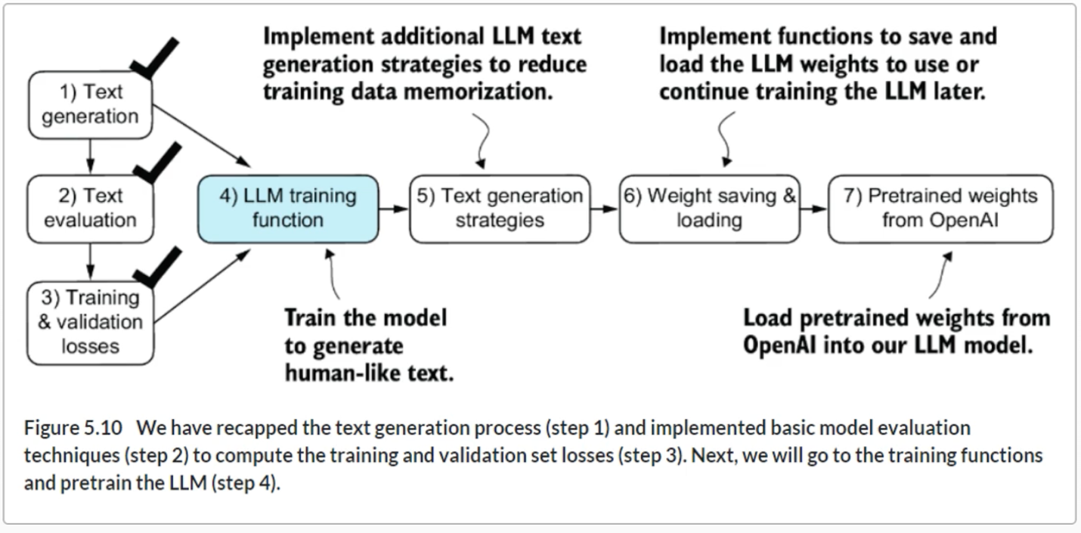

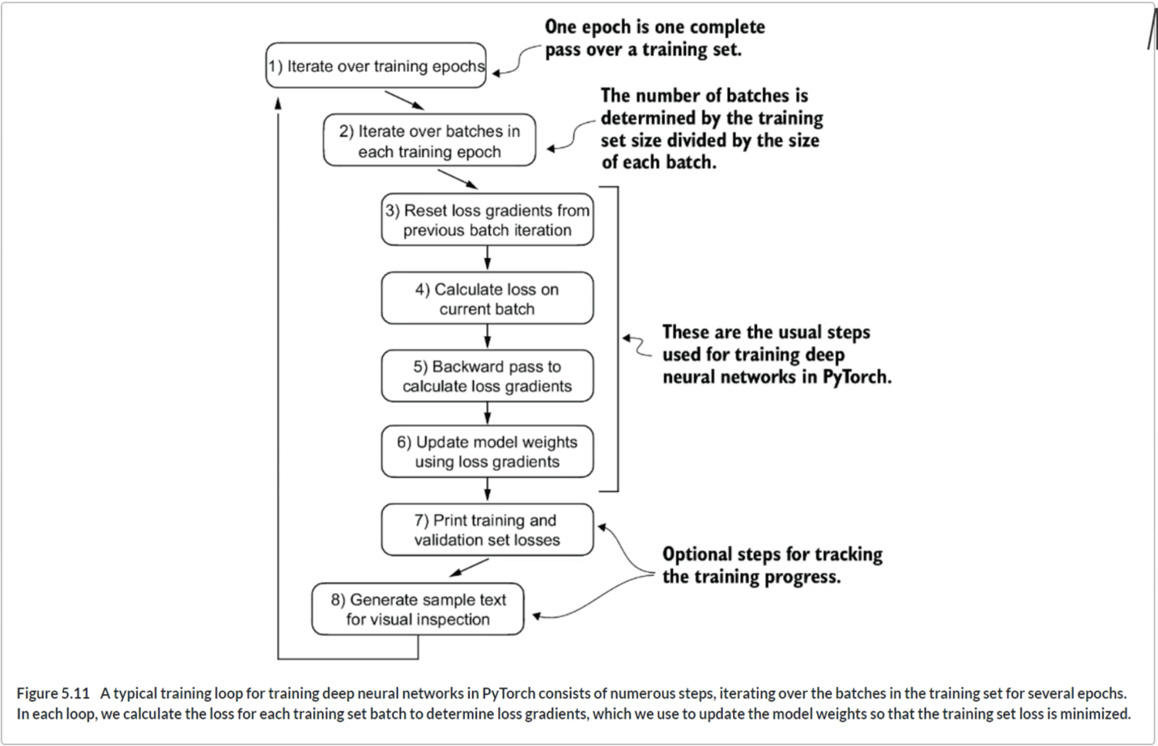

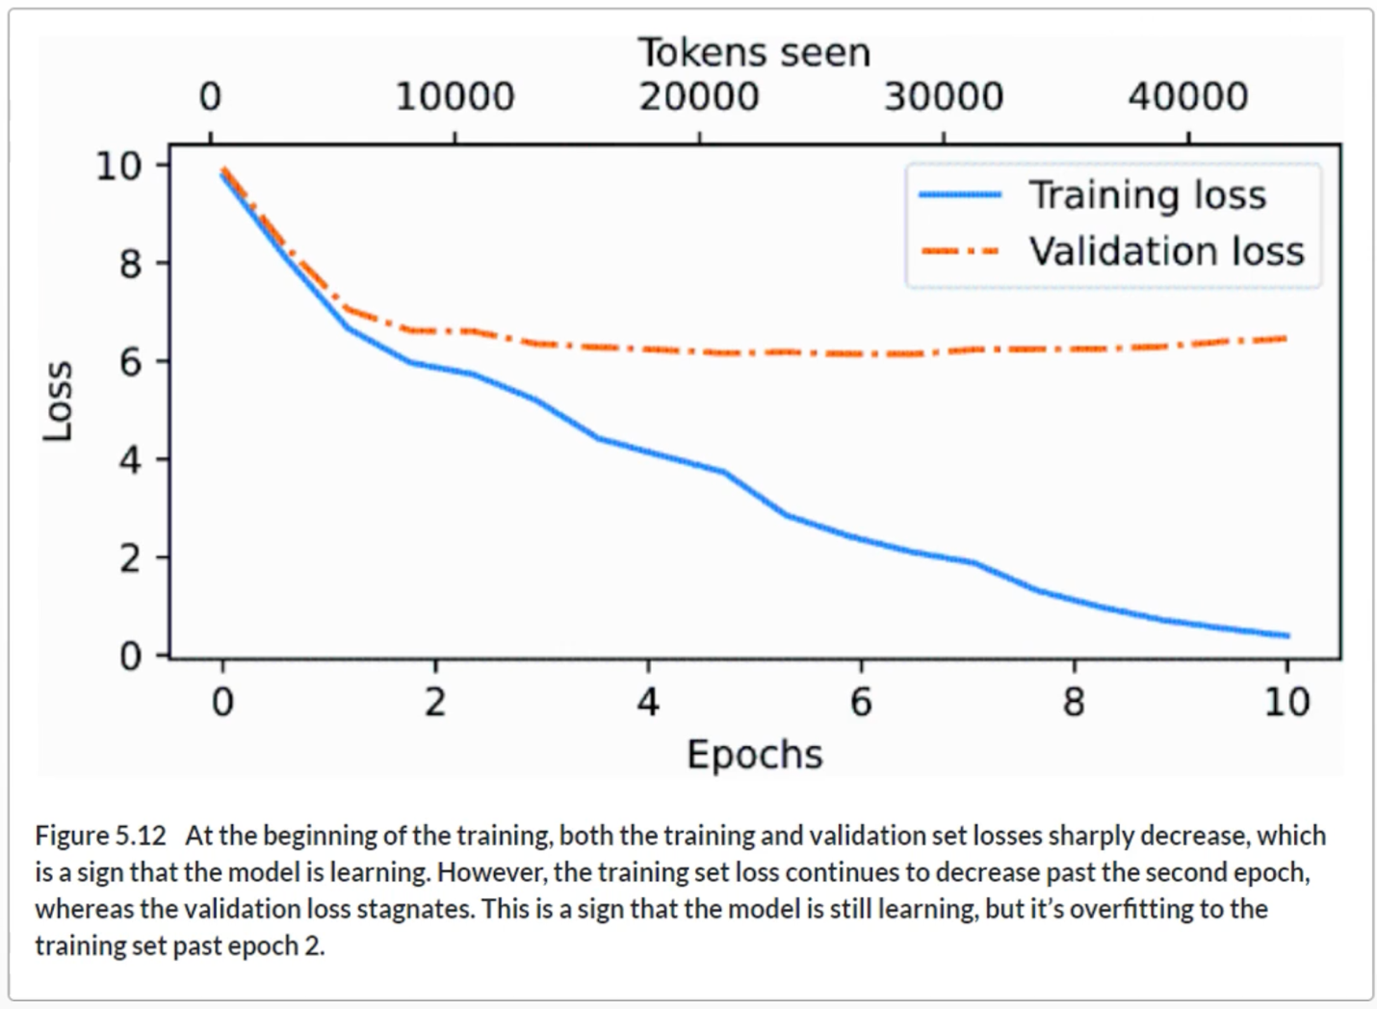

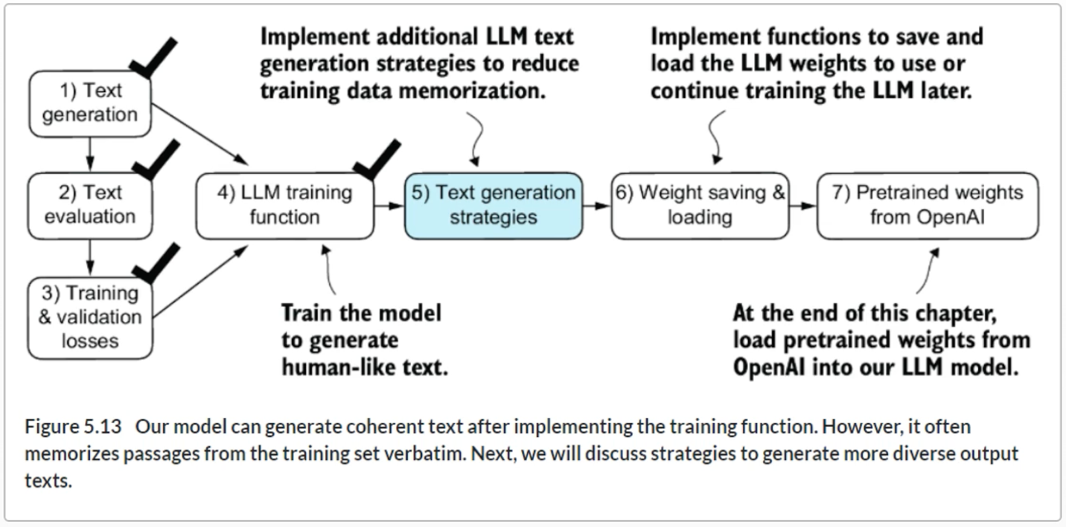

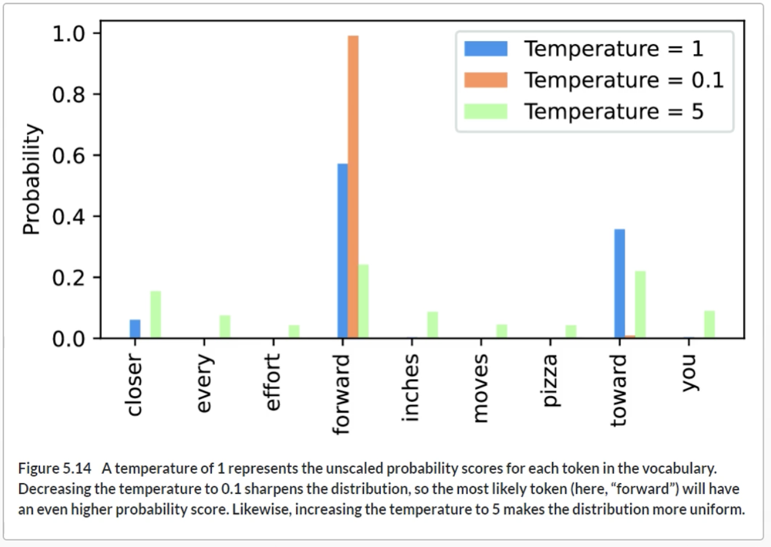

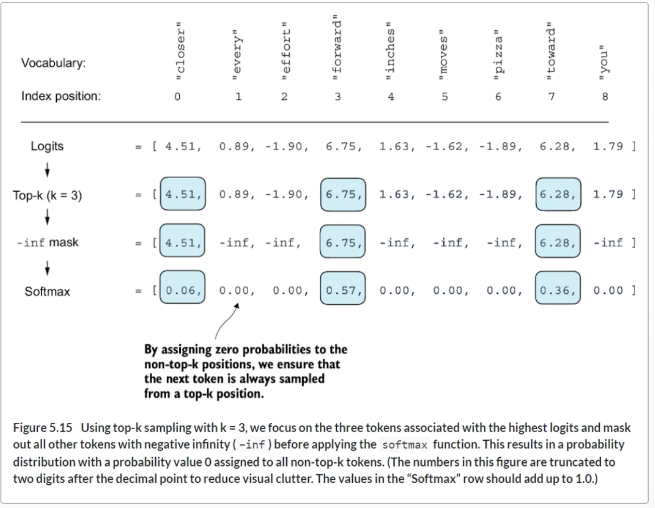

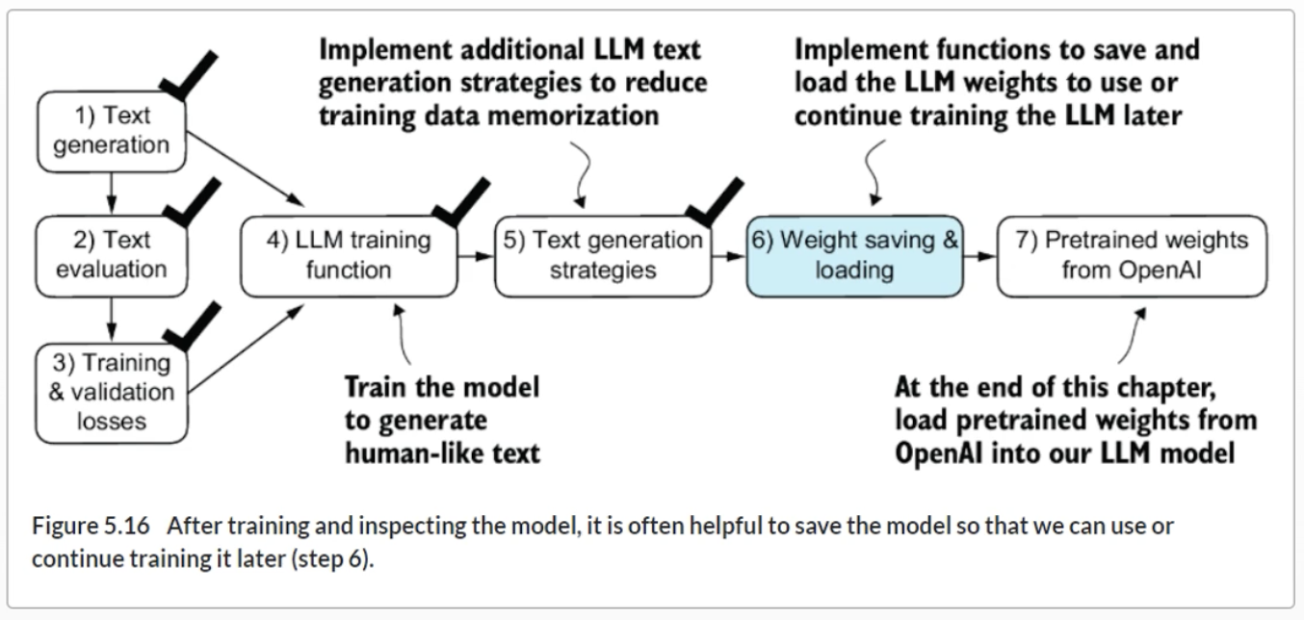

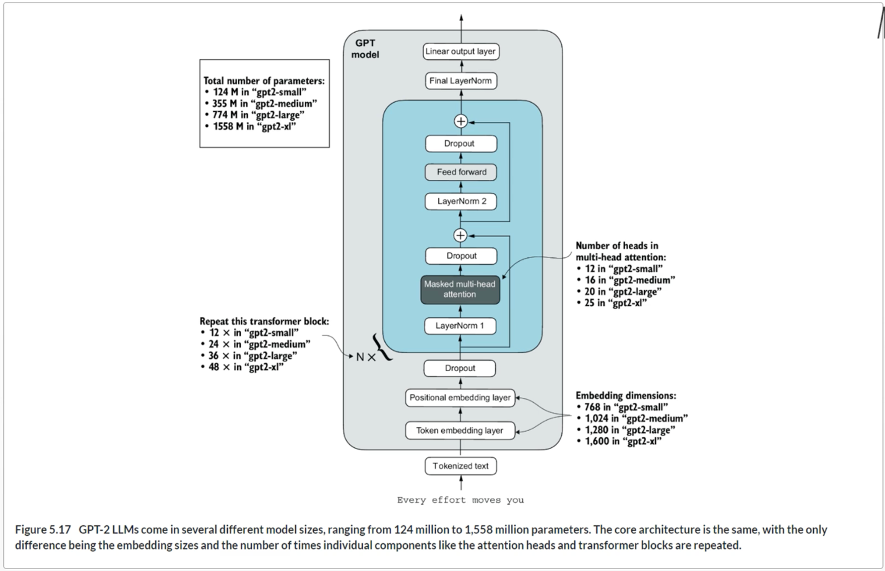

**Summary**

* When LLMs generate text, they output one token at a time.
* By default, the next token is generated by converting the model outputs into probability scores and selecting the token from the vocabulary that corresponds to the highest probability score, which is known as “greedy decoding.”
* Using probabilistic sampling and temperature scaling, we can influence the diversity and coherence of the generated text.
* Training and validation set losses can be used to gauge the quality of text generated by LLM during training.
* Pretraining an LLM involves changing its weights to minimize the training loss.
* The training loop for LLMs itself is a standard procedure in deep learning, using a conventional cross entropy loss and AdamW optimizer.
* Pretraining an LLM on a large text corpus is time- and resource-intensive, so we can load openly available weights as an alternative to pretraining the model on a large dataset ourselves.

**Chapter 6**

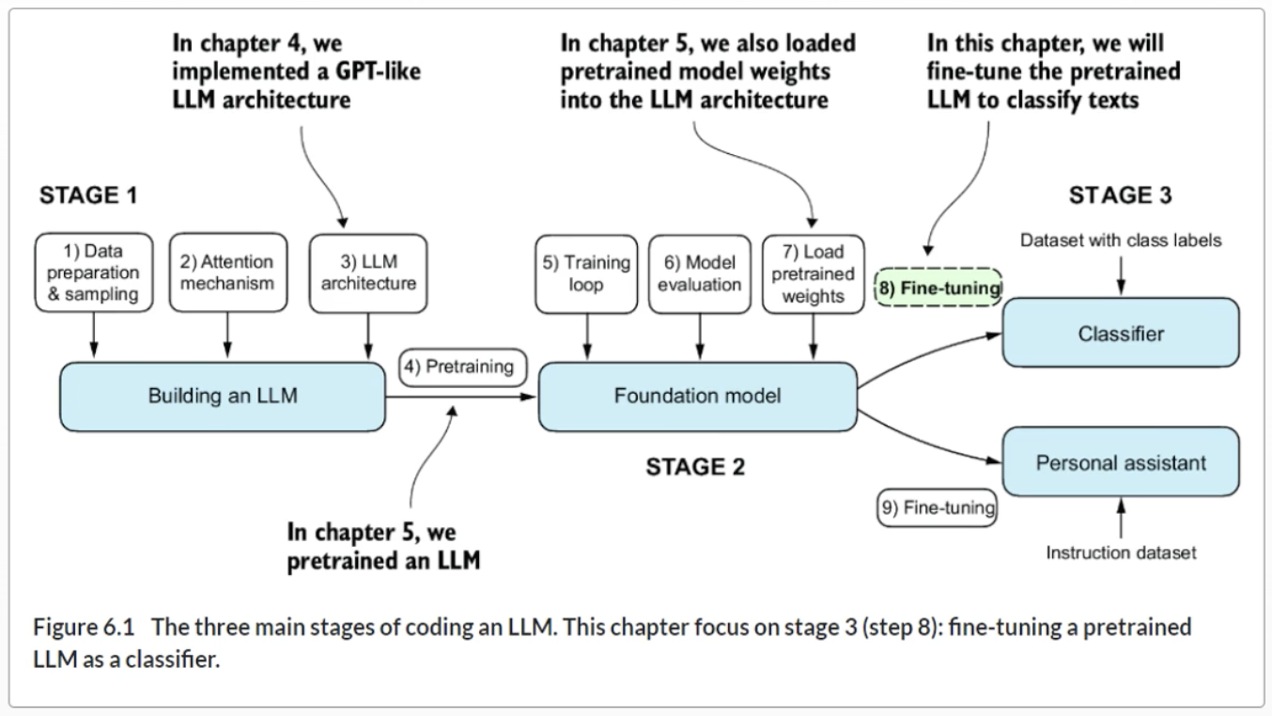

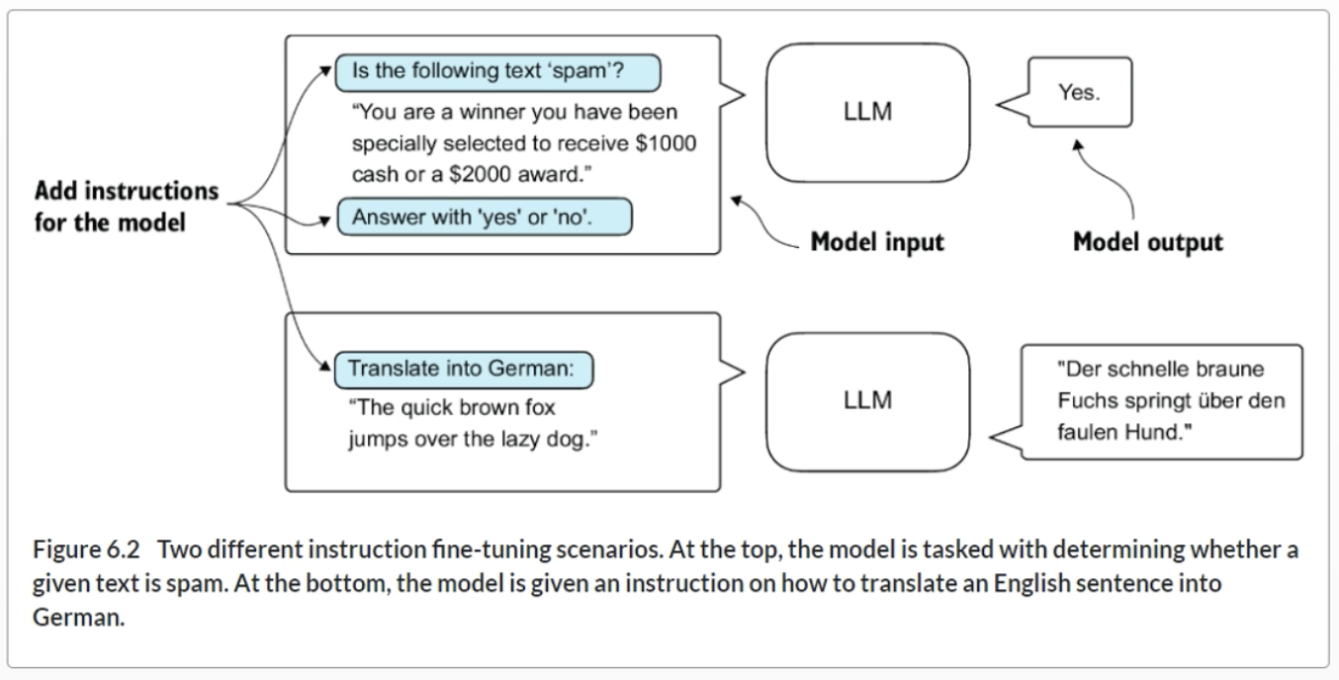

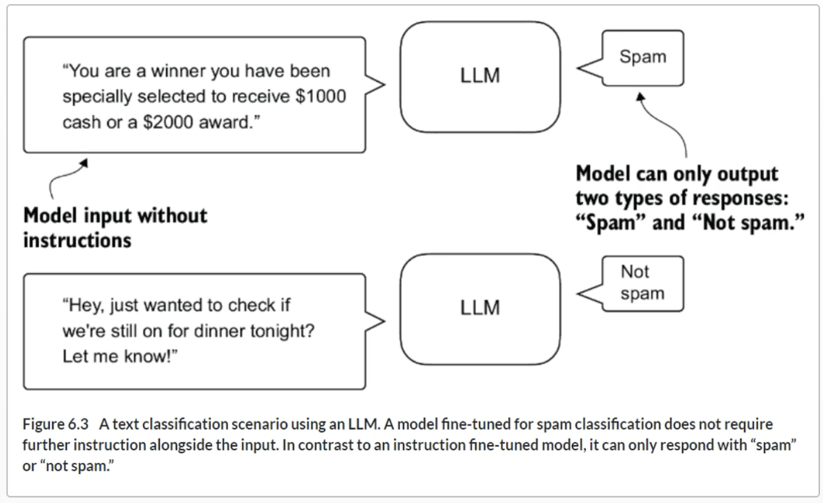

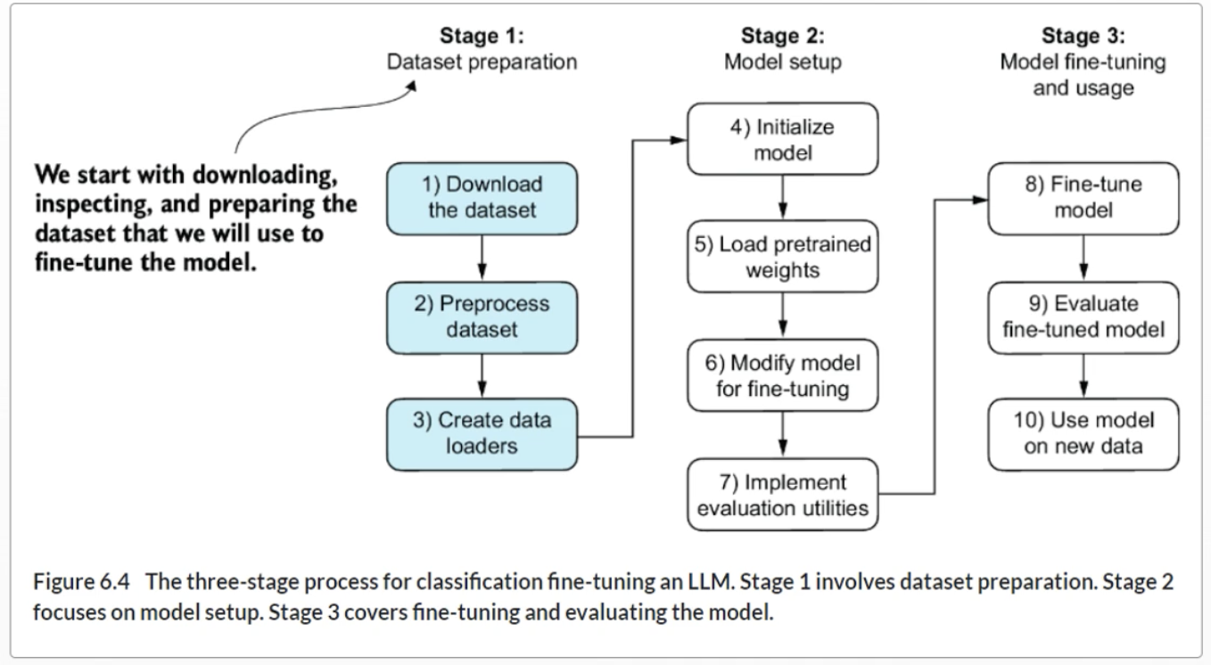

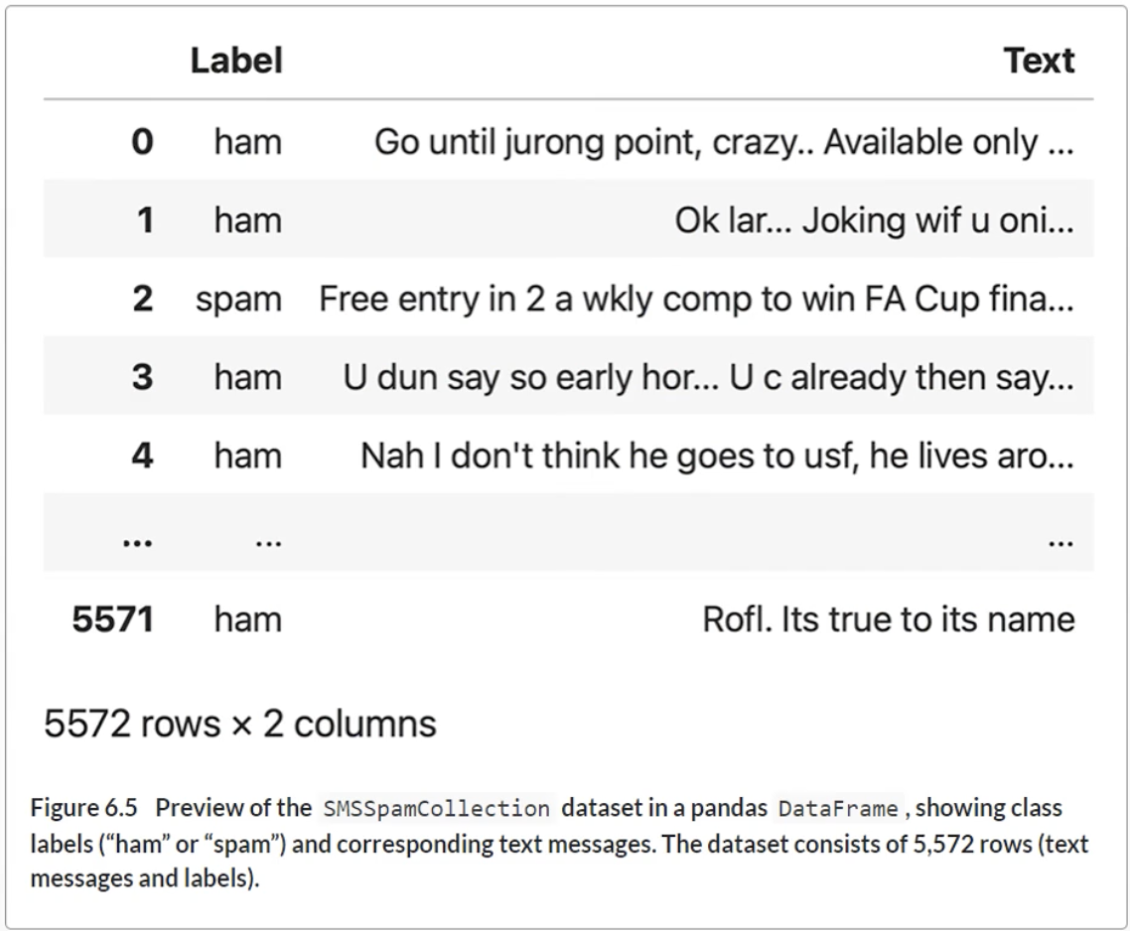

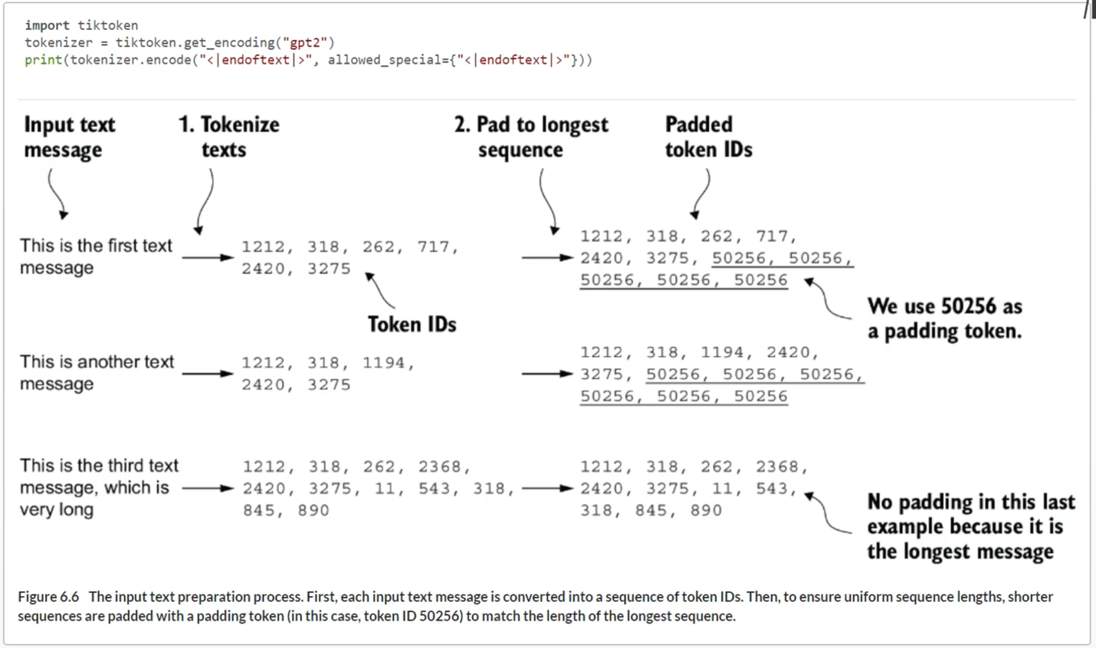

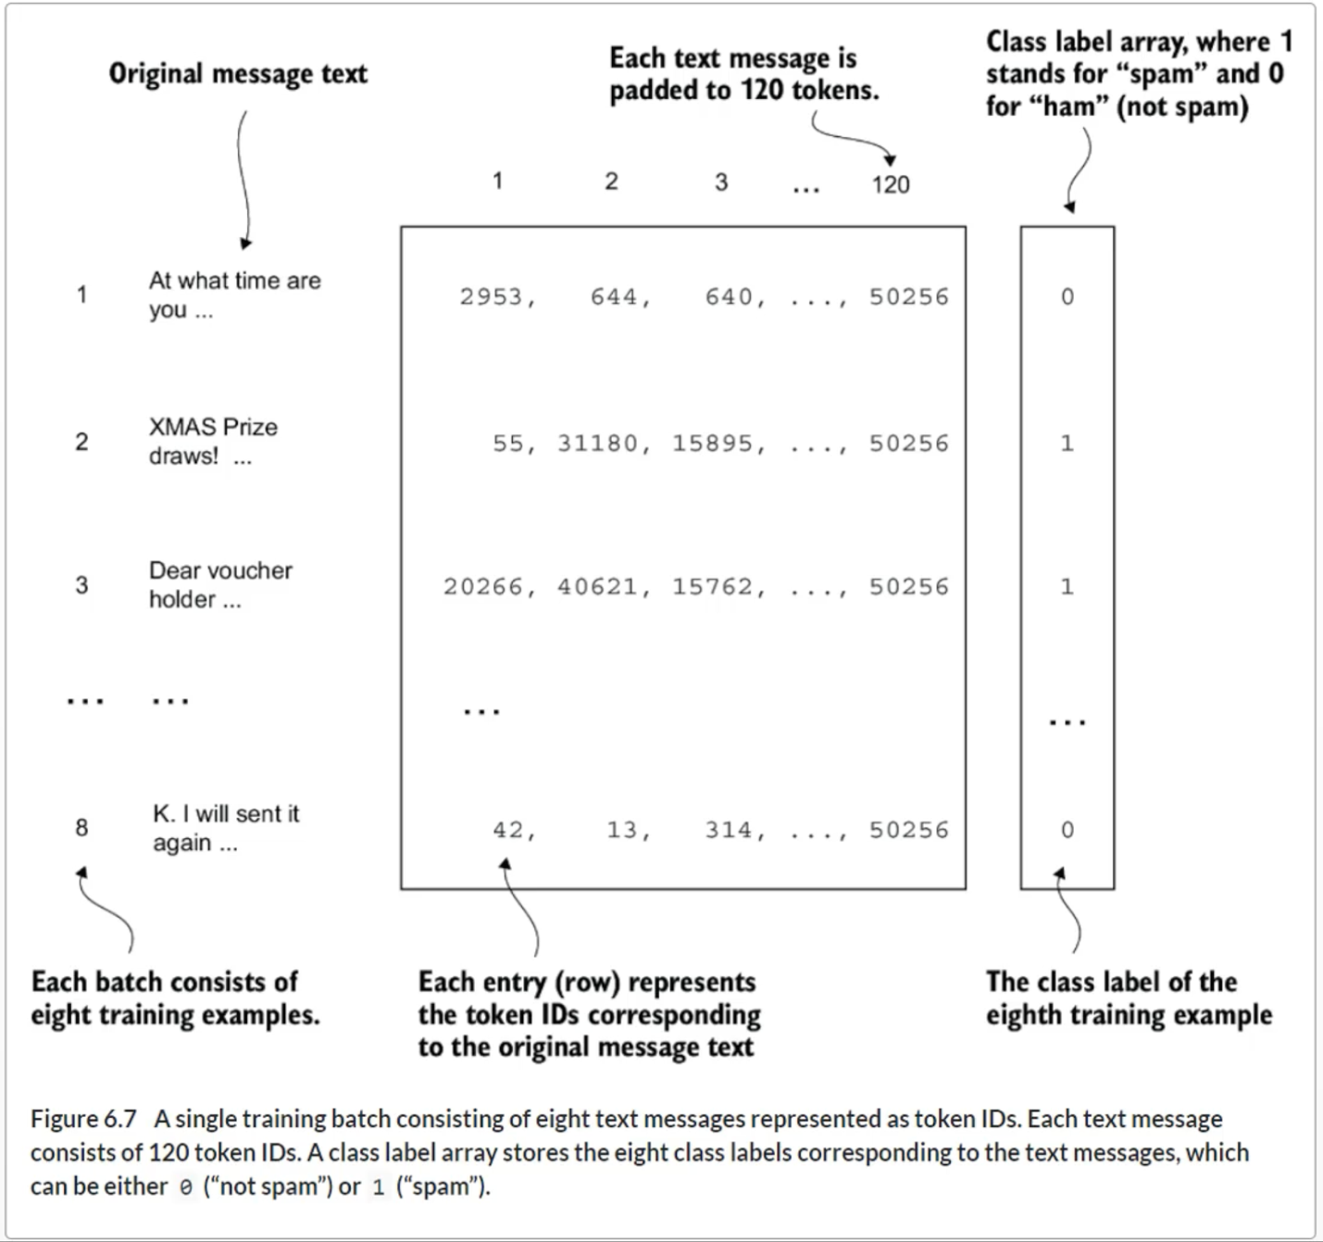

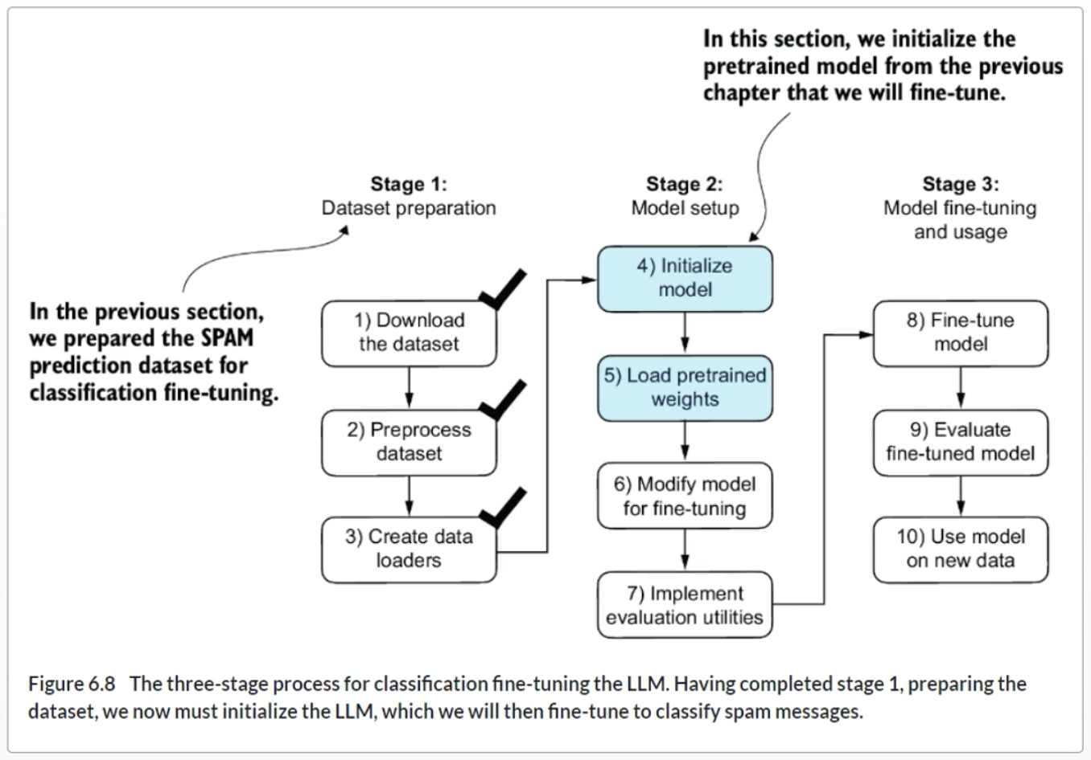

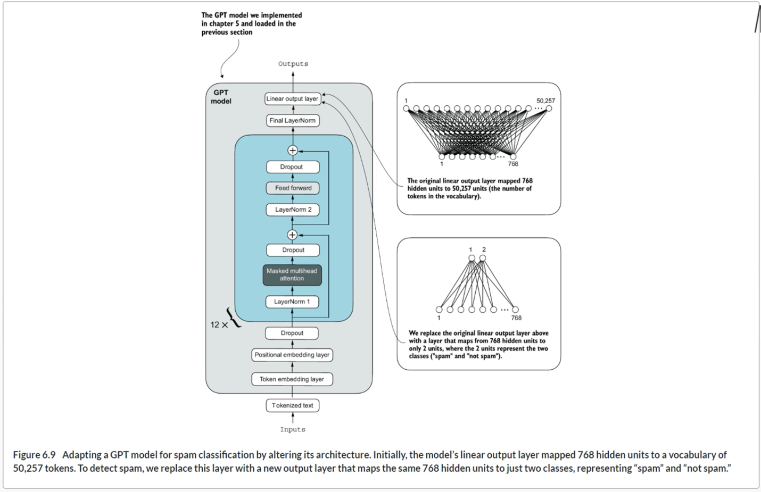

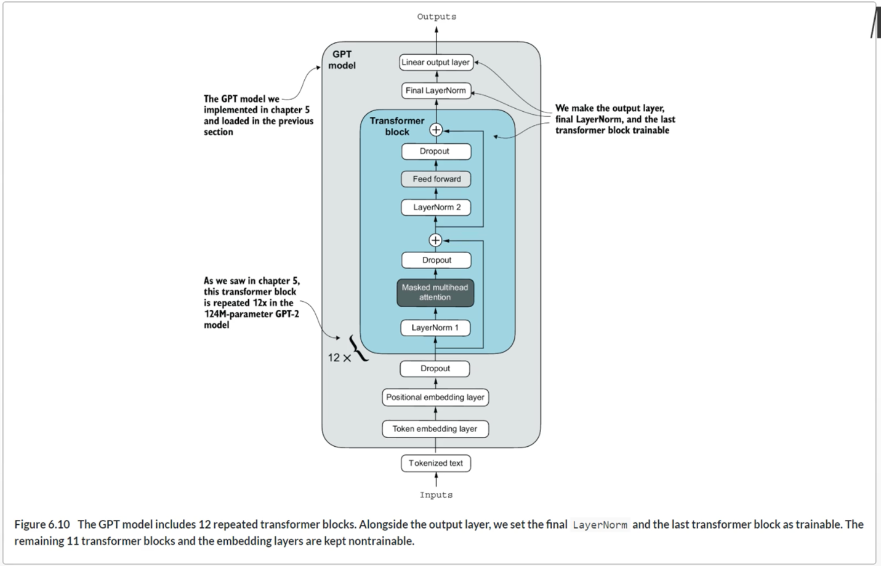

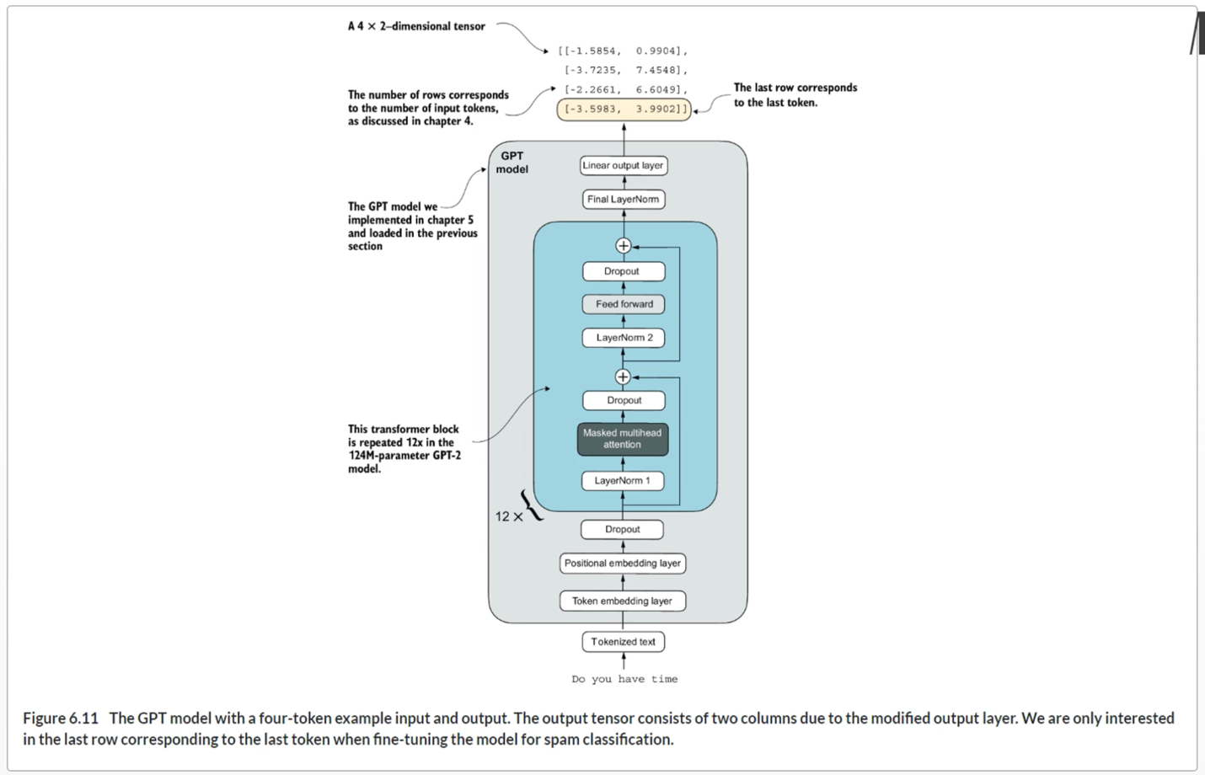

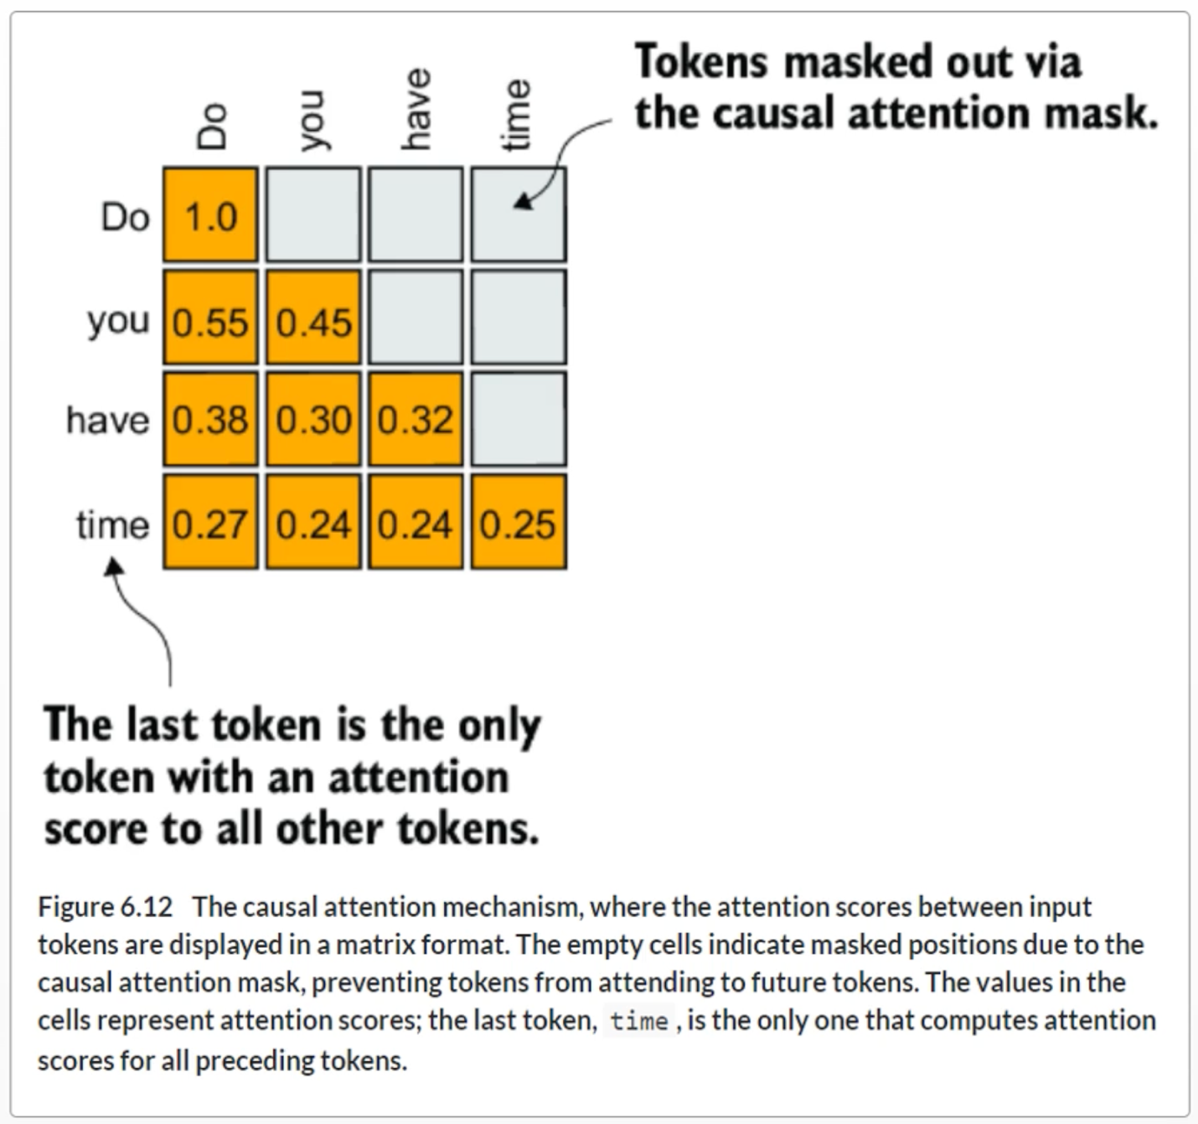

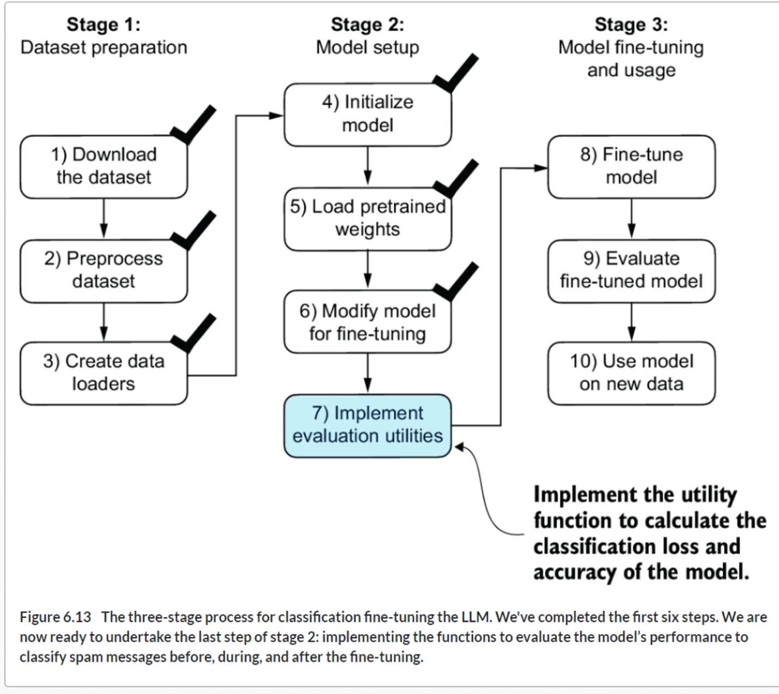

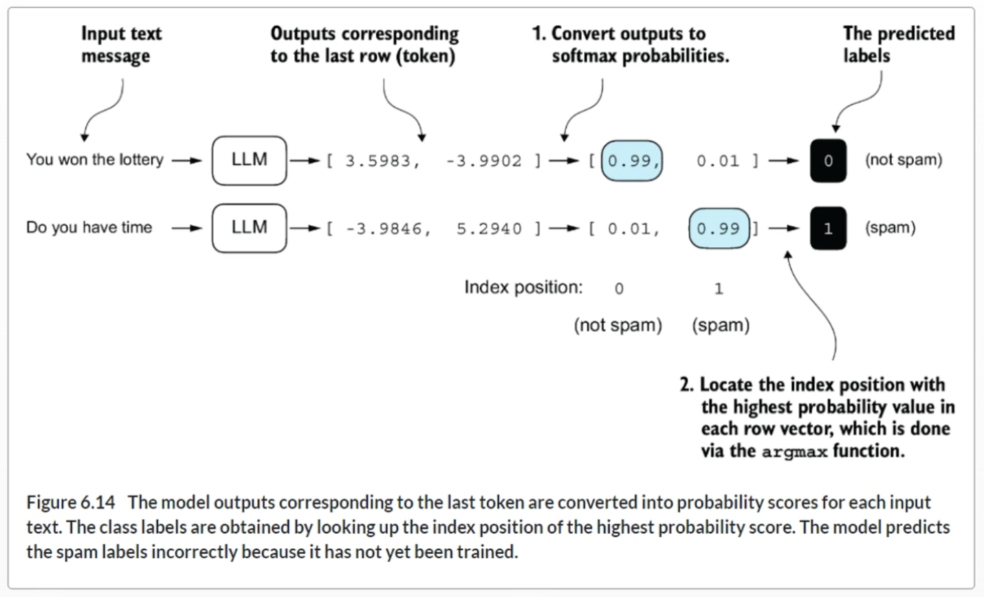

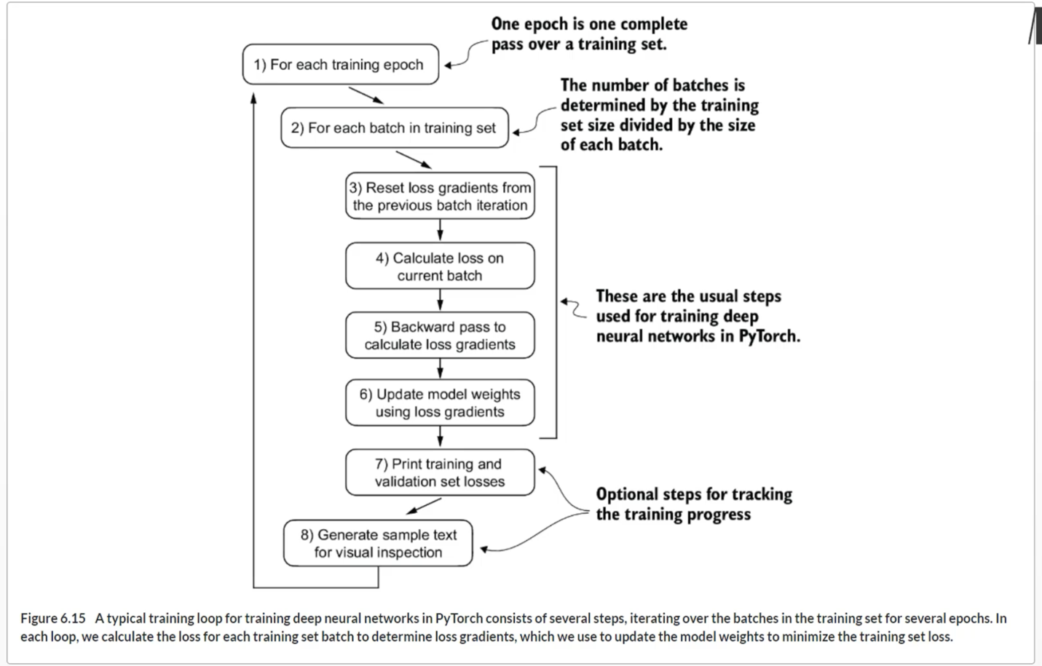

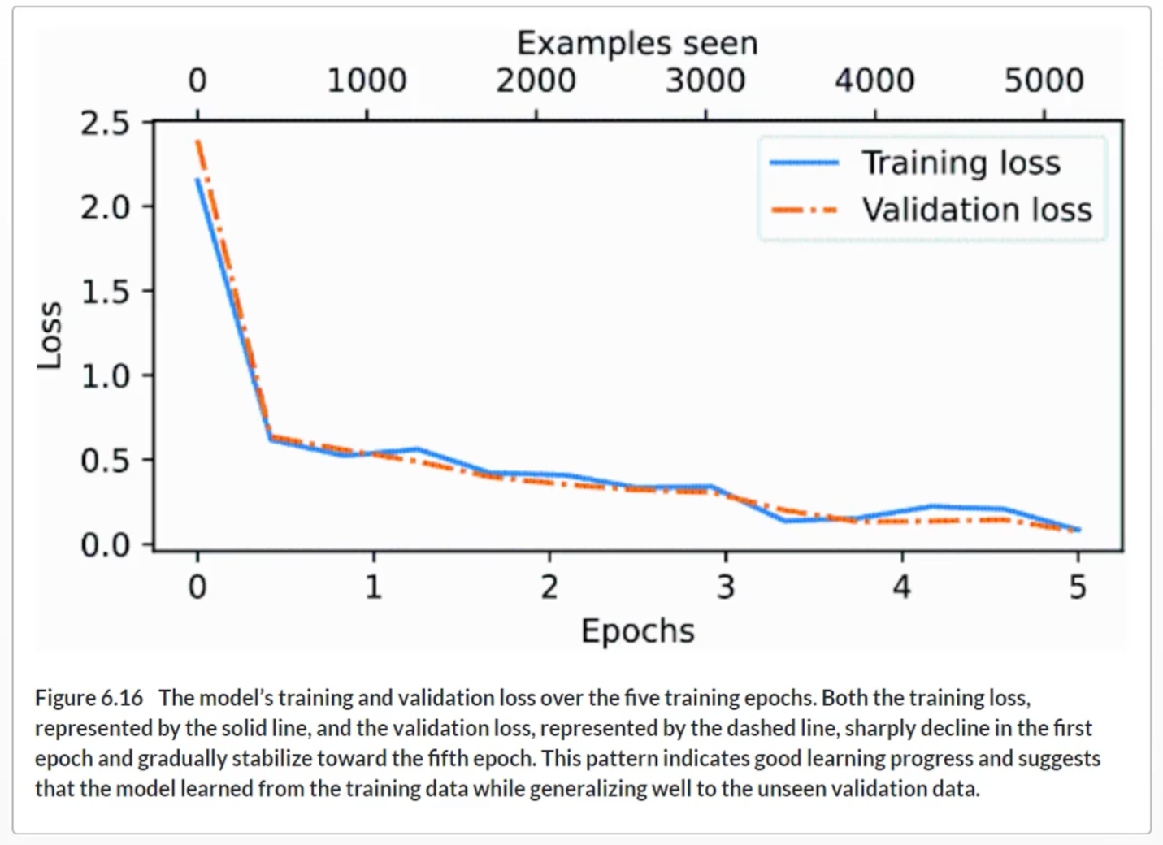

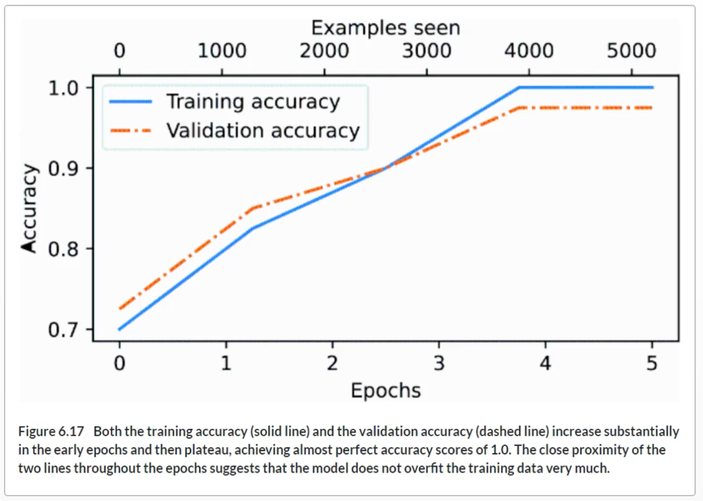

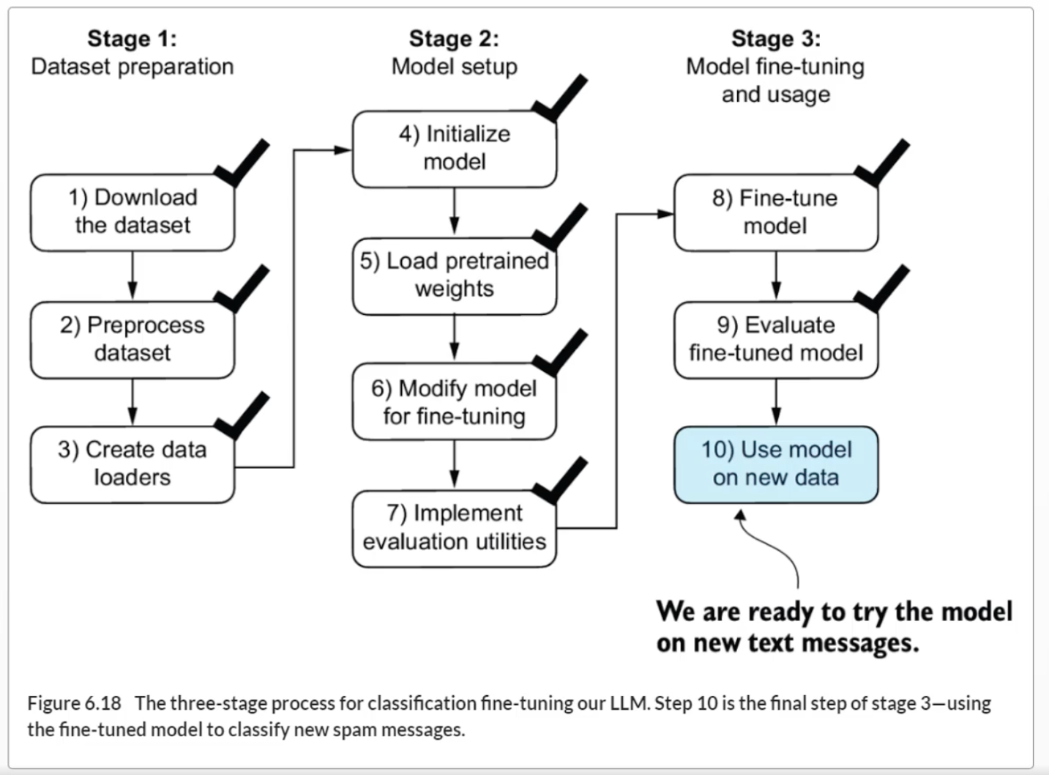

**Summary**

* There are different strategies for fine-tuning LLMs, including classification fine-tuning and instruction fine-tuning.
* Classification fine-tuning involves replacing the output layer of an LLM via a small classification layer.
* In the case of classifying text messages as “spam” or “not spam,” the new classification layer consists of only two output nodes. Previously, we used the number of output nodes equal to the number of unique tokens in the vocabulary (i.e., 50,256).
* Instead of predicting the next token in the text as in pretraining, classification fine-tuning trains the model to output a correct class label—for example, “spam” or “not spam.”
* The model input for fine-tuning is text converted into token IDs, similar to pretraining.
* Before fine-tuning an LLM, we load the pretrained model as a base model.
* Evaluating a classification model involves calculating the classification accuracy (the fraction or percentage of correct predictions).
* Fine-tuning a classification model uses the same cross entropy loss function as when pretraining the LLM.

**Chapter 7**

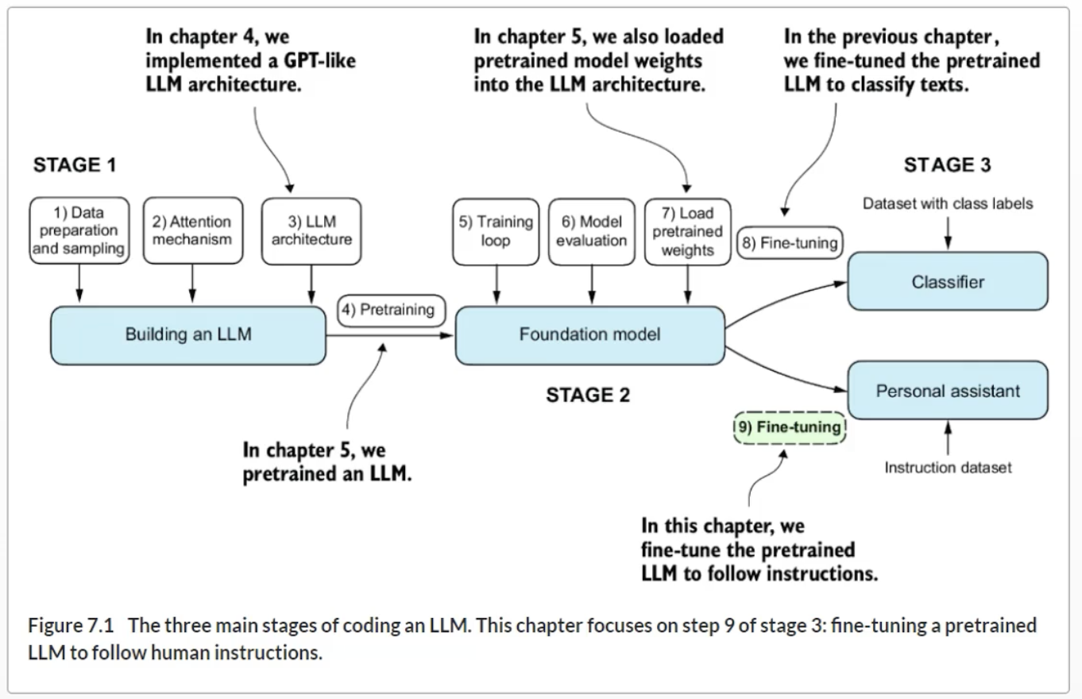

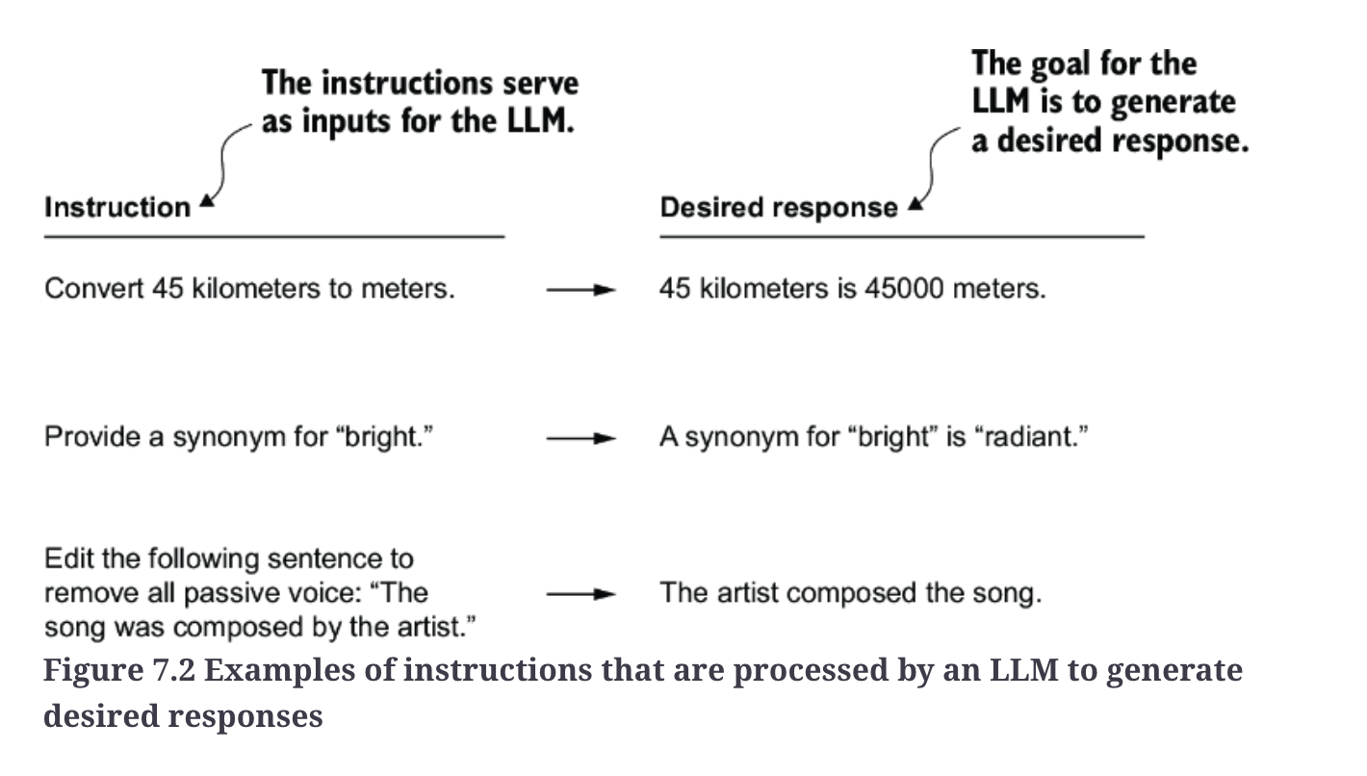

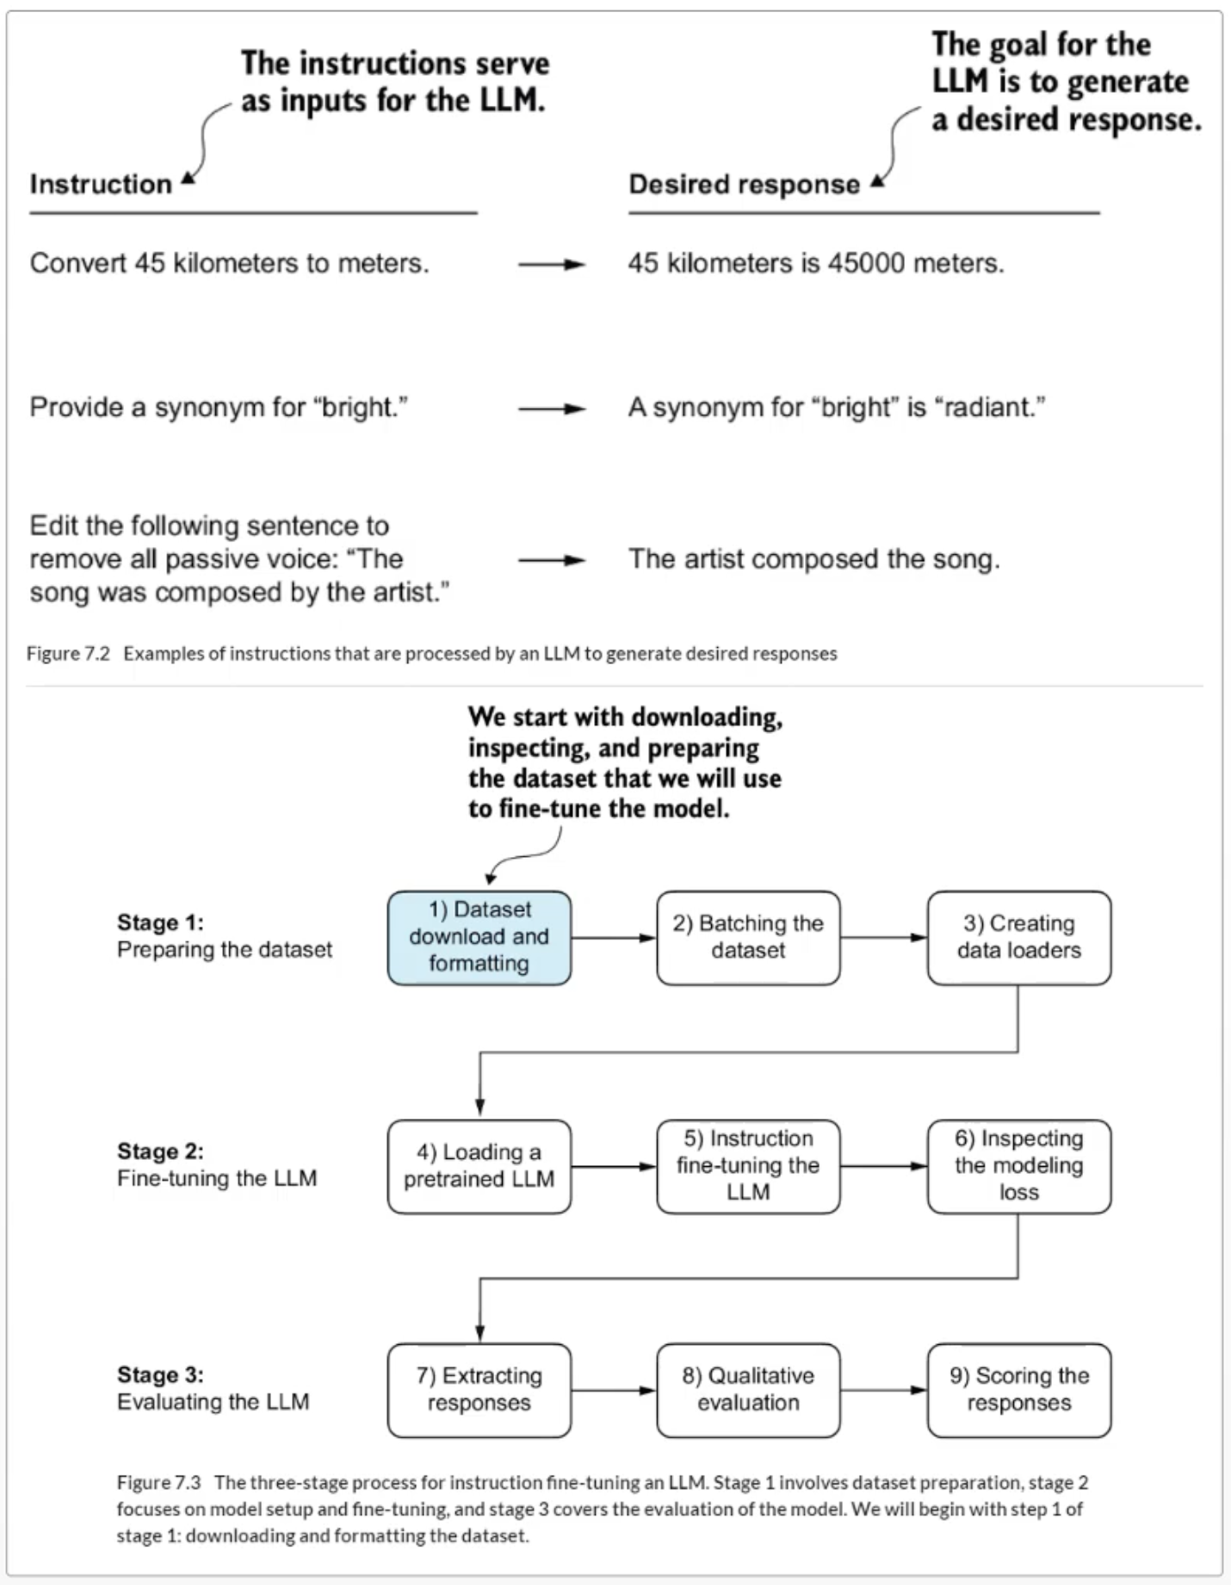

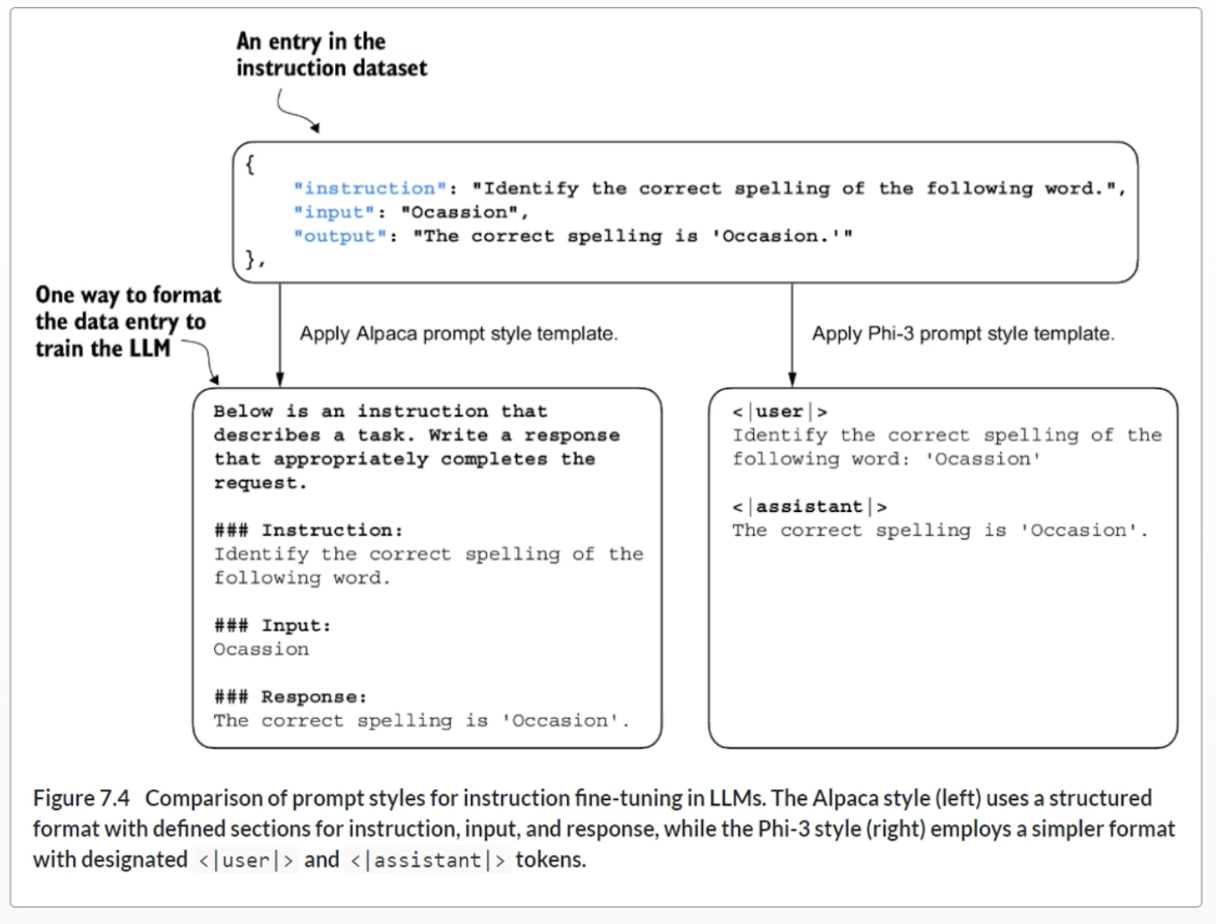

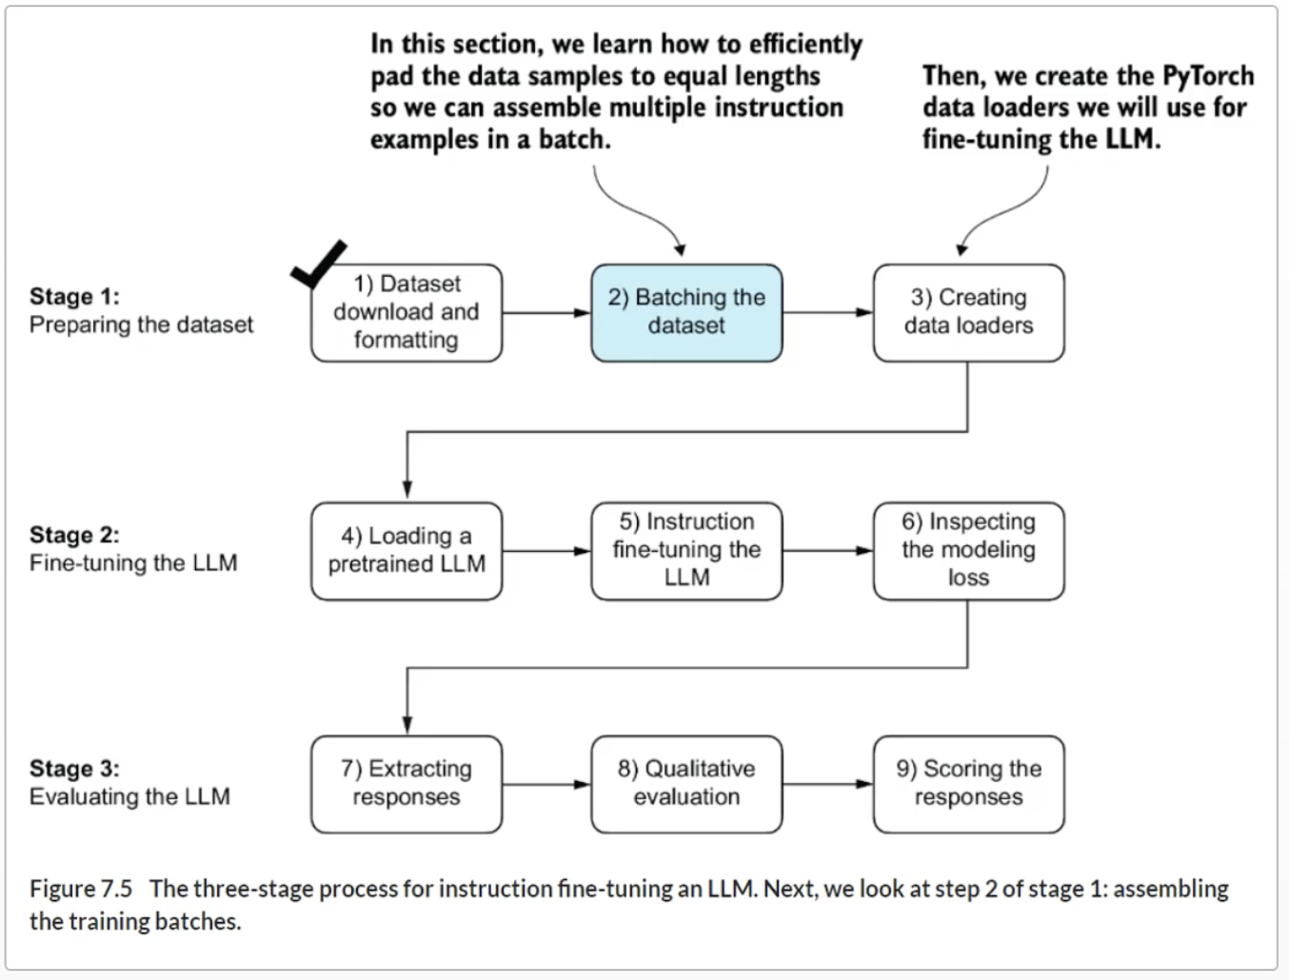

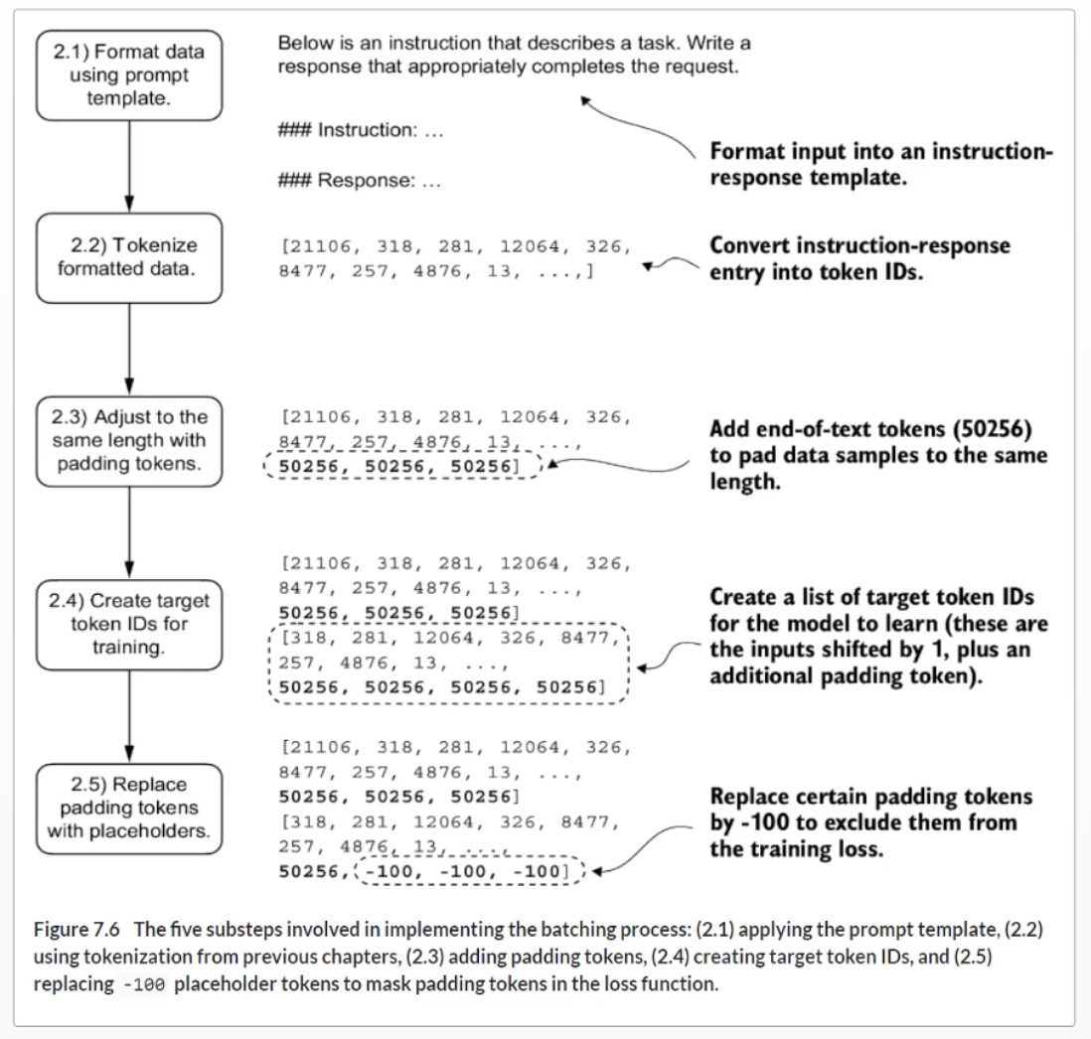

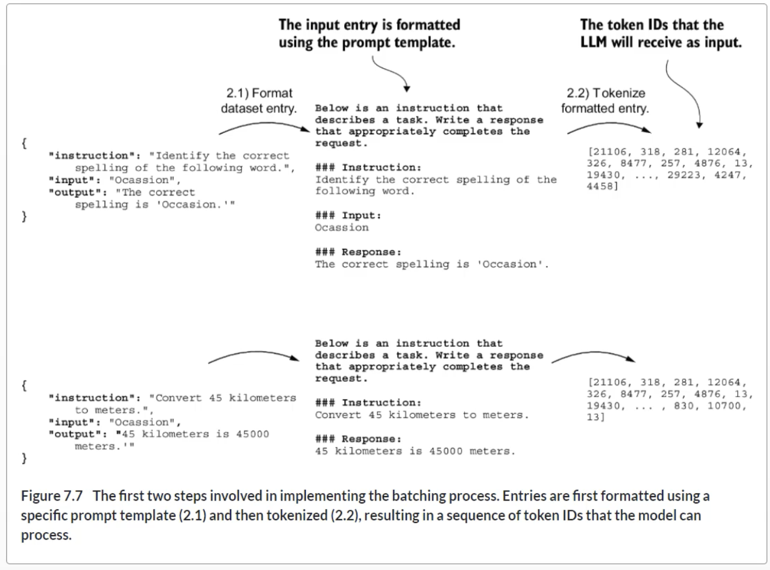

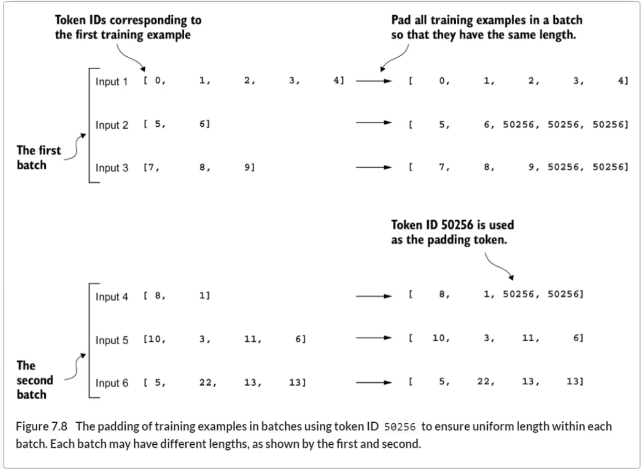

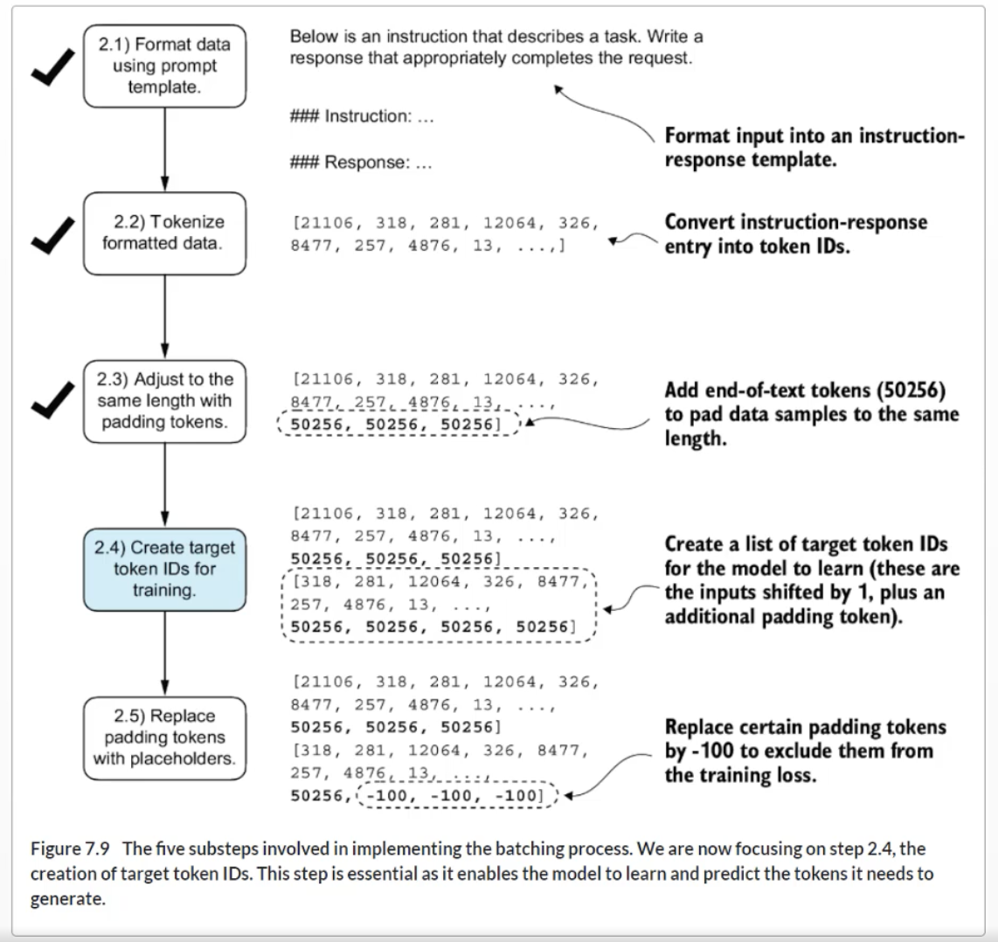

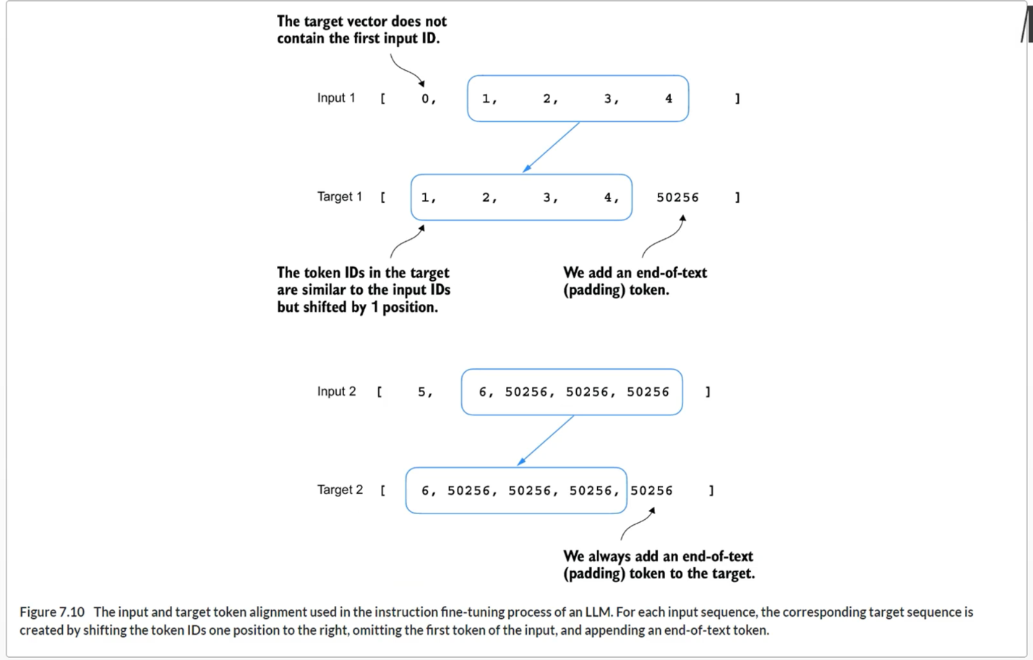

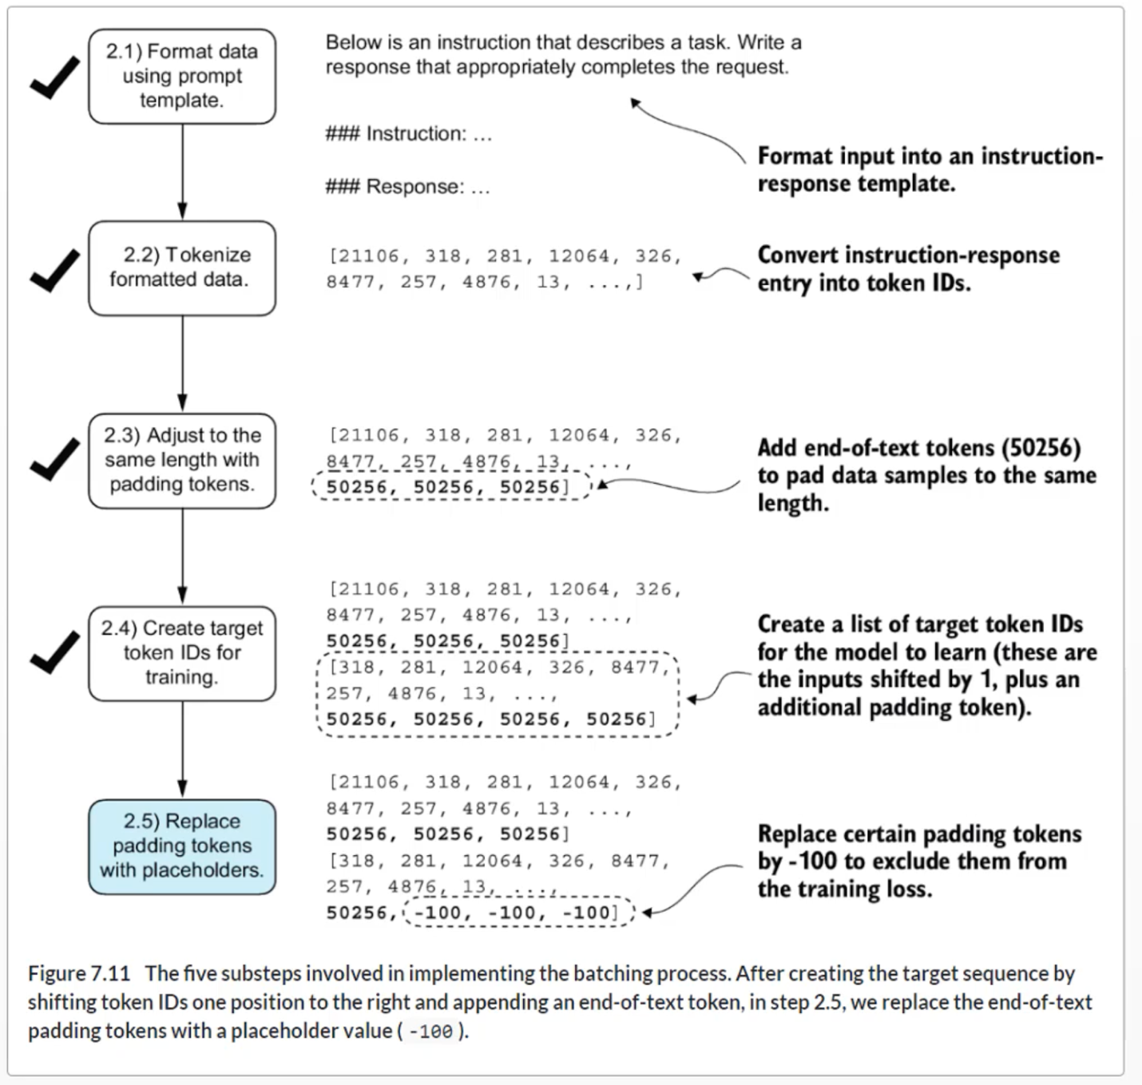

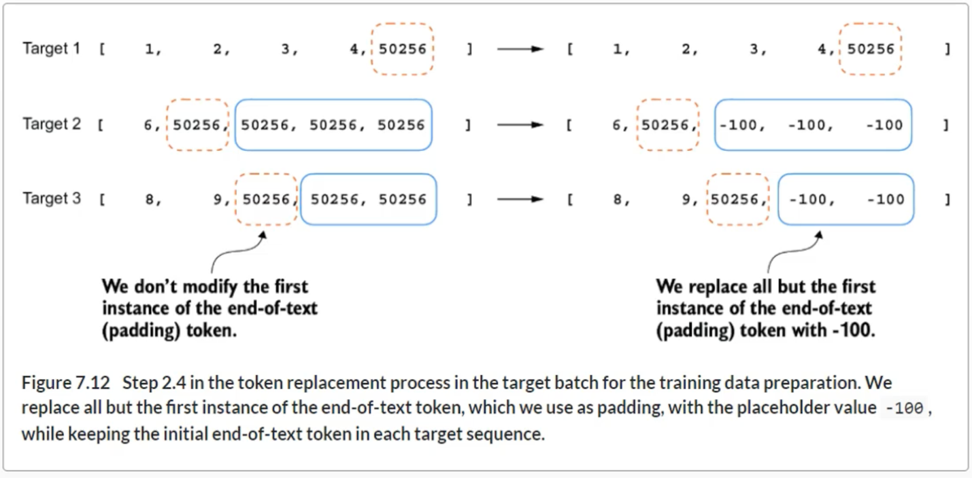

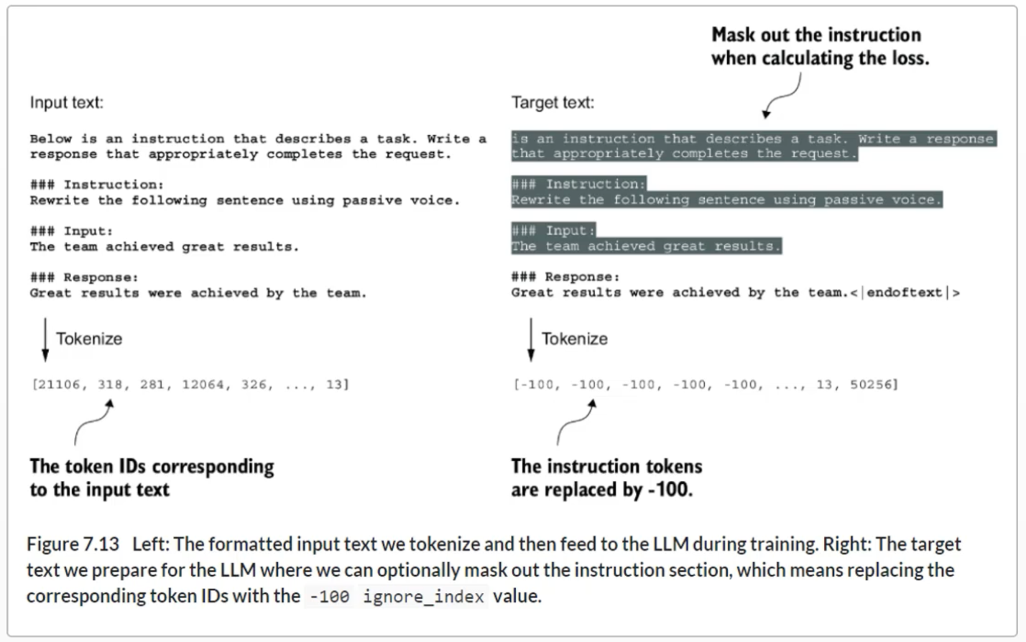

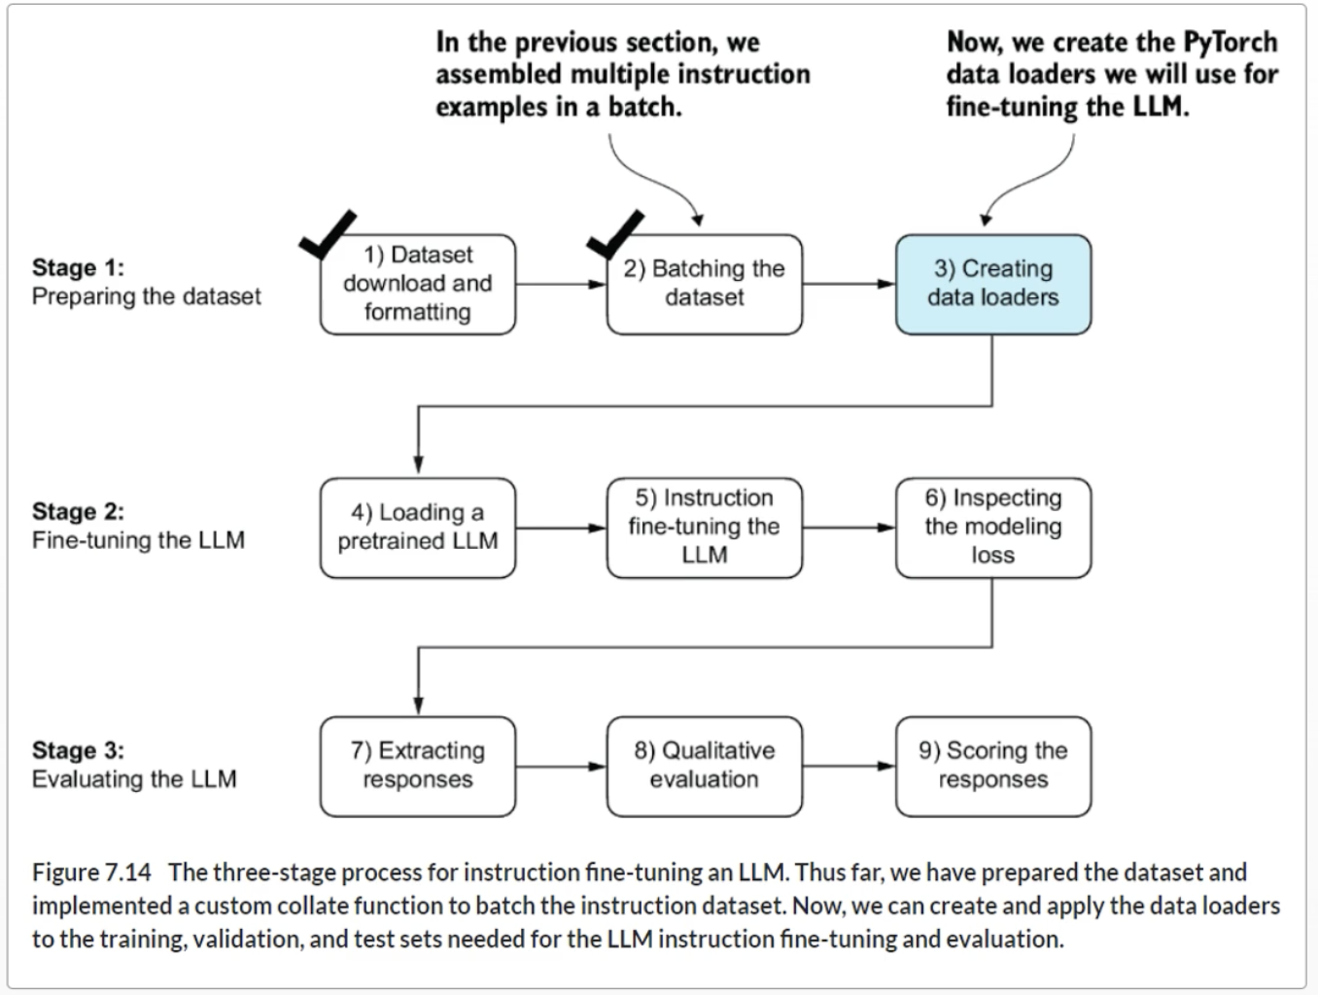

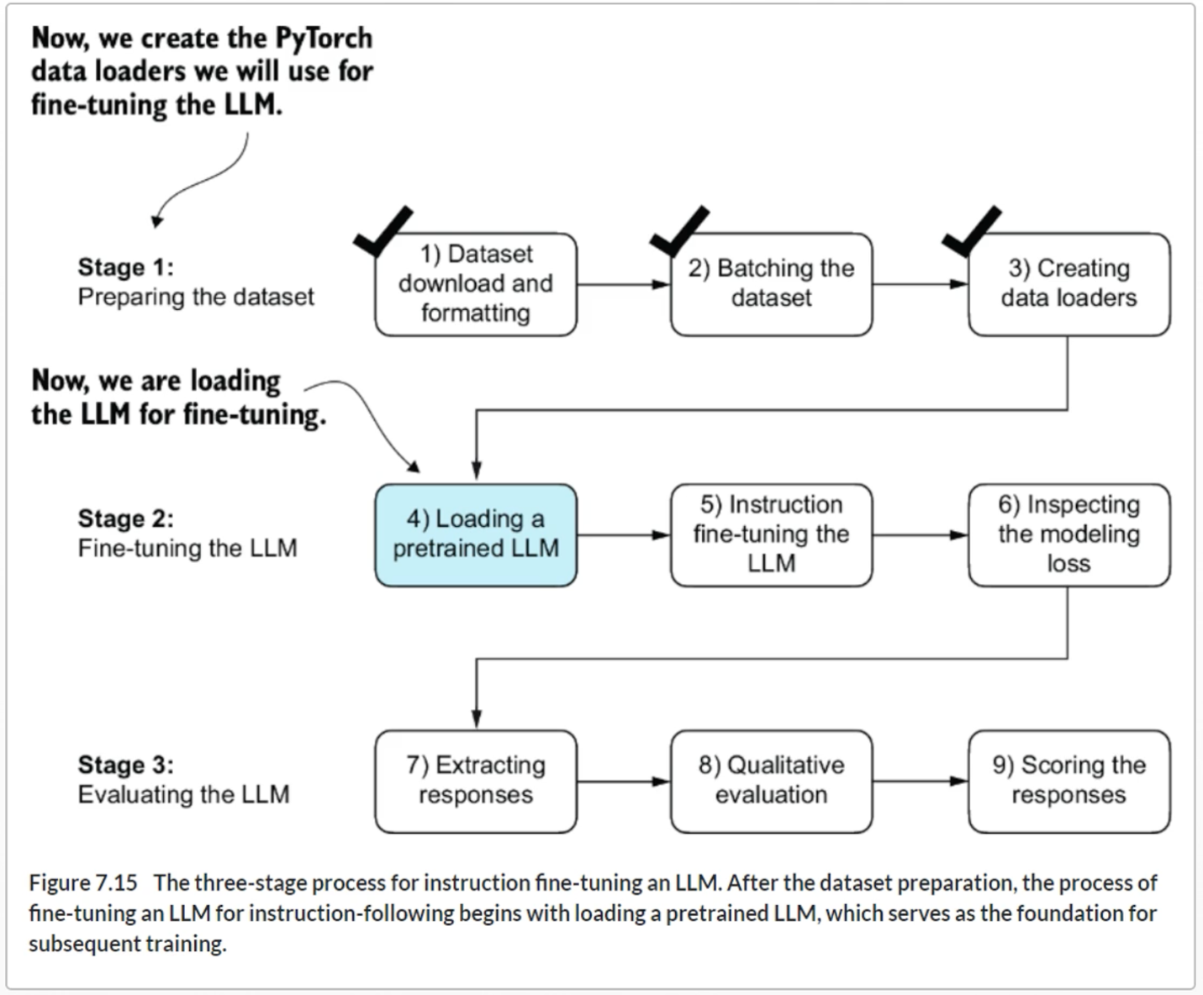

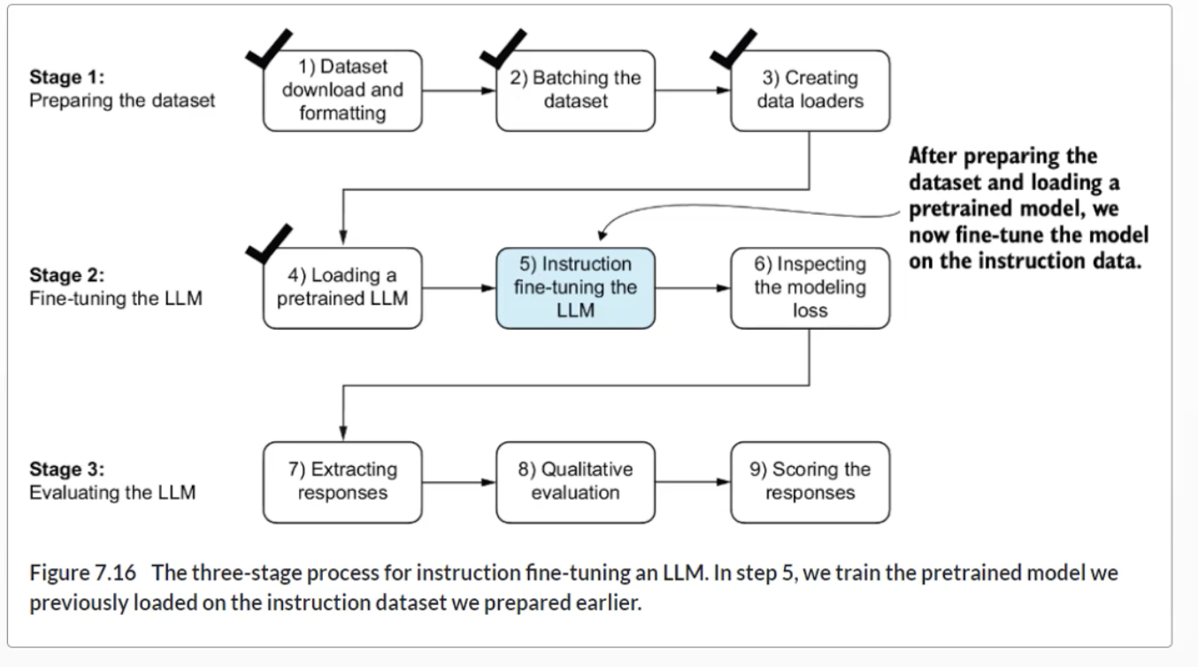

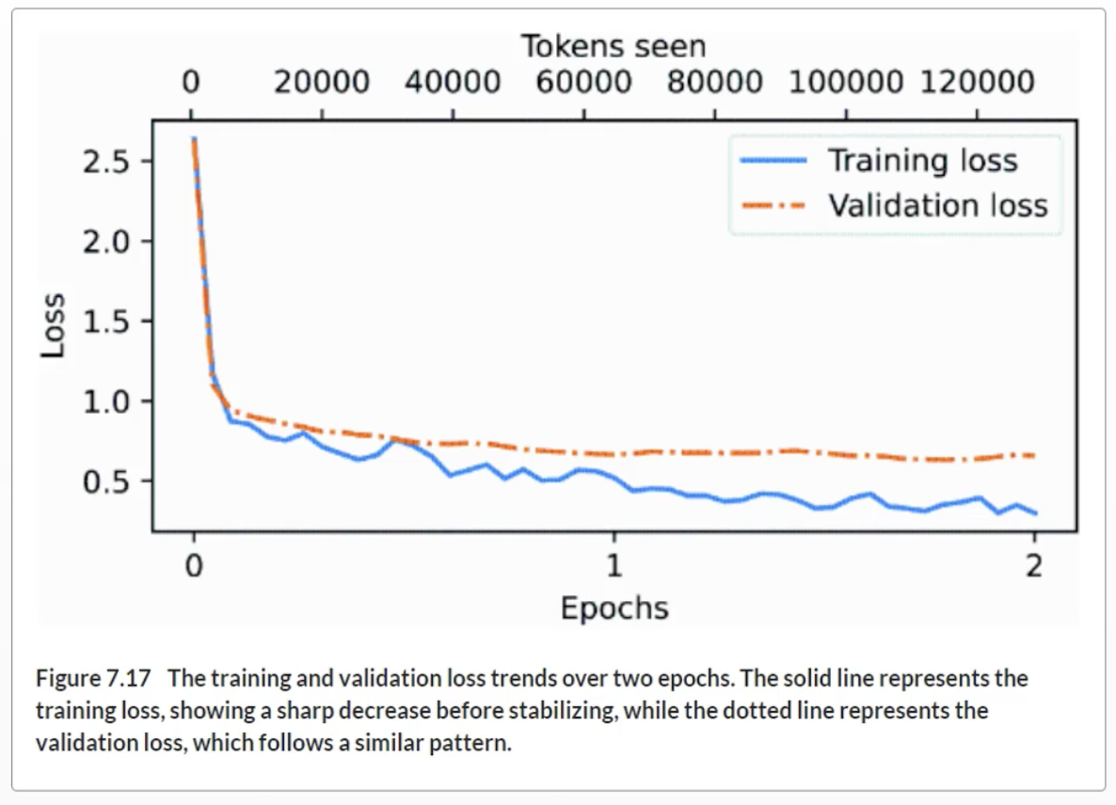

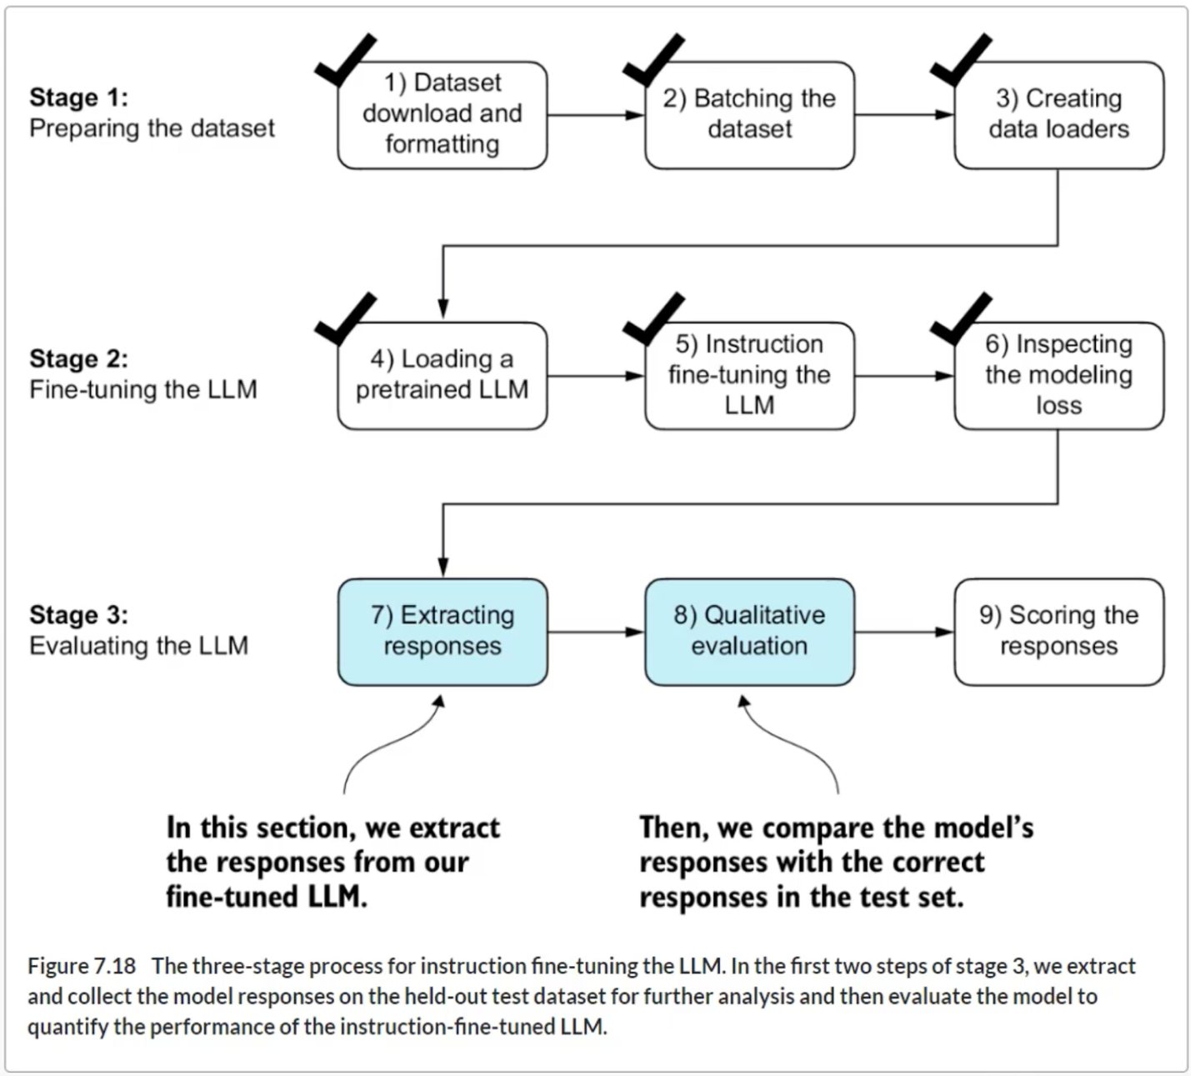

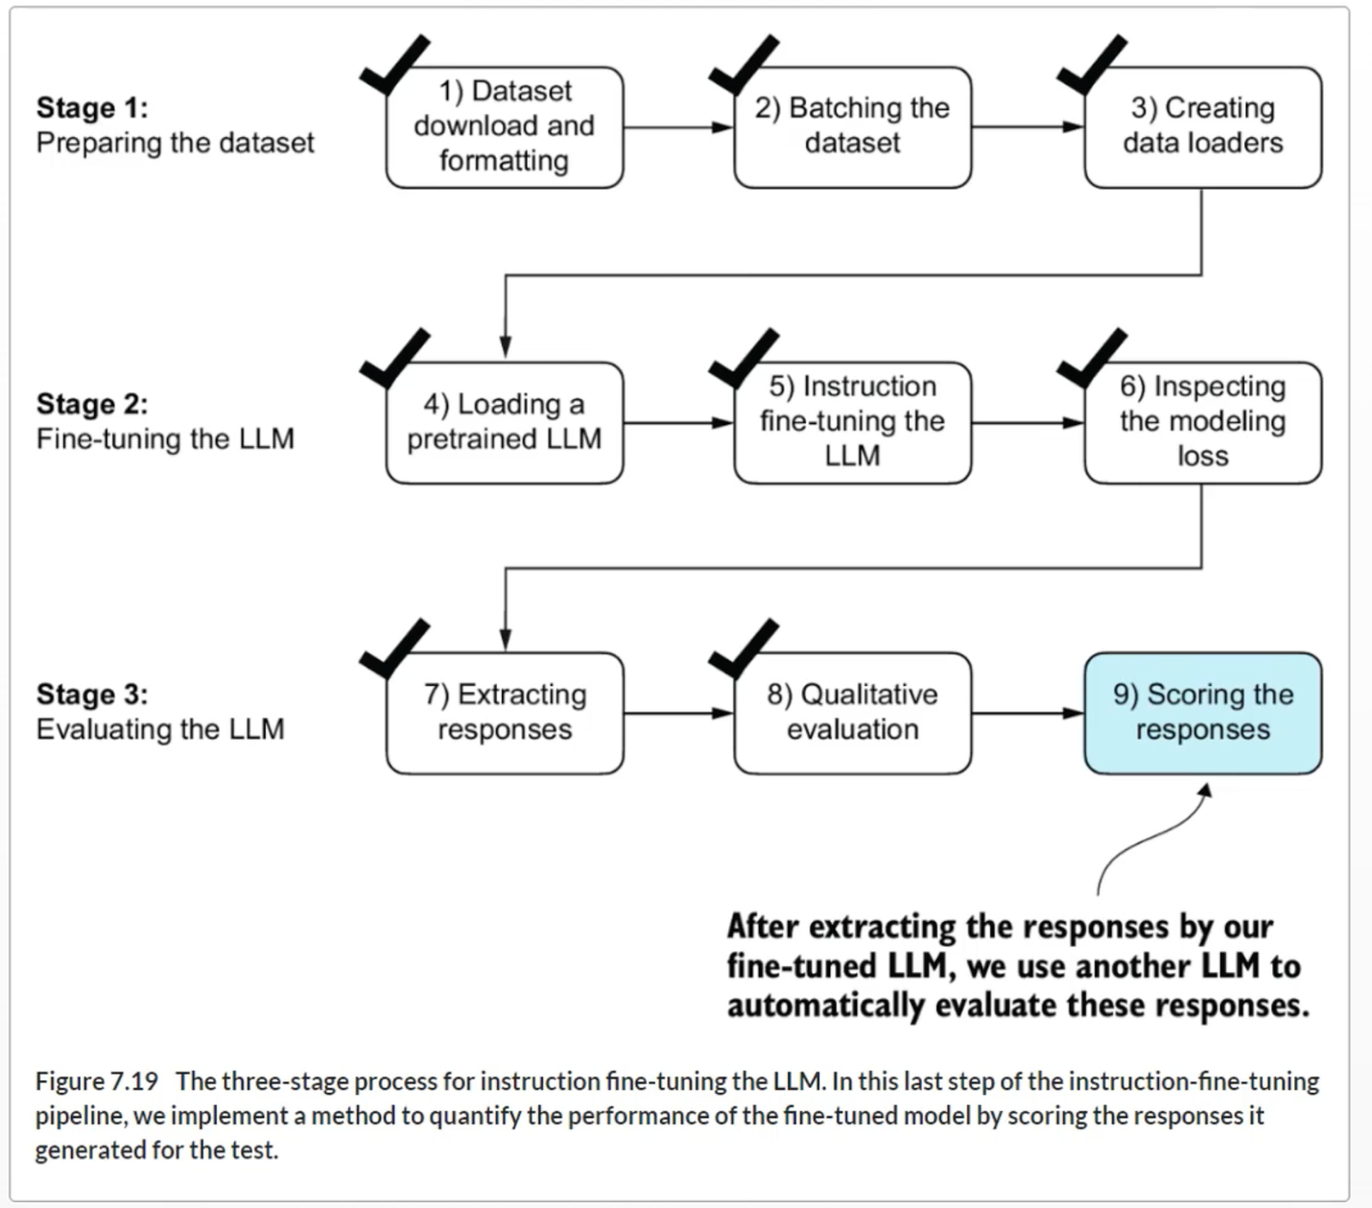

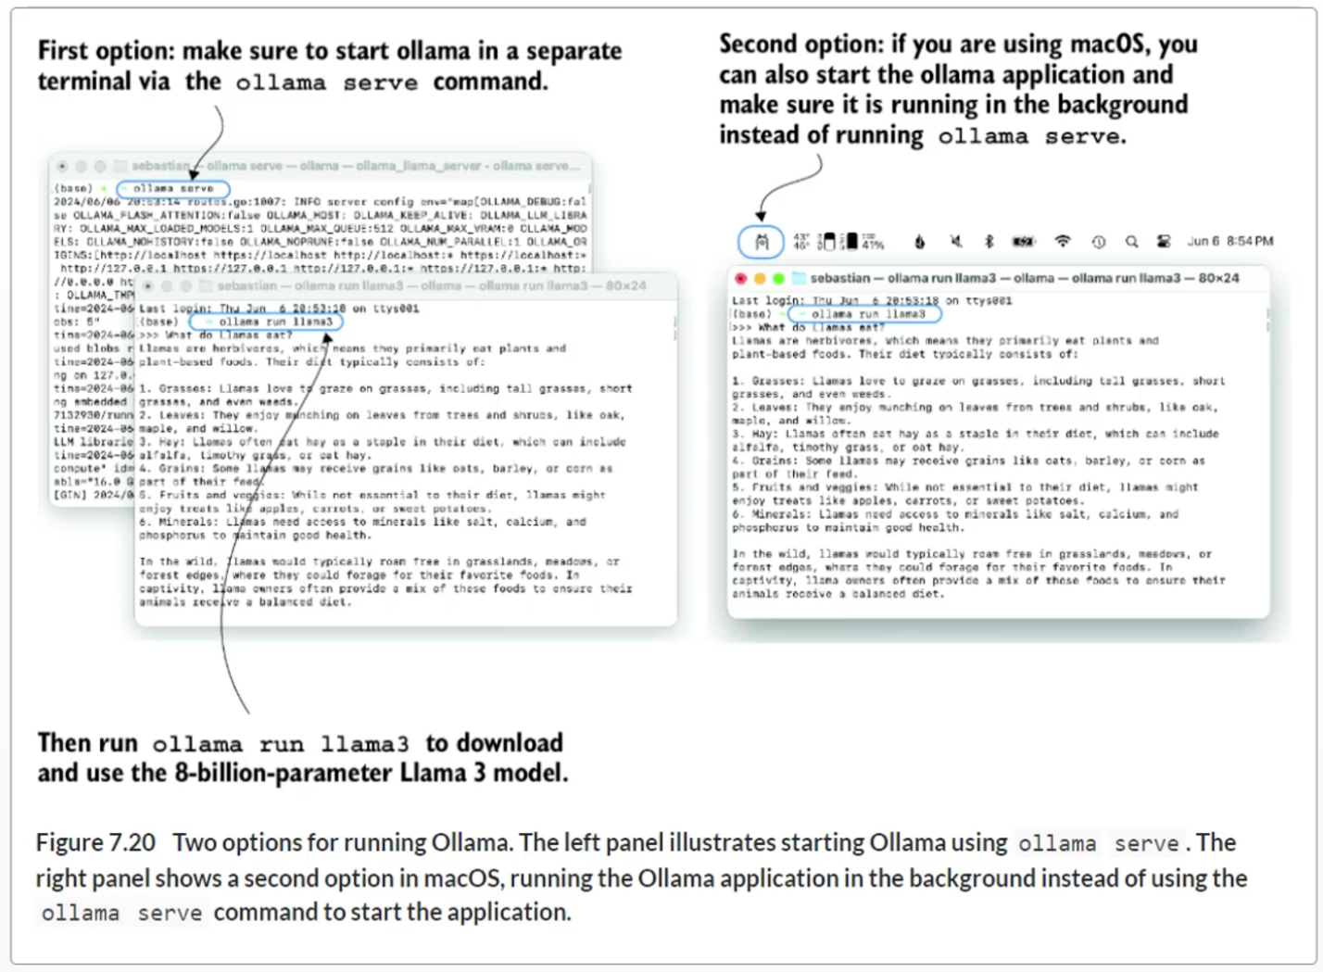

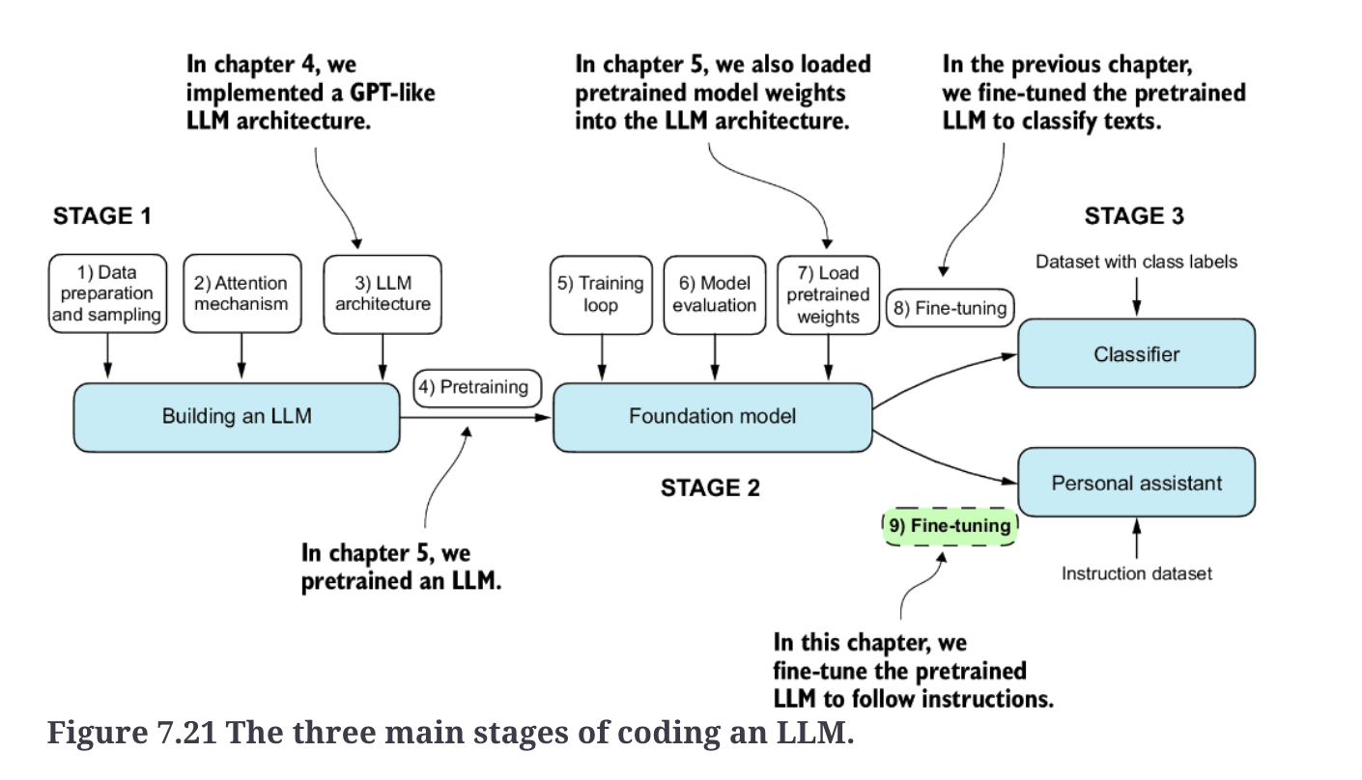

**Summary**

* The instruction-fine-tuning process adapts a pretrained LLM to follow human instructions and generate desired responses.
* Preparing the dataset involves downloading an instruction-response dataset, formatting the entries, and splitting it into train, validation, and test sets.
* Training batches are constructed using a custom collate function that pads sequences, creates target token IDs, and masks padding tokens.
* We load a pretrained GPT-2 medium model with 355 million parameters to serve as the starting point for instruction fine-tuning.
* The pretrained model is fine-tuned on the instruction dataset using a training loop similar to pretraining.
* Evaluation involves extracting model responses on a test set and scoring them (for example, using another LLM).
* The Ollama application with an 8-billion-parameter Llama model can be used to automatically score the fine-tuned model’s responses on the test set, providing an average score to quantify performance.

**Appendix A**

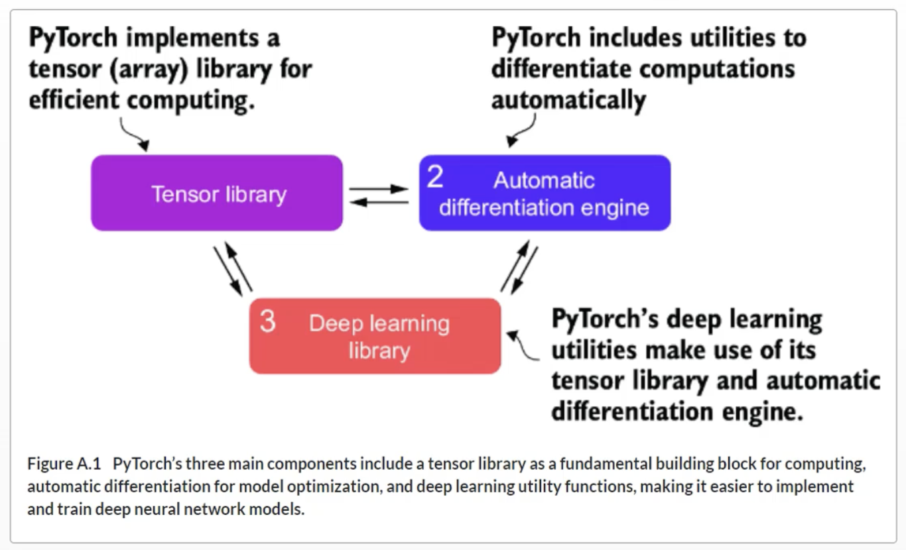

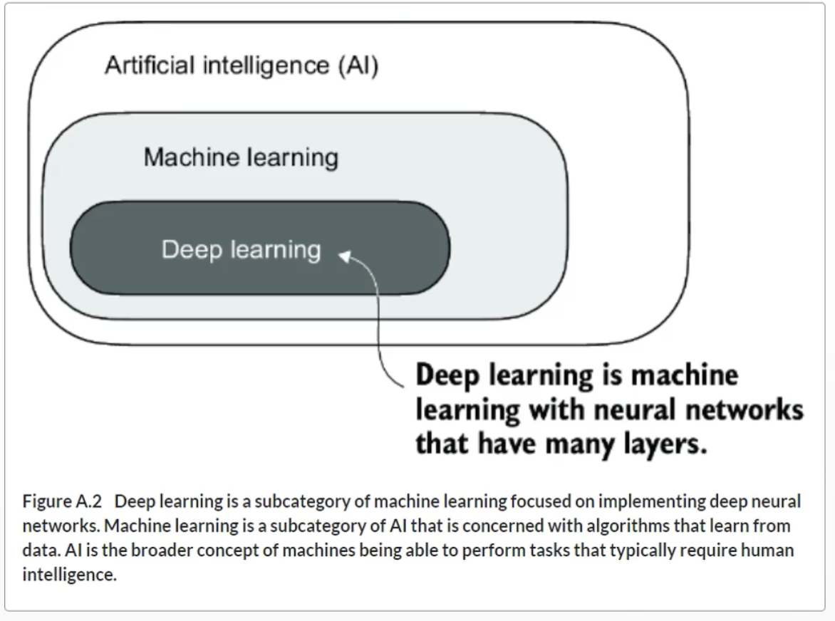

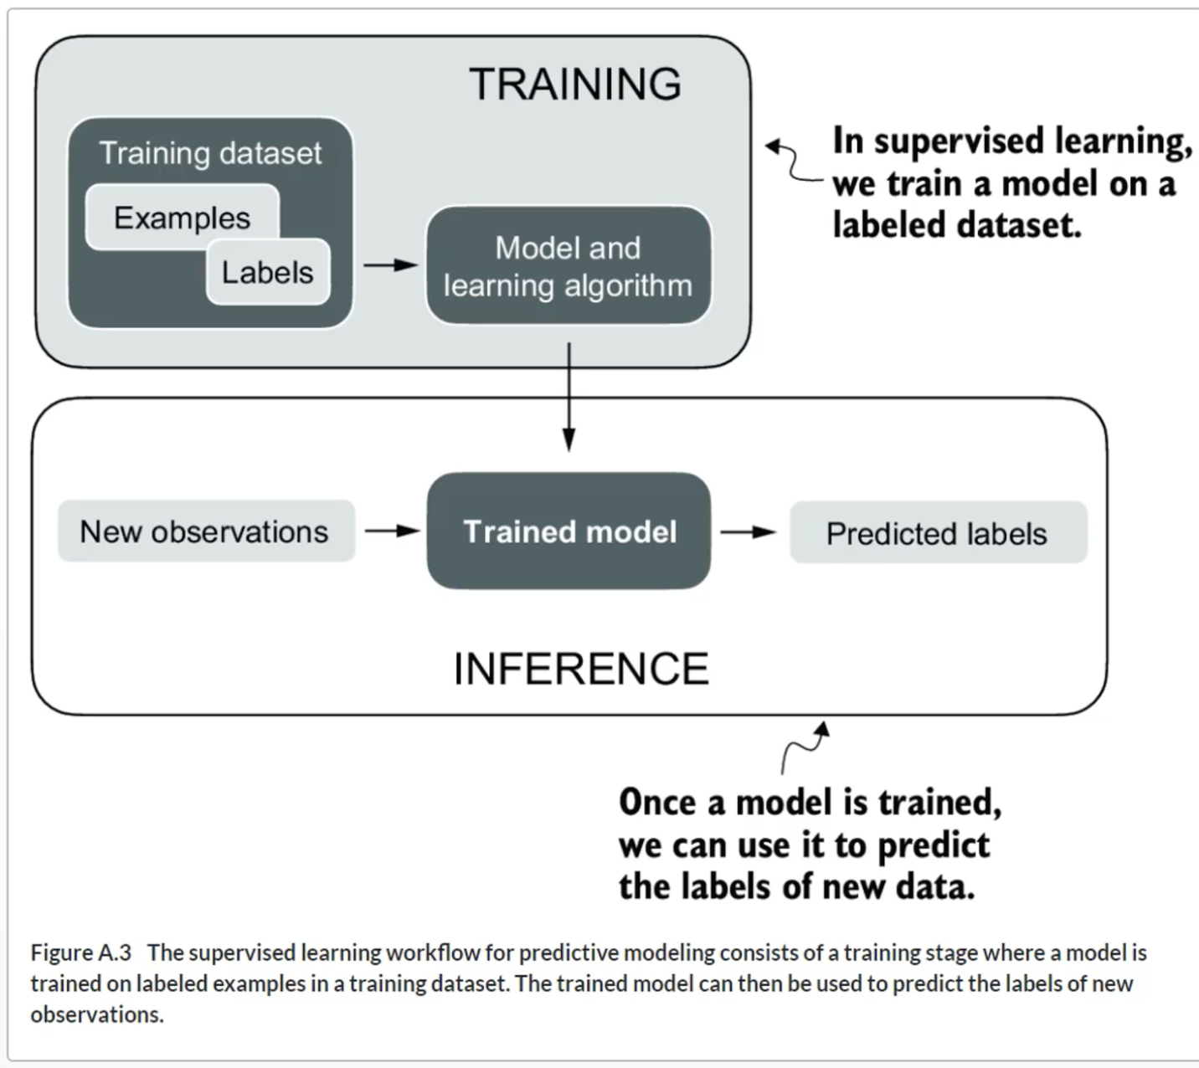

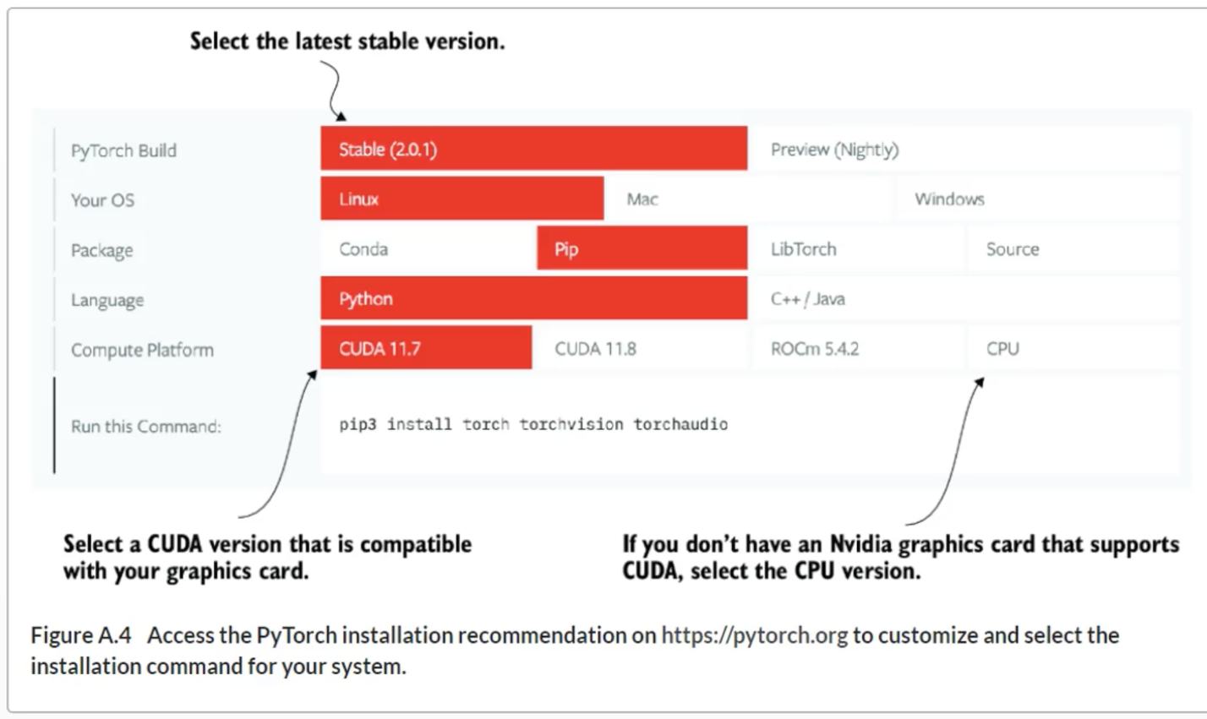

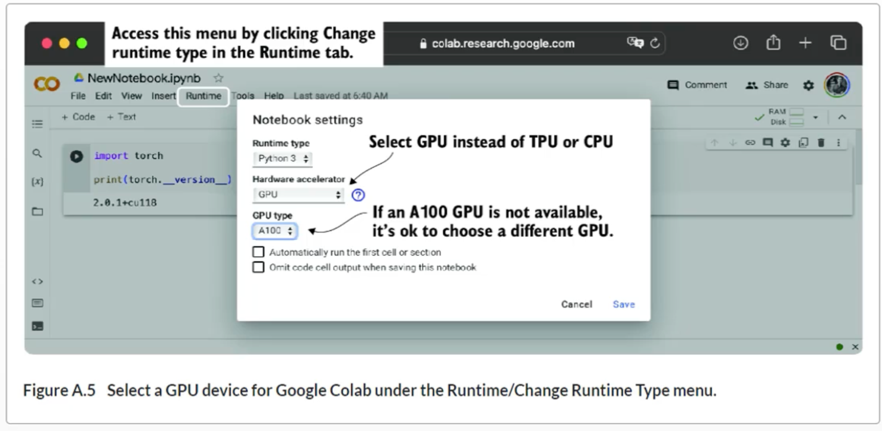

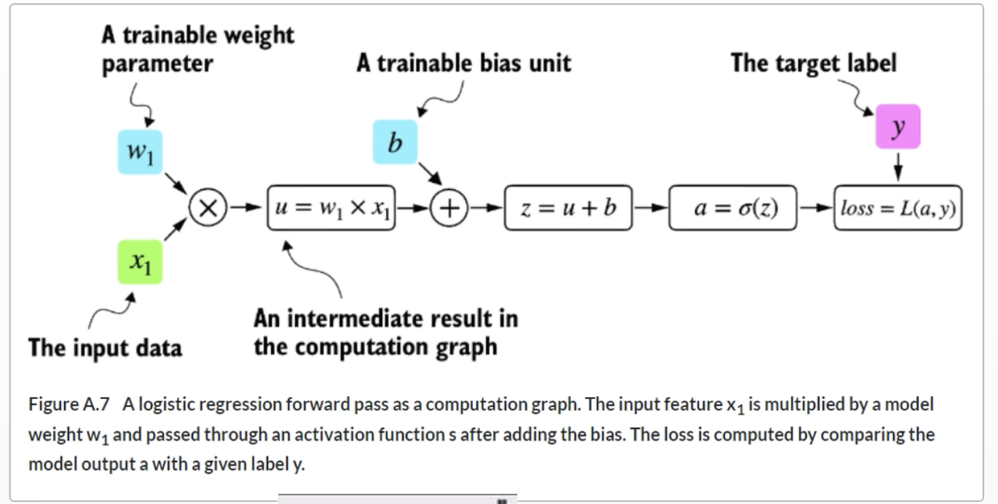

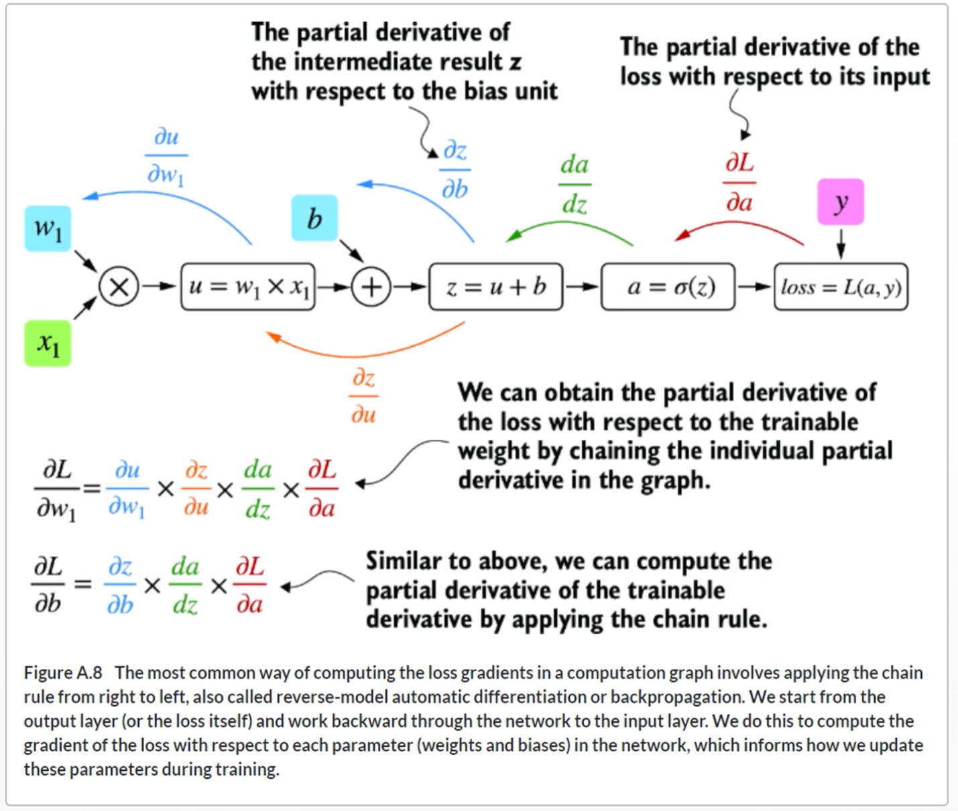

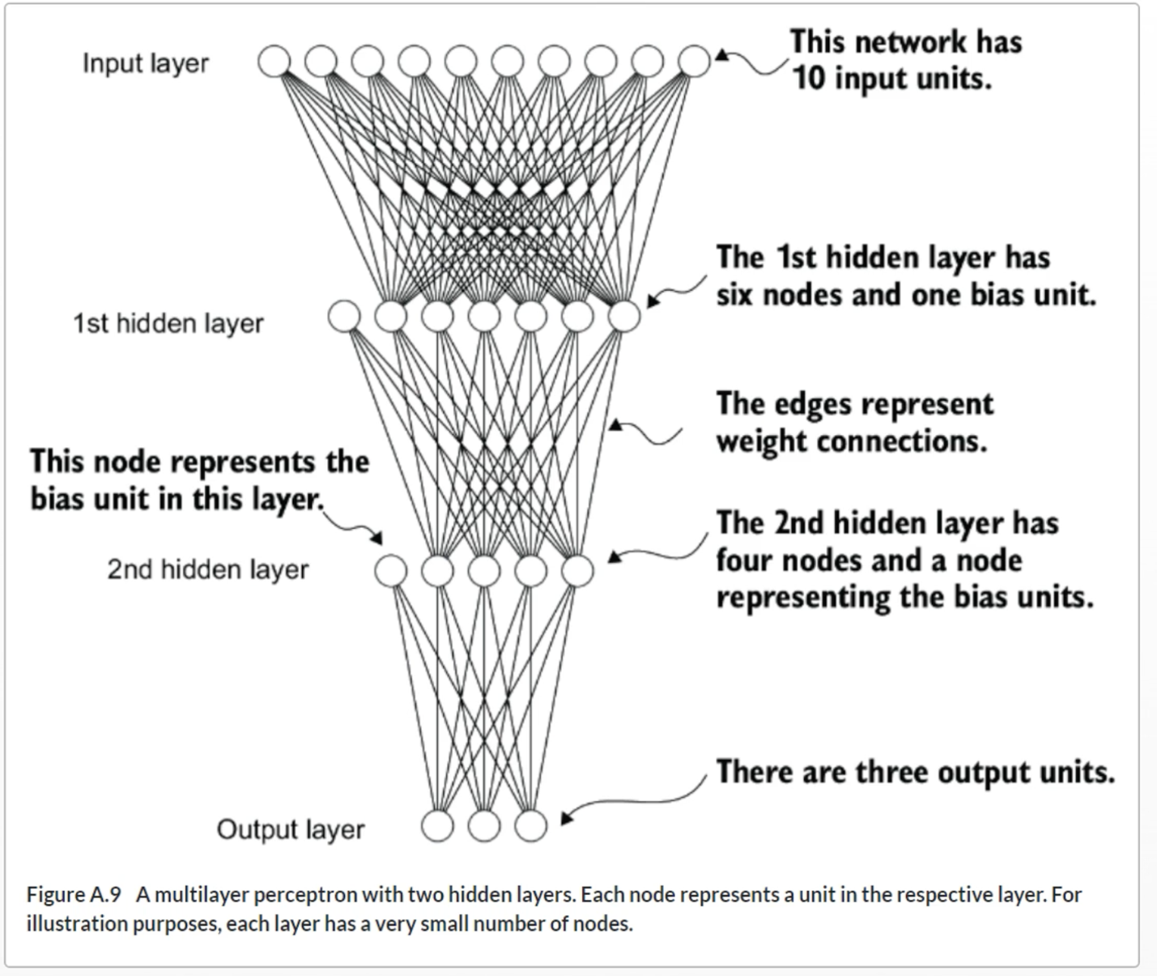

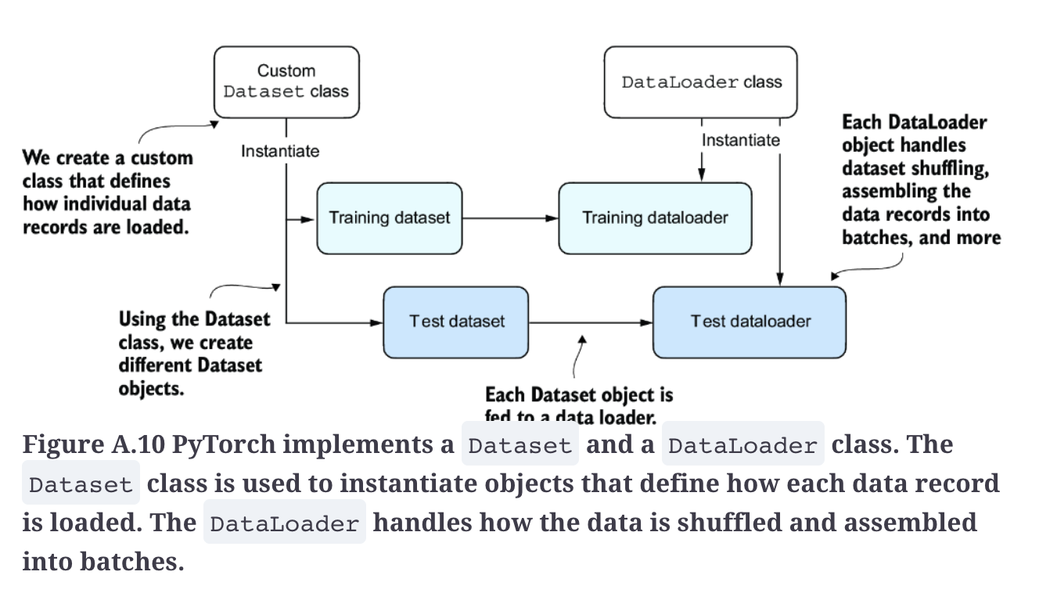

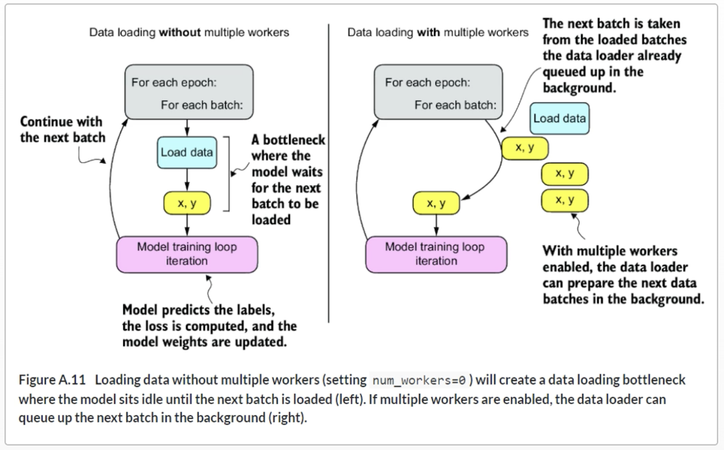

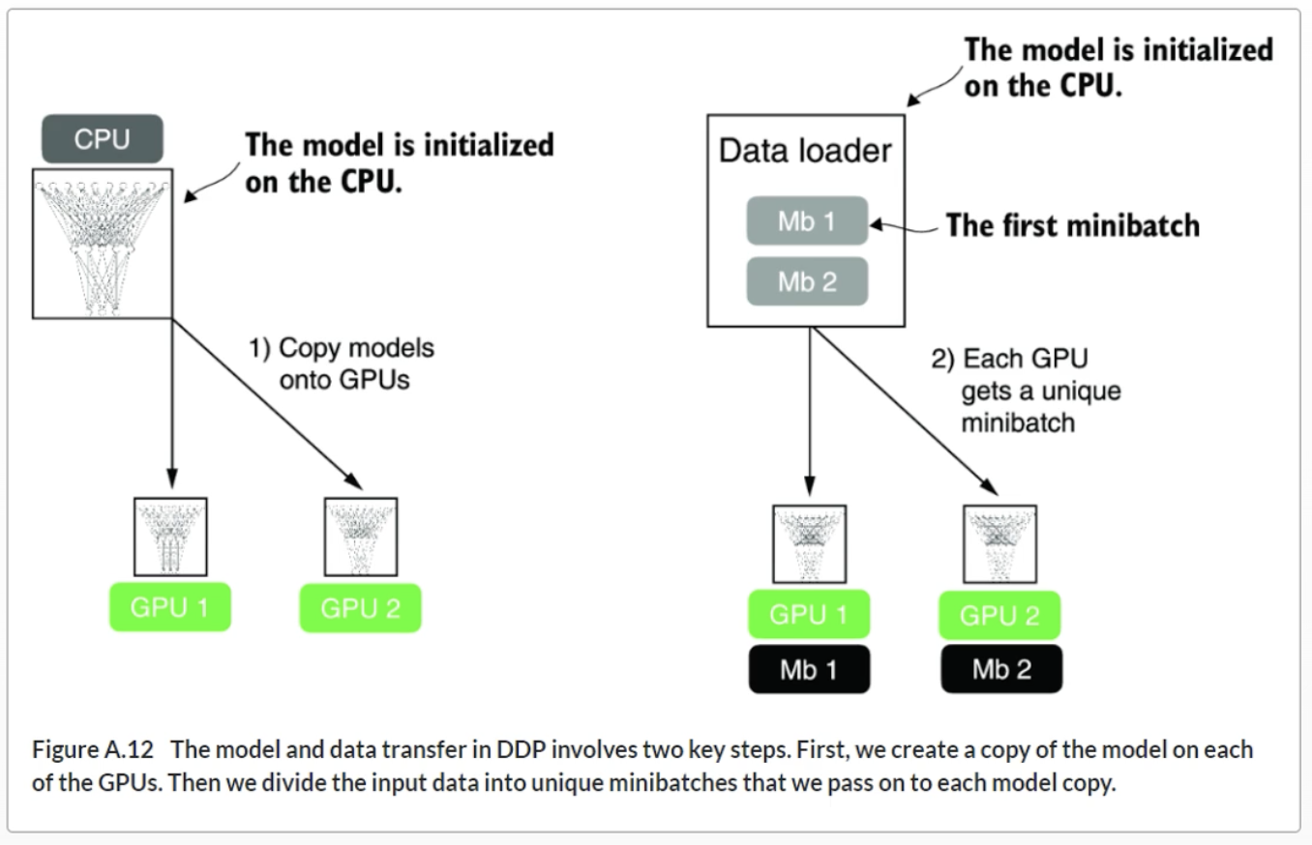

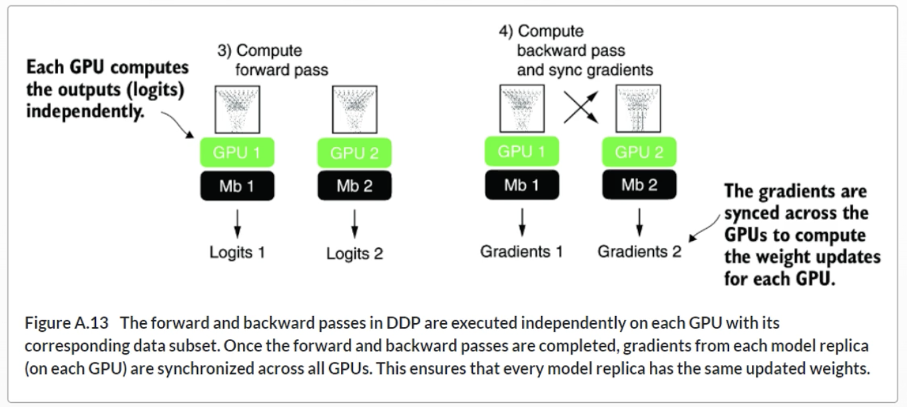

**Summary**

* PyTorch is an open source library with three core components: a tensor library, automatic differentiation functions, and deep learning utilities.
* PyTorch’s tensor library is similar to array libraries like NumPy.
* In the context of PyTorch, tensors are array-like data structures representing scalars, vectors, matrices, and higher-dimensional arrays.
* PyTorch tensors can be executed on the CPU, but one major advantage of PyTorch’s tensor format is its GPU support to accelerate computations.
* The automatic differentiation (autograd) capabilities in PyTorch allow us to conveniently train neural networks using backpropagation without manually deriving gradients.
* The deep learning utilities in PyTorch provide building blocks for creating custom deep neural networks.
* PyTorch includes Dataset and DataLoader classes to set up efficient data-loading pipelines.
* It’s easiest to train models on a CPU or single GPU.
* Using DistributedDataParallel is the simplest way in PyTorch to accelerate the training if multiple GPUs are available.

**Appendix D**

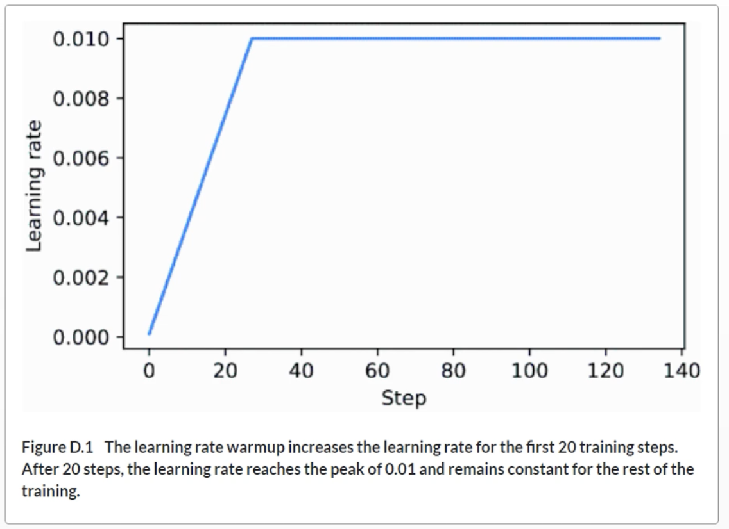

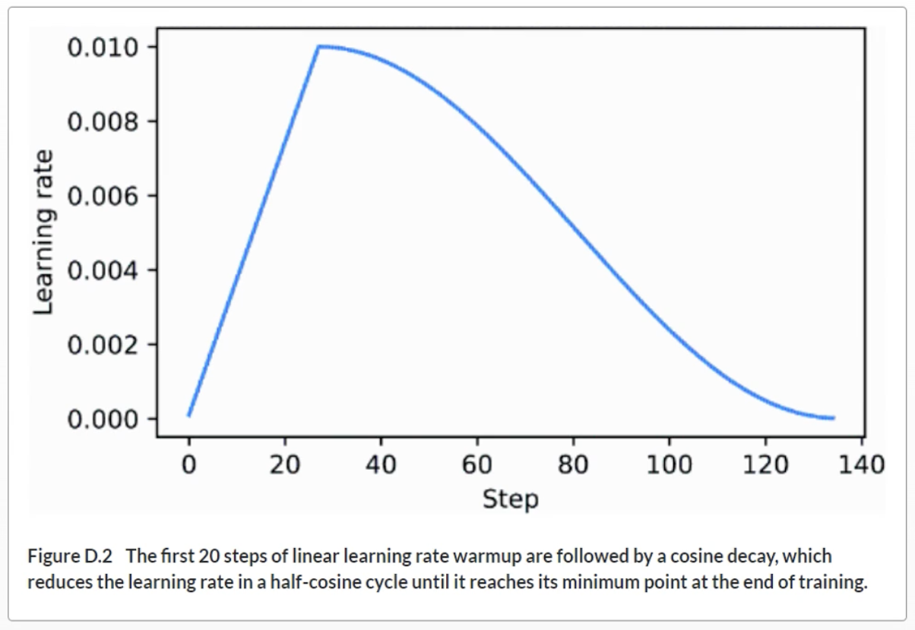

**Appendix E**